
PITHAPUR

RAJAH’S

GOVT

COLLGE

(
A),

KAKINADA

Re
-

Accredited

by

NAAC

with

B++Grade

DEPARTMENT

OF

ZOOLOGY

&

AQUACULTURE

BOARD

OF

STUDIES

B.Sc.

AQUACULTURE

Single
(

Major

System)

2025
-
2026

CHOICE

BASED

CREDIT

SYSTEM

Convened
(

on

11
-
08
-
2025)

B.Sc. Honours - AQUACULTURE
(SingleMajor)

2025-2026

Index

Sl.No | Name of the Item | Page no.
1 | Title page
22 | Proceedings of the BOS
33 | Composition of BOS
44 | Vision and Mission of the College
55 | Agenda
66 | Resolutions
77 | Departmental Action Plan
88 | Credits for each Paper
99 | Programme outcomes
110 | Syllabus with CO-PO mapping
111 | Changes in the syllabus
112 | List of Examiners and Paper setters
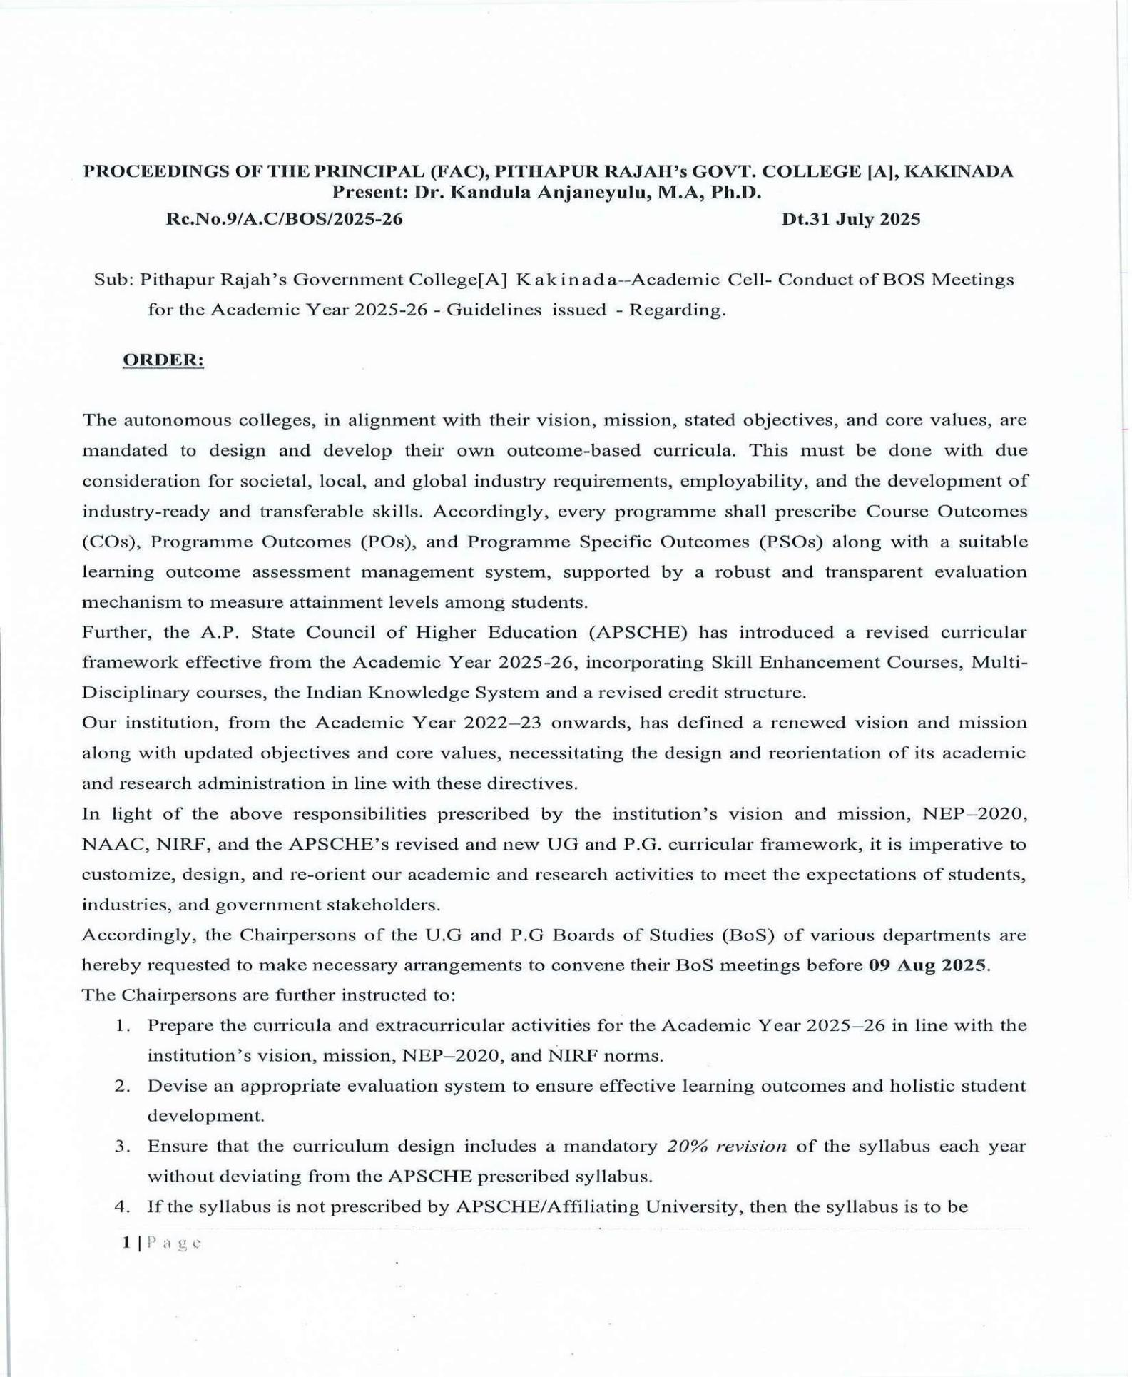
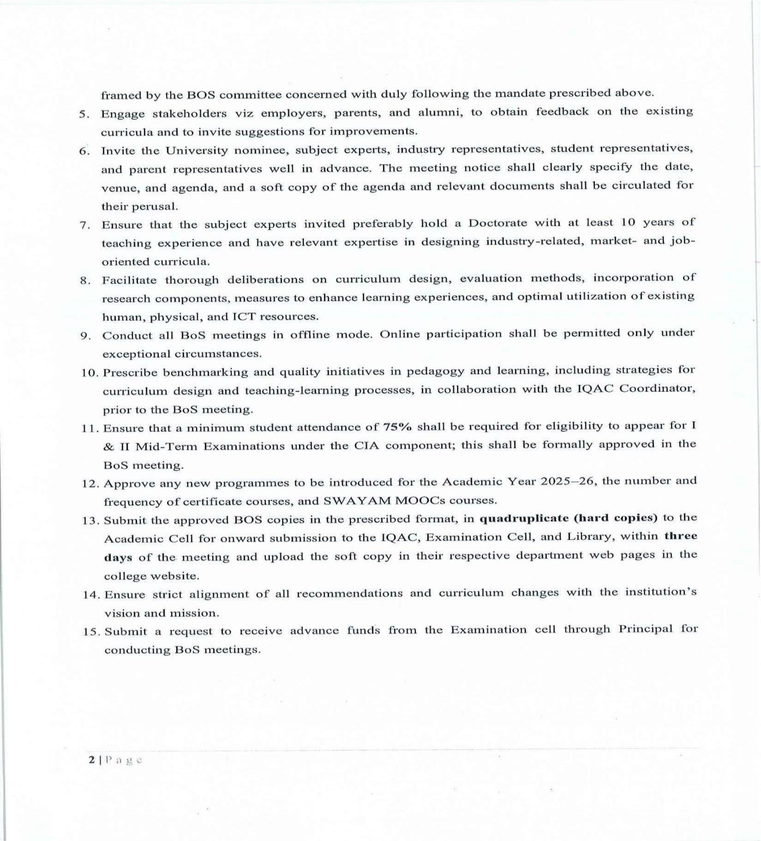
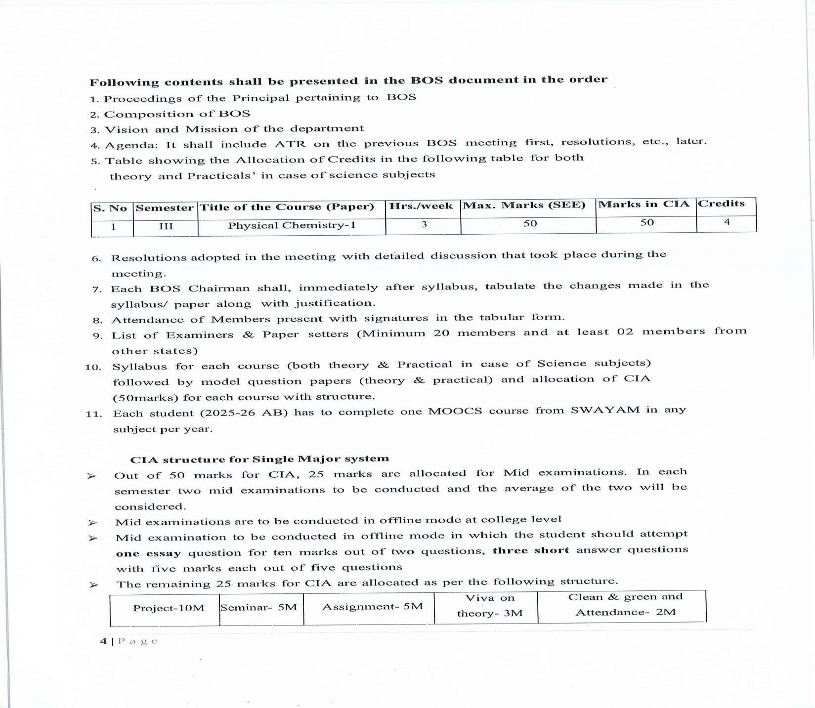



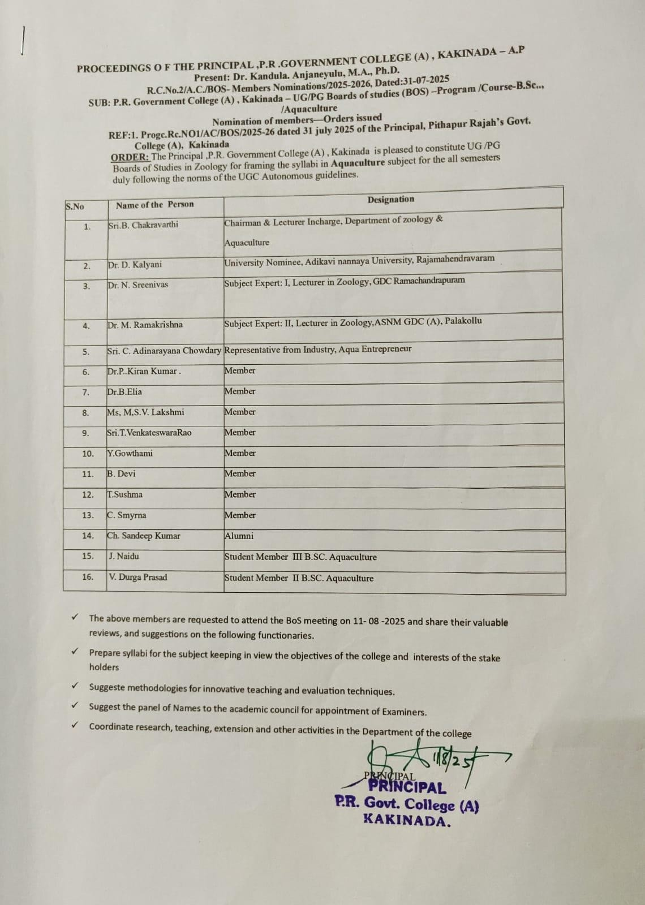

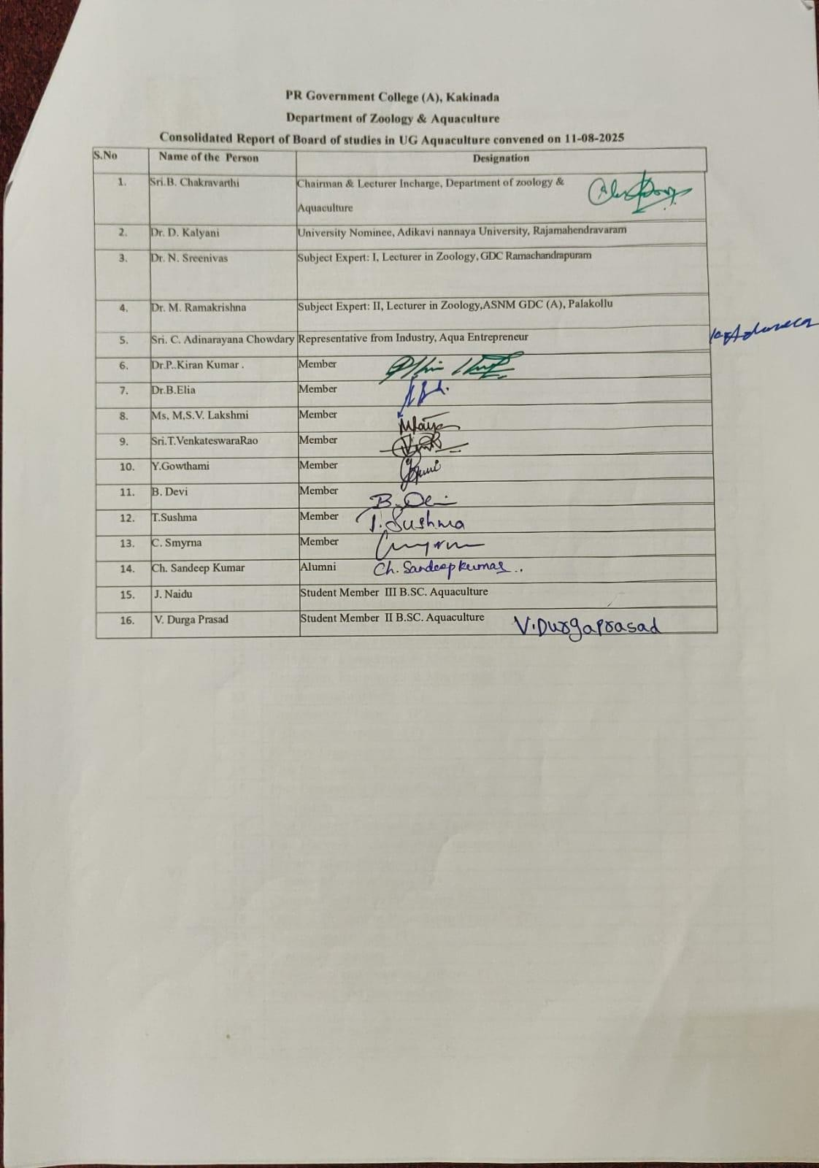
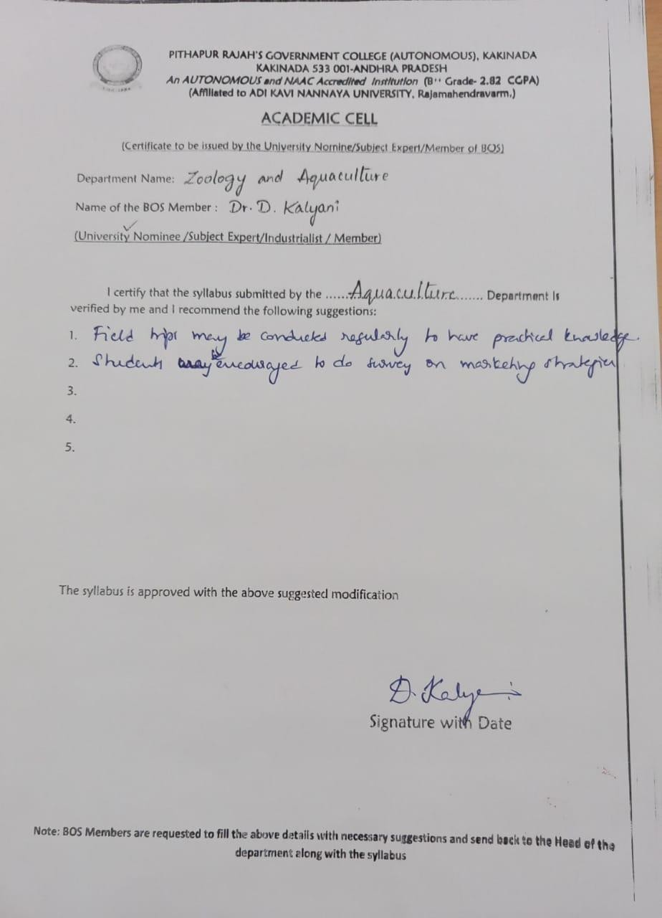
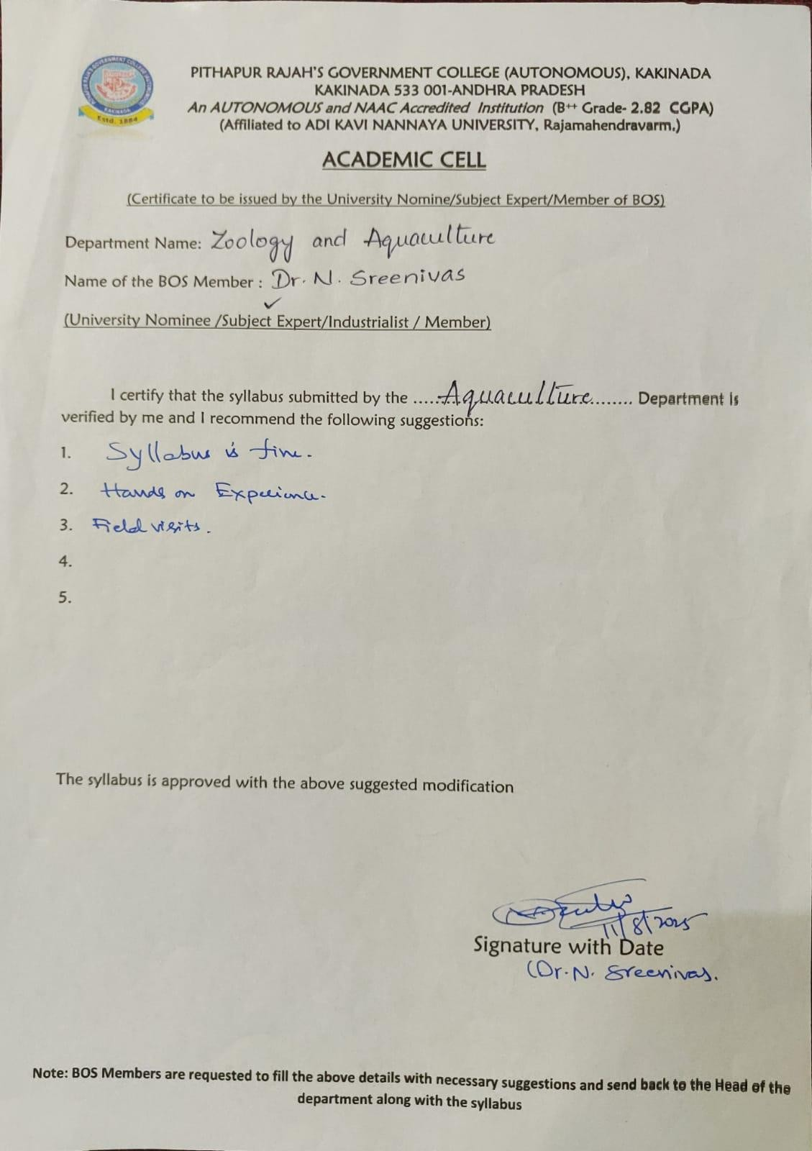
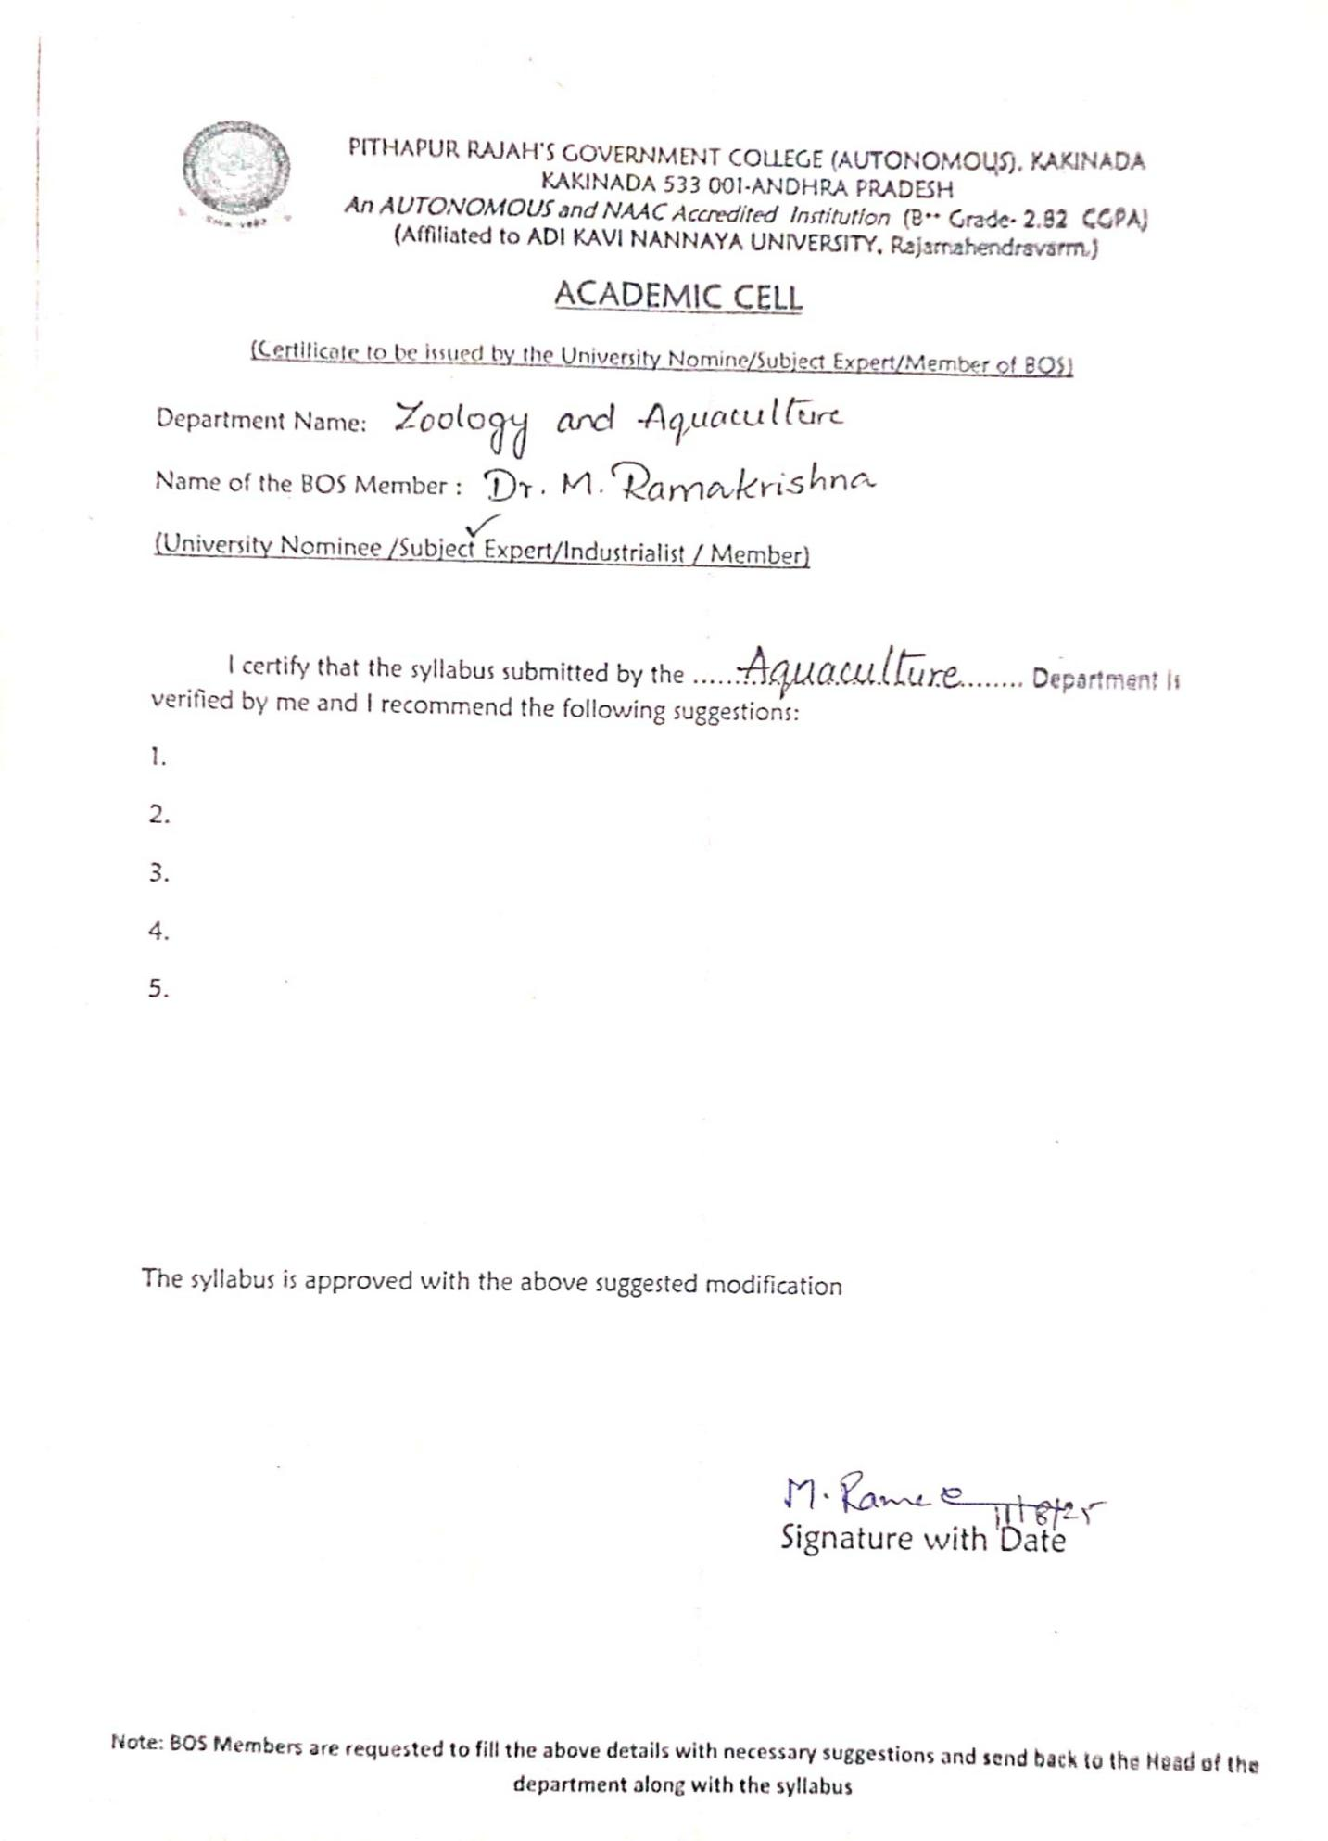

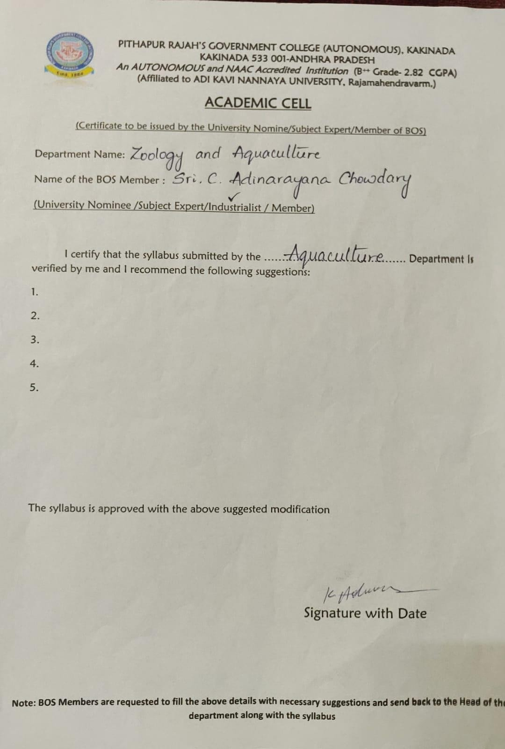

AGENDA FOR BOARD OF STUDIES MEETING-2025-2026

11/08/2025
- Approval of Single major system for UG B.Sc. Honors Aquaculture
- Approval of Syllabus for all the Semesters and implementation of Choice Based Credit System
- Model question papers, Blue Print Panel of paper setters and examiners.
- Methodologies of Teaching–Learning and Evaluation.
- Implementation of Skill Enhancement Courses (SEC’s) in Zoology & Aquaculture Technology by APSCHE through affiliating University for the fifth semester and select one pair of courses based on the choice of majority of the stakeholders.
- 75% 0f Attendance is compulsory to appear for any examination 7. Conduct of guest lectures, field visits, assigning of project works etc.
- Additional inputs and changes in the curriculum.
- Continuation of Certificate courses choosing from the entitled Certificate Course on Diseases of
Human Importance/Applied and Economic Zoology/Ornamental Fishery/Water quality Assessment
- Continuous Internal Assessment pattern (CIA)introduced by APCCE
- Designing and conduct of workshops and seminars
- Arrangement of skill development, training programmes and MOUs.
- Conduct of Bridge Course and Remedial Coaching.
- Approval of new courses introduced in the academic year 2025-26
- Actionplan2025-2026
- Any other proposal with the permission of the Chair.

Discussion:
The members of BOS have discussed all the points of Agenda extensively and approved with following suggestions which are incorporated in the resolutions.
Dr. D. Kalyani, University nominee has suggested to conduct more field trips and market strategy surveys may be conducted with students.
Dr. N. Srineevas has suggested to provide hands on training programs

PITHAPUR RAJAH’S GOVT COLLGE( A), KAKINADA DEPARTMENT OF ZOOLOGY & AQUACULTURE
BOARD OF STUDIES MEETING (2025-26) CONVENED ON 11 August 2025
Resolutions

The members, Board of Studies, Aquaculture met through online and offline on 11 August 202512.00 Noon to discuss the agenda points and to approve the course structure, Theory and Practical syllabus, Blue Print, Model question papers, Additional inputs in the Curriculum, Study Projects, Co- curricular and extracurricular activities of Department, Skill Development Courses and Certificate Courses offered , Internship programmes, Continuous Internal Assessment pattern (CIA) and Semester End examination Pattern.
The following resolutions are made.

Resolution-1

It is resolved to adapt Single major system for UG B.Sc Hounours Aquaculture from the adamic year 2023-24 as per the Guidelines of APSCHE.
It is resolved to follow the syllabus for single major system as well as Choice Based Credit System introduced by UGC/APSCHE through Adikavi Nannaya University, Rajamahendravaram for I,IIIII,IV, V & VI semesters from the academic year 2023-24. Also resolved to implement syllabus given by APSCHE in toto for III, IV, V & VI semesters in the AY 2025-2026

Resolution-2

Resolved to approve the panel of Examiners and Question paper setters, Model papers-and blueprint for all Semesters

Resolution-3

Resolved to implement 50 %external and 50% internal marks for theory exams from the academicyear 2021- 22,2023-2024admitted batches, and 60% -40% for 2020-2021 admitted batch as mentioned below and also resolved to split up 50marks of the or internal as 25 marks for mid exams and 10 marks for project 3 marks for viva,5marks for assignment,2 marks for clean and green activity.

 | Internal Assessment 50M |  |  |  |  |  | Ext’ l  Assessment
I Mid | II  Mid | Project | Viva | Seminar | Assignment | Clean &  Green | 50 M (2023  admitted Batch)
25M | 25M | 10 | 03 | 05 | 05 | 02 | 50 M (2023  admitted Batch)
I Mid | II Mid | Project |  | Seminar | Assignment  etc, | Total | 50 M (2021  Admitted batch)
25M | 25M | 10M |  | 5M | 10M | 50M
25M | 25M |  |  | 5M | 10M | 40M | 60 M (2020  Admitted batch)

Resolution-4

It is resolved to adopt newly introduced Skill Enhancement Courses (SEC’s) in Aquaculture V Semester for the academic year 2025-2026 as given by APSCHE through affiliating University. It is also resolved to choose Courses12 ,13, 14 & 15 from the list of Skill Enhancement Courses (SEC’s) for V Semester for the academic year 2025-2026

Resolution-5

Resolved to offer choice-based Skill Development Courses by Department of Zoology entitled Health and Hygiene as SD course in III Semester and ES in V Semester as prescribed by APSCHE / AKNU

Resolution-6
Resolved to allow students who have put up 75% of attendance to any examination
conducted by the institution. It is also resolved to offer Certificate courses choosing from the entitled list Diseases of Human Importance/Applied and Economic Zoology/Ornamental Fishery/Water quality Assessmein the academic year 2025-26.
Resolution-7
Resolved to implement the SOP given by APSCHE through Adikavi Nannaya University regarding CSP/Short termInternship/Semester Internship at the end of III year
Resolution-8
Resolved to approve assessment process for I, II and III Internships in the following manner.

First internship (Community Service Project) will be taken up after the I year II semester end examinations or the summer vacation in the intervening 1st and 2nd years of study. The assessment is to be conducted for 100 marks. The number of credits assigned is 4. Later the marks are converted into grades and grade points to include finally in the SGPA and CGPA.
The weightage shall be:

Project Log | 20%
Project Implementation | 30%
Projec treport | 25%,
Presentation | 25%

Second Internship shall be undertaken by the students in the intervening summer vacation between 2nd and 3rd years or after the II-year IV semester end examinations. There will be only internal evaluation for this internship. The assessment is to be conducted for 100 marks and the credits assigned are 4. The marks are converted into grades and grade points to include finally in the SGPA and CGPA.

The weightage shall be:

Project Log | 20%
Project report | 25%
Presentation | 25%

Third internship shall be for the entire 6th Semester; the student shall undergo Apprenticeship/ Internship /
On the Job Training. The assessment for the Semester long apprenticeship is for200 marks and credits assigned are 12. The assessment for this internship / on the job training will be both internal and external assessment. The internal assessment will be for 25% of marks which will be continuous and the assessment by the industry/enterprise/organization where the student does his/her internship will be indicated in grades. The Project Presentation is to be made by the student after he/she reports back to the College. Grading given by the Company / Business unit / Enterprise where the student has undergone the training and these grades shall be converted into marks on the scale followed by the University. The weight age shall be:

Internal Assessment Component | Max. Marks | Marks Awarded
Project Log | 10
Project Implementation | 20
Project Report | 10
Presentation | 10
TOTAL | 50
External Assessment Component | Max.  Marks | Marks  Awarded

Performance Assessment by the  Evaluation Committee,converting the grades awarded  by the  industry, enterprise,etc | 100
External Viva Voce | 50
Total | 150
Grand Total | 200

Resolution-9
It is resolved to implement 100% external assessment for Skill Development Courses and 100% internal assessment for Certificate Course and resolved to follow the standard operating procedures given by APSCHE through Adikavi
Nannaya University for the evaluation of CSP/Short term Internship/Apprenticeship (AnnexureII)

Resolution-10

Resolved to arrange Bridge Course for the newly admitted students and remedial classes for slow learners

Resolution-11

It is resolved to make 90% of attendance compulsory for all the students to appear for MID and Sem
End exams

Resolution-12

It is resolved to conduct Co- curricular activities like Student Seminars, quiz programmes, elocution, debate, Group discussion, Extension Activities, Study Projects and field trips and to encourage experiential learning and student participation in extracurricular activities of the college.

Resolution-13

Resolved to conduct Student and Staff Exchange Programmes with ASD Government College for
Women(A), Kakinada, GDC Ravulapalem, GDC Vidavaluru, Silver jubilee Government College,
Kurnool as a part of fulfilling the norms of MoU. Resoved to enter into MOUs with Industries or training
institutes

Resolution-14
It is resolved to take Feedback on Curriculum design and development from Students,Alumni, Teachers,Parents,and industry at the end of the semester.

Resolution-15

It is resolved to introduce the following new courses in—B.Sc.(Honours) Aquaculture, from the AY2025-26 as per the curriculum given by APSCHE for V semester

V | 2 2 | Extension, Economics & Marketing- (T)
V | 2 2 | Extension, Economics & Marketing- (P) | 2 | 1
V | 13  13 | Ornamental Fishery- (T) | 3 | 3
V | 13  13 | Ornamental Fishery - (P) | 2 | 1
V | 14 | Fishery Engineering- (T) | 3 | 3
V | 14 | Fishery Engineering - (P) | 2 | 1
V | 15 | Fish Processing Technology- (T) | 3 | 3
V | 15 | Fish Processing Technology- (P) | 2 | 1

Resolution 16

Resolved to implement Action plan for the Academic year 2025-26

Resolution-17

Resolved that the chairman, BOS is authorized to take up necessary amendments, changes, additions, and others as and when required as per the instructions of the University, APSCHE and other exigencies in consultation with the controller of examinations if necessary

S.No | Activity planned | Date/ Period | Outcomes/ Objectives | Approximate Budget | Remarks
1 | Preparation of Annual Curricular Plans and Pre BOS arrangements | Ist week of June  2025 | *To deliver content in a systematic way  * To design, develop and enrich curriculum
2 | *Free Medical Camp for all staff | July IV week | 5000
4 | *Publications By Faculty in UGC Care /Scopus Journals  *Launch of Certificate Course  BOS Meetings  *MOU with Industry  *Invited Lecture  Field Trips to II- & III-Year students | August 2025  1-08-2025  2nd Week of August  3rd week of August  4th week of  August | Research and academic  excellence  Faculty welfare,  Curriculum Enrichment  Experiential Learning
5 | *Student Seminars  *Field trip to I Year students  *Blood Donation Camp/Blood Group  Identification  *Remedial coaching | Ist week of  September  II week of  September  4th week of  September | Curriculum enrichment & Evaluation  Experiential Learning  Community service
6 | *Awareness program on Seasonal diseases  *Remedial coaching | 1st week of October 2025 | Extension Activity at nearby schools
7 | *World Fisheries Day  *National Conference on “Zoology  Reimagined: AI Tools for Wildlife and  Ecosystems” | 21-11-2025  4th week of November | To highlight the importance  of fisheries sector  To Explore and to integrate AI tools for Wild life conservation

8 | *Student Training Program at SIFT  *Student Seminars | December 2025 | Skill Development
9 | *Faculty Exchange Program under MOU | January 2025 | To Exchange academic resources and Knowledge sharing
10 | *Student Exchange Program under MOU  *PG CET Coaching | February 2025 | To Exchange academic resources and Knowledge sharing
11 | *Publications By Faculty in UGC Care /Scopus Journals  *Remedial Coaching | March 2025 | Research/Academic  Excellence  Outcome achievement

Single major System
2025-2026 Admitted Batch onwards
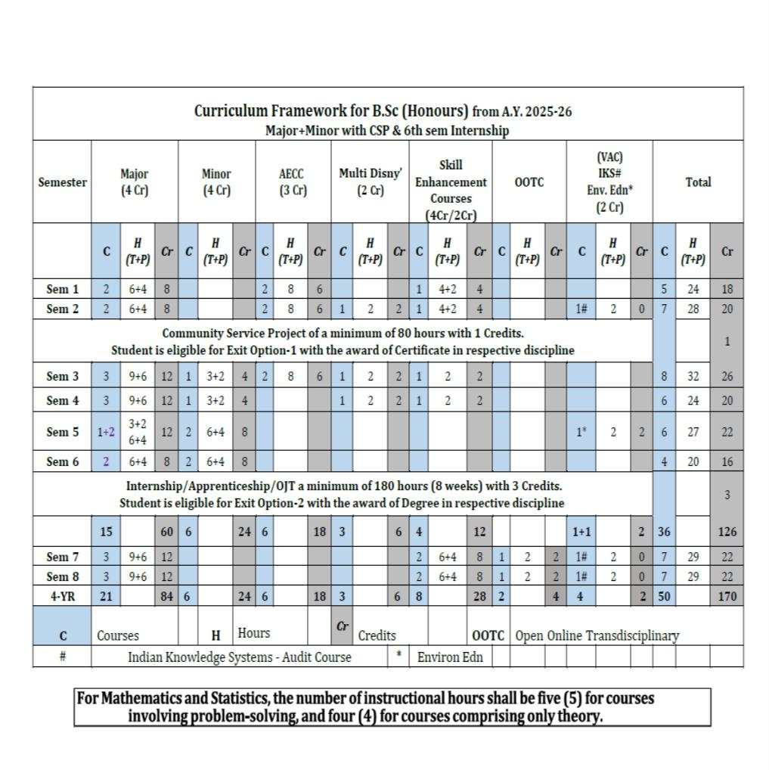

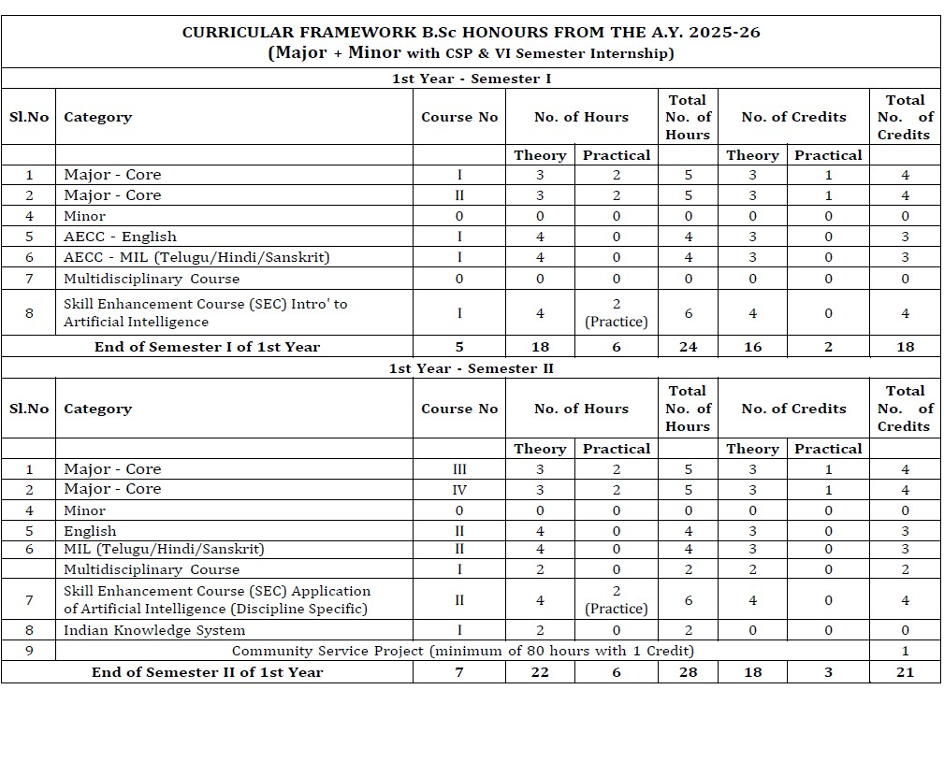
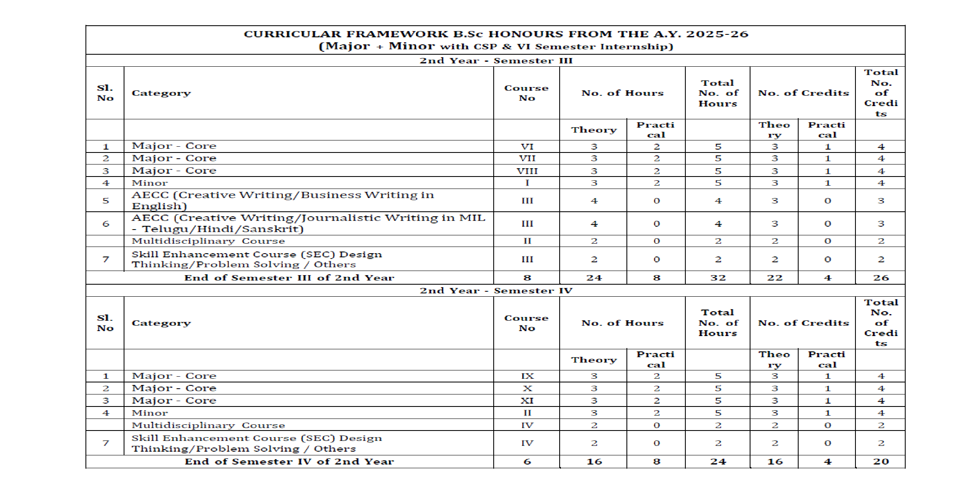
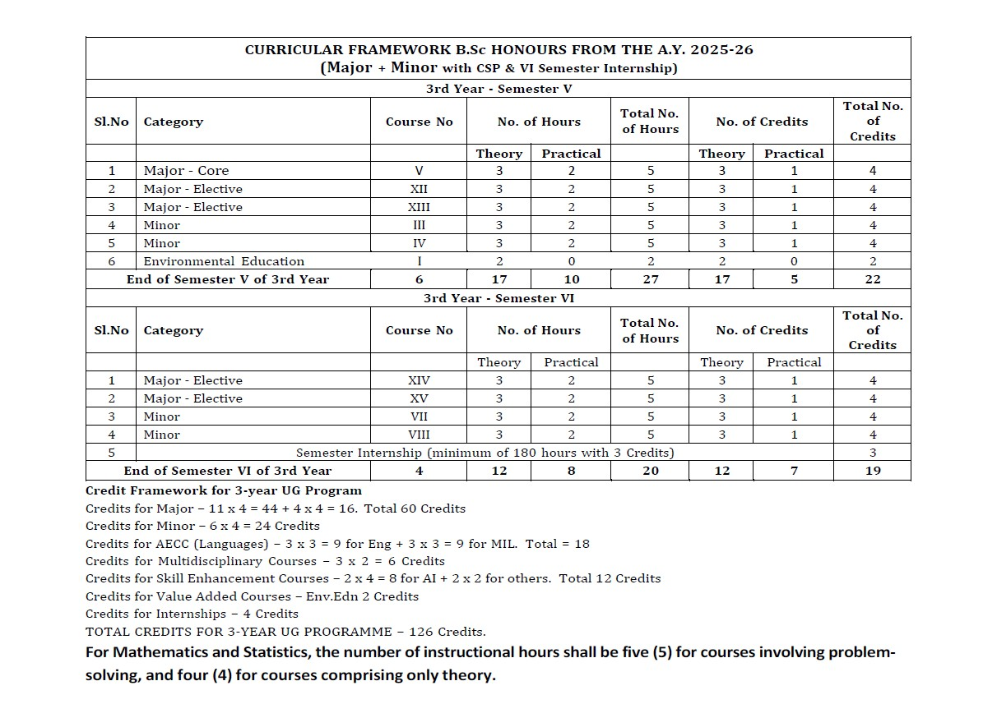

 | ANDHRA PRADESH STATE COUNCIL OF HIGHER  EDUCATION

Syllabus for 4-Year UG Honours in B.Sc. (Aquaculture) as Major in consonance with Curriculum framework
w.e.f. AY 2025-26
Prepared by Acharya Nagarjuna University, Guntur

COURSE STRUCTURE (for Semester I to II)

Year | Semester | Course | Title of the Course | No. of Hrs  /Week | No. of Credits
I | I | 1 | Basic Principles and Practices of Aquaculture | 3 | 3
I | I | 1 | Basic Principles and Practices of Aquaculture- Practical | 2 | 1
I | I | 2 | Biology of Finfish & Shellfish | 3 | 3
I | I | 2 | Biology of Finfish & Shellfish - Practical | 2 | 1
I | II | 3 | Freshwater Aquaculture | 3 | 3
I | II | 3 | Freshwater Aquaculture - Practical | 2 | 1
I | II | 4 | Brackish water Aquaculture and Mariculture | 3 | 3
I | II | 4 | Brackish water Aquaculture and Mariculture - Practical | 2 | 1
II | III | 5 | Fish Health Management | 3 | 3
II | III | 5 | Fish Health Management - Practical | 2 | 1
II | III | 6 | Shrimp Health Management | 3 | 3
II | III | 6 | Shrimp Health Management - Practical | 2 | 1
II | III | 7 | Fish Nutrition & Feed Technology | 3 | 3
II | III | 7 | Fish Nutrition & Feed Technology - Practical | 2 | 1
II | IV | 8 | Fish Immunology | 3 | 3
II | IV | 8 | Fish Immunology - Practical | 2 | 1
II | IV | 9 | Fish Processing Technology | 3 | 3
II | IV | 9 | Fish Processing Technology -Practical | 2 | 1
II | IV | 10 | Extension, Economics and Marketing | 3 | 3
II | IV | 10 | Extension, Economics and Marketing- Practical | 2 | 1
 |  | 11 | Ornamental Fish Culture | 3 | 3
 |  | 11 | Ornamental Fish Culture -Practical | 2 | 1
 |  |  | Soil and Water Quality Management | 3 | 3

12 A
III | V |  | Soil and Water Quality Management-Practical | 2 | 1
III | V |  | OR
III | V | 12 B | Coastal Aquaculture | 3 | 3
III | V | 12 B | Coastal Aquaculture - Practical | 2 | 1
Year | Semester | Course | Title of the Course | No. of  Hrs  /Week | No. of Credits
 |  |  | OR
 |  | 12 C | Crustacean Culture | 3 | 3
 |  | 12 C | Crustacean Culture - Practical | 2 | 1
 |  | 13 A | Aquaculture Microbiology | 3 | 3
 |  | 13 A | Aquaculture Microbiology - Practical | 2 | 1
 |  |  | OR
 |  | 13 B | Aquaculture Engineering | 3 | 3
 |  | 13 B | Aquaculture Engineering - Practical | 2 | 1
 |  |  | OR
 |  | 13 C | Molluscan and Seaweed culture | 3 | 3
 |  | 13 C | Molluscan and Seaweed culture - Practical | 2 | 1
 | VI | 14 A | Post-Harvest Technology & Transportation | 3 | 3
 | VI | 14 A | Post-Harvest Technology & Transportation - Practical | 2 | 1
 | VI |  | OR
 | VI | 14 B | Hatchery Technology in Aquatic organisms | 3 | 3
 | VI | 14 B | Hatchery Technology in Aquatic organisms - Practical | 2 | 1
 | VI |  | OR
 | VI | 14 C | Genetics in Aquaculture | 3 | 3
 | VI | 14 C | Genetics in Aquaculture - Practical | 2 | 1
 | VI | 15 A | Techniques for Aqua Lab | 3 | 3
 | VI | 15 A | Techniques for Aqua Lab - Practical | 2 | 1
 | VI |  | OR
 | VI | 15 B | Aquaculture Biotechnology | 3 | 3
 | VI | 15 B | Aquaculture Biotechnology - Practical | 2 | 1
 | VI |  | OR
 | VI | 15 C | Quality Control in Processing Plants | 3 | 3
 | VI | 15 C | Quality Control in Processing Plants- Practical | 2 | 1

Note: In the III Year (during the V and VI Semesters), students are required to select a pair of electives from one of the Three specified domains. For example: if set ‘A’ is chosen, courses 12 to 15 to be chosen as 12 A, 13 A, 14 A and 15 A. To ensure in-depth understanding and skill development in the chosen domain, students must continue with the same domain electives in both the V and VI Semesters.

Pithapur Rajah’s Govt. Degree College (A) Kakinada SEMESTER-I

COURSE 1: BASIC PRINCIPLES AND PRACTICES OF AQUACULTURE
Theory Credits: 3 3 hrs/week
COURSE OBJECTIVES:
- To study the significance, history, present status of aquaculture in world, India and AP • To gain knowledge on various types of aquaculture systems and practices
- To learn the design and construction principles of aqua farms and hatcheries.
- To understand the significance of water and soil quality parameters in aquaculture ponds.
- To study the methods of eradication of aquatic weeds, insects, unwanted fishes and algal blooms in culture ponds.
- To improve technical skills in water analysis, identification of pond biota and gain hands-on and field experience by visiting aqua farms.

LEARNING OUTCOMES:
By the completion of the course, student will be able to –
- Understand the scope and status of aquaculture with related schemes and its significance.
- Differentiate various aquaculture systems and culture practices, and their significance.
- Explain design and construction principles of aqua farms and hatcheries.
- Analyse the physico-chemical and biological parameters of water and soil in aquaculture ponds and maintain their optimum levels for better production.
- Implement proper liming and fertilization techniques for maintaining pond health.
- Apply proper pond culture management practices for high yielding profitable culture.

SYLLABUS:

UNIT-I: Introduction
1.1. Definition, Significance and History of Aquaculture.
1.2. Concept of Blue Revolution and Pradhan Mantri Matsya SampadaYojana (PMMSY)
1.3. Present status of Aquaculture at global, India and Andhra Pradesh level
1.4. Aquaculture versus Agriculture; Present day needs with special reference to A.P.

UNIT-II: Aquaculture Systems and Practices
2.1. Types of aquaculture: Freshwater aquaculture, Brackish water aquaculture and Mariculture
2.2. Culture Systems: Ponds, Raceways, Cages, Pens, Rafts, Water Recirculating Systems, Bio- floc technology and 3C system
2.3. Culture practices: Traditional, Extensive, Modified Extensive, Semi-Intensive, Intensive and Super Intensive systems of fish and shrimp.
2.4. Culture methods: Monoculture, Poly culture, Mono-sex culture and Integrated fish farming.

UNIT-III: Design and Construction of Aqua Farms
3.1. Functional classification of ponds – head pond, hatchery, nursery, rearing, production, stocking and quarantine ponds
3.2. Criteria for the selection of site for freshwater and brackish water pond farms
3.3. Design and construction of an ideal fish and shrimp farms.
3.4. Design and construction of fish and shrimp hatcheries.

UNIT-IV: Pond Culture Management-I
4.1. Water quality in freshwater fish ponds: Significance of physico-chemical (temperature, transparency, turbidity, light, pH, DO, CO2, orthophosphates, NH3, NO2) and biological (plankton and benthos) characteristics and their management at optimal levels in ponds.
4.2. Water quality in shrimp culture ponds: Significance of physico-chemical and biological characteristics and their management at optimal levels in ponds.
4.3. Significance of soil characteristics and their optimal levels for culture
4.4. Liming and fertilization: Lime and Fertilizers (organic manures and chemical Fertilizers) - Types and need of their application in ponds

UNIT-V: Pond Culture Management-II
5.1. Common aquatic weeds- advantages and disadvantages and their control in culture ponds
5.2. Aquatic insects: Disadvantages of insects and their control
5.3. Unwanted fishes: Common weed and predatory fishes - Disadvantages and their control.
5.4. Algal blooms: Bloom forming algae and their control

REFERENCE BOOKS:
- Jhingran VG 1998. Fish and Fisheries of India. Hindustan Publishing Corporation, New Delhi
- Pillay TVR & Kutty MN. 2005. Aquaculture- Principles and Practices. 2nd Ed. Blackwell
- Pillay TVR & Dill MA. 1979. Advances in Aquaculture. Fishing News Books Ltd., London
- Stickney RR 1979. Principles of Warm Water Aquaculture. John Wiley & Sons Inc.1981
- Boyd CE 1982. Water Quality Management for Pond Fish Culture. Elsivier Scientific Publ.
- Bose AN et.al, 1991. Costal Aquaculture Engineering. Oxford & IBH Publishing Company.

CO-PO Mapping:
( 1: Slight [Low] 2: Moderate [Medium];3: Substantial [High], : 0 : No Correlation)
 | PO1 | PO2 | PO3 | PO4 | PO5 | PO6 | PO7 | PO8 | PO9 | PO10 | PSO1 | PSO2 | PSO3
CO1 | 3 | 2 | 2 | 1 | 2 | 1 | 3 | 2 | 3 | 2 | 1 | 2 | 2
CO2 | 2 | 1 | 3 | 2 | 1 | 1 | 2 | 3 | 1 | 1 | 2 | 2 | 2
CO3 | 1 | 1 | 2 | 3 | 3 | 1 | 1 | 1 | 2 | 3 | 1 | 2 | 1
CO4 | 3 | 2 | 3 | 2 | 2 | 2 | 1 | 2 | 1 | 2 | 2 | 1 | 2
CO5 | 1 | 2 | 1 | 1 | 1 | 2 | 2 | 1 | 1 | 1 | 1 | 1 | 2

Pithapur Rajah’s Govt. College (A) Kakinada.
DEPARTMENT OF ZOOLOGY
SEMESTER I
COURSE 1: BASIC PRINCIPLES AND PRACTICES OF AQUACULTURE

BLUE PRINT

Time: 2 hrs Max. Marks: 50

Unit |  | Essay | Short
 | I | 1 | 1
 | II | 1 | 1
 | III | 1 | 2
 | IV | 2 | 2
 | V | 1  Out of 6, 3 questions should be answered  3X10=30M | 1  Out of 7, 4questions should be answered  4X5=20M

BASIC PRINCIPLES AND PRACTICES OF AQUACULTURE
QUESTION BANK

Essay Questions

UNIT – I
- Describe the Status of aquaculture in India.
- Explain the concept of the Blue Revolution and its impact on aquaculture development.
- Write an essay on objectives and components of (Pradhan Mantri Matsya Sampada Yojana)
- Discuss the present status of aquaculture in Andhra Pradesh.

UNIT – II
- Explain Freshwater aquaculture, including its types and advantages.
- Describe Backish water aquaculture and its scope in India.
- Explain Mariculture and its economic and ecological importance.
- Explain Polyculture in aquaculture with examples and benefits.

UNIT – III
10. Describe the functional classification of ponds in aquaculture.
- Explain the criteria for selecting a site for freshwater and brackish water farms.
- Write an essay on the design and construction of an ideal fish farm.
- Explain the design and construction of a shrimp hatchery with essential features.

UNIT – IV
- Discuss the significance of water quality parameters and their management in aquaculture ponds.
- Explain the importance of soil characteristics in aquaculture ponds.
- Write an essay on types, methods of liming in aquaculture ponds.
- Explain fertilization in aquaculture ponds, including types of fertilizers and application methods.

UNIT – V
- Describe common aquatic weeds in culture ponds and their control measures.
- Discuss aquatic insects in ponds, their impact on culture, and control methods.
- Explain the problems caused by predatory and unwanted fishes in ponds.
- Discuss algal blooms in aquaculture ponds.

Short Questions

UNIT – I
- Blue Revolution.
- PMMSY
- Present status of aquaculture in India.

UNIT – II
- Extensive culture system.
- Semi-intensive culture system.
- Intensive culture system.
- Mono-sex culture.

UNIT – III
- Head pond.
- Hatchery pond.
- Nursery pond.
- Rearing pond.

UNIT – IV
- Turbidity in ponds.
- Dissolved Oxygen (DO) in ponds.
- Ammonia (NH3) in ponds.

UNIT – V
- Examples of aquatic weeds.
- Examples of predatory fishes.
- Examples of bloom-forming algae.
- Control of aquatic weeds.
- Control of aquatic insects.

Course I: Semester I
Basic Principles and Practices of Aquaculture
MODEL QUESTION PAPER

Time: 3 Hours Max. Marks: 50

SECTION- A

Answer any THREE questions choosing at least one question from each section.
Draw the diagrams wherever necessary 3 X10 = 30

PART – I
- Describe the Status of aquaculture in India.
- Explain freshwater aquaculture, including its types and advantages
- Describe the functional classification of ponds in aquaculture
Part II
- Write an essay on Liming types and methods of in aquaculture ponds.
- Describe common aquatic weeds in culture ponds and their control measures.
- Discuss the significance of water quality parameters and their management in aquaculture ponds

SECTION B

Answer any Four of the following. 4x5=20
- Site selection
- Mono sex culture
- Nursery pond
- Soil Characteristics
- Pond fertilization
- Predatory fish
- Shrimp Hatchery

SEMESTER-I

COURSE 1: BASIC PRINCIPLES AND PRACTICES OF AQUACULTURE

Practical Credits: 1 2 hrs/week
- Estimation of Dissolved Oxygen in pond water.
- Estimation of total alkalinity, Bicarbonates and Carbonates in water samples.
- Estimation of total hardness of water sample.
- Estimation of Ammonia in water.
- Study of beneficial and harmful algal species.
- Collection, identification and isolation of zooplankton and phytoplankton.
- Collection and study of aquatic weeds, aquatic insects, weed, predatory and larvivorous fishes.
- Field visit to hatchery, nursery, rearing and stocking ponds of aqua farms.

Pithapur Rajah’s Govt. Degree College (A) Kakinada.
DEPARTMENT OF ZOOLOGY & AQUACULTURE
SEMESTER-I
COURSE I: BASIC PRINCIPLES AND PRACTICES OF AQUACULTURE
PRACTICAL MODEL PAPER
I. Estimation of DO - Major experiment 10 M

II. Identification 4X5=20M a) Algae
- Zooplankton
- Aquatic weed
- Aquatic predator
III Field Visit + Note book 10M

V.Record -5M
VI.Viva -5M
Total -50M
*****

Pithapur Rajah’s Govt. Degree College (A) Kakinada.
DEPARTMENT OF ZOOLOGY & AQUACULTURE SEMESTER-I
COURSE 2: BIOLOGY OF FINFISH & SHELLFISH
Theory Credits: 3 3 hrs/week
COURSE OBJECTIVES:
To understand the classification, morphology and digestive system of fish and shrimp.

To study the structure and functioning of respiratory, circulatory and endocrine systems of fish and shrimp.
To explore the excretory, sensory, and reproductive systems in fish and shrimp.
To understand feeding, methods of determination of age and growth in fish and shrimp. To study breeding biology, parental care and developmental stages in fish and shrimp.

LEARNING OUTCOMES:
By the completion of the course student will be able to –
Identify and describe general features and digestive system of fish and shrimp.
Explain gill structure,mechanism of respiration and gaseous exchange and endocrine glands Compare circulatory physiology in fish (closed) and shrimp (open).
Gain knowledge on endocrine glands and their significance in fish and shrimp.
Describe excretory,sensory and reproductive systems in fish and shrimp.
Provide suitable type of feeding for fish and shrimp in culture ponds.
Apply different methods (scales, otoliths, skeletal parts) for age and growth determination. Outline breeding activity and larval development in fish and shrimp

SYLLABUS:
UNIT-I: General characters, Classification, External Morphology and Digestive System
1.1. General characters of fishes and crustaceans
1.2. Classification of fish and crustaceans up to classes 1.3. External morphology of teleost fish and shrimp
1.4. Digestive system of fish and shrimp.

UNIT-II: Respiratory, Circulatory and Endocrine systems
2.1. Structure of gills, Mechanism of Respiration and gaseous exchange in fish and shrimp 2.2. Structure of heart in fishes
2.3. Physiology of Circulation in fish and Shrimp
2.4. Endocrine glands and their role in fish and shrimp.

UNIT-III: Excretory, Sensory and Reproductive Systems 3.1. Structure and function of kidneys in fishes.
3.2. Excretory organs in shrimp.
3.3. Sensory organs in fish and shrimp.
3.4. Reproductive structure in Fishes and Shrimp
UNIT-IV: Feeding and Growth
4.1. Natural food and feeding habits of commercially important fishes and shrimp.
4.2. Methods of determination of age and growth in fishes - scale method, otolith method, skeletal parts as age indicators
4.3. Factors affecting growth in fish and shrimp.
4.4. Molting and molting stages in shrimp.

UNIT-V: Reproductive and Developmental Biology
5.1. Breeding in fishes - breeding places and breeding habits
5.2. Parental care in fishes
5.3. Life cycle of carp and shrimp.
5.4. Larval forms of prawn and shrimp.

REFERENCE BOOKS:
- Lagler KF, Bardach, JE, Miller, RR, Passino DRM. 2005. Ichthyology, John Wiley & Sons.
- Nikolsky GV. 1963. Ecology of Fishes, Academic Press.
- Hoar WS and Randall DJ. 1970. Fish Physiology, Vol. I-IX, AP.
- Bond E. Carl. 1979. Biology of Fishes, Saunders.
- Norman JR and Greenwood PH 1975. A History of Fishes, Halsted Press.
- Moyle PB and Joseph J. Cech. Fishes: An Introduction to Ichthyology, Prentice Hall.
- Bone Q et al., 1995. Biology of fishes, Blackie academic & professional, LONDON.
- Barnes RD. Invertebrates Zoology, III edition, W.B. Saunders Co., Philadelphia. 9. Saxena AB 1996. Life of Crustaceans. Anmol Publications Pvt.Ltd., New Delh
- Barrington EJW. 1971. Invertebrates: Structure and Function. ELBS.
- Tandon KK & Johal MS 1996. Age and Growth in Indian Freshwater Fishes. Narendra Publishing House, New Delhi.
- Raymond T et al., 1990. Crustacean Sexual Biology, Columbia University Press, New York
- Guiland J.A (ed) 1984. Penaeid shrimps- Their Biology and Management.
- Barrington FJW 1971. Invertebrates: Structure and Function
- Parker TJ & Haswell WA1992. The text book of Zoology, Vol I. Invertebrates (eds. Marshal AJ & WD Williams). ELBS & Mc Millan & Co.

CO-POMapping:
(1:Slight[Low];2:Moderate[Medium];3:Substantial[High], -':No Correlation)

 | PO1 | PO2 | PO3 | PO4 | PO5 | PO6 | PO7 | PO8 | PO9 | PO10 | PSO1 | PSO2 | PSO3
CO1 | 1 | 2 | 2 | 1 | 2 | 2 | 3 | 2 | 3 | 2 | 2 | 2 | 2
CO2 | 2 | 1 | 2 | 2 | 1 | 1 | 2 | 3 | 1 | 2 | 2 | 2 | 2
CO3 | 1 | 1 | 2 | 3 | 2 | 1 | 1 | 2 | 2 | 2 | 1 | 2 | 1
CO4 | 2 | 2 | 3 | 2 | 2 | 2 | 2 | 2 | 2 | 2 | 2 | 2 | 2
CO5 | 2 | 2 | 1 | 1 | 1 | 2 | 2 | 1 | 1 | 1 | 1 | 1 | 2

Pithapur Rajah’s Govt. Degree College (A) Kakinada.
DEPARTMENT OF ZOOLOGY & AQUACULTURE
Semester-I
COURSE 2, TITLE : BIOLOGY OF FIN FISH & SHELL FISH
MODEL QUESTION PAPER
Time: 2 hrs Max. Marks :50

SECTION- A

Note: Answer any THREE questions choosing at least one question from each section. Draw the diagrams wherever necessary 3 X10 = 30

PART – I

- Explain the digestive system of a fish
- Explain the structure of gills in fishes and add a note on mechanism of respiration and gaseous exchange in fishes
- Write an essay on sense organs in fishes

Part – II

- What are the different methods of determination of age and growth in fishes? Explain
- Write an essay on Parental care in fishes
- Explain the Life cycle of shrimp with a neat labelled diagram

SECTION-B

Answer any Four of the following. 4x5=20
- Chondrichthyes
- Heart in fishes
- Excretory organs in shrimp
- Natural food of fishes
- Moulting in shrimp
- Breeding in fishes
- Nauplius

****

Pithapur Rajah’s Govt. Degree College (A) Kakinada.
DEPARTMENT OF ZOOLOGY & AQUACULTURE

BLUE PRINT FOR QUESTION PAPER
I SEMESTER

Course No.: 2 – BIOLOGY OF FIN FISH & SHELL FISH

Time: 21/2 hrs Max. Marks: 50
Unit | Essay | Short
I | 1 | 1
II | 1 | 1
III | 1 | 1
IV | 1 | 2
V | 2 | 2
 | Out of 6, 3 questions should be answered  3X10=30M | Out of 7, 4questions should be answered  4X5=20M

*****

Pithapur Rajah’s Govt. Degree College (A) Kakinada.
DEPARTMENT OF ZOOLOGY & AQUACULTURE
I SEMESTER
Course No. 2: BIOLOGY OF FIN FISH & SHELL FISH

QUESTION BANK
I. ESSAY TYPE QUESTIONS
- Explain the digestive system of a fish
- Explain the external morphology of a teleost fish
- Explain the general characters of fishes
- Explain the external morphology of shrimp
- Explain the structure of gills in fishes and add a note on mechanism of respiration and gaseous exchange in fishes
- Write an essay on heart in fishes
- Write an essay on Endocrine glands and their role in fishes.
- Explain the Structure and function of kidneys in fishes.
- Explain the Reproductive system in Fishes
- Explain the Reproductive system in shrimp
- Write an essay on sense organs in fishes
12.What are the different methods of determination of age and growth in fishes? Explain
- Write an essay on the Natural food and the feeding habits of commercially important fishes
- Write an essay on Parental care in fishes
- Explain the Life cycle of shrimp with a neat labelled diagram
- Explain the life cycle of a carp fish

II. SHORT ANSWER TYPE
- Chondrichthyes
- Osteichthyes
- Crustaceans general characters
- Shrimp external morphology
- Structure of gills
- Heart in fishes
7.Physiology of circulation in fishes
8.Pituitary gland
9.Adrenal gland
10. Corpuscles of stannius
11.Ultimobranchial gland
- Sense organs in shrimp
- Lateral line system
14.Swim bladder
- Excretory organs in shrimp
- Natural food of fishes
17.Factors affecting growth in fish
18.Scale method
- Otolith Method
- Moulting in shrimp
- Breeding in fishes
22.Life cycle of shrimp
23. Nauplius
24.Zoea
25.Mysis

****

Pithapur Rajah’s Govt. Degree College (A) Kakinada.
DEPARTMENT OF ZOOLOGY & AQUACULTURE SEMESTER-I
COURSE 2: BIOLOGY OF FIN FISH & SHELLFISH
Practical Credits: 1 2 hrs/week
- External morphology of fish and shrimp.
- Digestive system of herbivorous, carnivorous and predatory fishes, and in shrimp.
- Gut content analysis in fish and shrimp
- Mouth parts and appendages of cultivable prawn and shrimp.
- Endocrine glands and its significance in fish and shrimp.
- Study of eggs of fish, shrimp and prawn.
- Study of maturity stages and fecundity in fish and shellfish 8. Life cycles of carp and shrimp.
- Observation of crustacean larvae
- Study of nest building and brooding of fishes

Pithapur Rajah’s Govt. Degree College (A) Kakinada.
DEPARTMENT OF ZOOLOGY & AQUACULTURE SEMESTER-I
COURSE 2: BIOLOGY OF FIN FISH & SHELLFISH PRACTICAL MODEL PAPER
- Digestive system of herbivorous, carnivorous and predatory fishes 10M
- Draw neat labelled diagrams of mouth parts and appendages of cultivable prawn 10M

III. Identification of Crustacean larvae 4X5=20M a) Nauplius
- Zoea
- Mysis
- Phyllosoma/ Alima

V.Record -5M
VI.Viva -5M
Total -50M
*****

PR GOVERNMENT COLLEGE (A) KAKINADA
SEMESTER-II

COURSE 3: FRESHWATER AQUACULTURE
Theory Credits: 3 3 hrs/week
COURSE OBJECTIVES:
- To understand the status and prospects of freshwater aquaculture in world, India and AP.
- To know the criteria for the selection of species for culture and major cultivable species.
- To study the bundh and induced breeding techniques, and types of hatcheries.
- To learn the nursery, rearing and production pond management of Indian major carps. • To know the culture of exotic and air-breathing fishes and their role in aquaculture
- To understand the biology, seed production, and culture practices of freshwater prawns. • To acquire knowledge on freshwater ornamental fishes and sewage-fed fish culture.

LEARNING OUTCOMES:
By the completion of the course student will be able to
- Explain the scope of freshwater aquaculture and water bodies suitable for culture.
- Select the species for culture and know the commercially important species of culture.
- Practice bundh and induced breeding of carps and hatchery management. • Manage nursery, rearing and production ponds of Indian major carps
- Analyse the impact of exotic fishes, and culture of air-breathing fishes.
- Describe commercial prawn species, and their biology, seed production and culture.
- Fabricate and maintain aquaria and practice breeding and rearing of ornamental fishes.

SYLLABUS:

UNIT-I: Introduction to Freshwater Aquaculture
1.1. Status, scope and prospects of freshwater aquaculture in the world, India and AP
1.2. Freshwater bodies suitable for culture in India – ponds, swamps, reservoirs and flood plain wetlands or beels.
1.3. Criteria for the selection of species for culture.
1.4. Major cultivable freshwater fish for aquaculture and their commercial importance.

UNIT-II: Carp Culture
2.1. Bundh breeding of Indian major carp
2.2. Induced breeding of Indian major car.
2.3. Types of hatcheries – traditional, chinese and jar hatcheries.
2.4. Preparation and Management of Indian major carp culture ponds. UNIT-III: Culture of Exotic and Air-breathing fishes
3.1. Exotic fishes introduced into India and their impact on indigenous fishes
3.2. Culture of Tilapia and Pangasius.
3.3. Recent developments in the culture of murrels, magur and koi.
3.4. Advantages and constraints in the culture of air-breathing fishes.

UNIT-IV: Culture of freshwater prawns
4.1. Fresh water prawns of India - commercial value
4.2. Macrobrachium rosenbergii and M. malcolmsonii – biology and seed production.
4.3. Preparation and management of freshwater prawn culture ponds.
4.4. Morphotypes and harvesting techniques of prawns.

UNIT-V: Ornamental and sewage-fed fish culture 5.1. Common freshwater ornamental fishes.
5.2. Fabrication, setting up and maintenance of an aquarium.
5.3. Breeding and rearing of freshwater ornamental fishes.
5.4. Sewage-fed fish culture

REFERENCE BOOKS:

- Jhingran VG 1998. Fish and Fisheries of India. Hindustan Publishing Corporation, New Delhi
- MPEDA: Handbooks on culture of carp, shrimp, etc.
- Pillay TVR. 1990. Aquaculture- Principles and Practices. Fishing News Books Ltd., London.
- Pillay TVR & Kutty MN. 2005. Aquaculture- Principles and Practices. 2nd Ed. Blackwell
- ICAR. 2006. Hand Book of Fisheries and Aquaculture. ICAR.
- FAO. 2007. Manual on Freshwater Prawn Farming.
- Stickney RR. 1979. Principles of Warmwater Fish Culture. John Wiley & Sons.Santharam R, N Sukumaran & P Natarajan 1987. A manual of aquaculture, Oxford-IBH, New Delhi 8. Srivatsava 1993. Fresh water aquaculture in India, Oxford-IBH, New Delhi
- Rath RK. 2000. Freshwater Aquaculture. Scientific Publ.
- Chakraborty C & Sadhu AK. 2000. Biology Hatchery and Culture Technology of Tiger Prawn and Giant Freshwater Prawn. Daya Publ. House.
- Huet J. 1986. A text Book of Fish Culture. Fishing News Books Ltd.
- Marcel H 1972. Text book of fish culture. Oxford fishing news books.

CO-POMapping:
(1:Slight[Low];2:Moderate[Medium];3:Substantial[High], 0 No Correlation)
 | PO1 | PO2 | PO3 | PO4 | PO5 | PO6 | PO7 | PO8 | PO9 | PO10 | PSO1 | PSO2 | PSO3
CO1 | 1 | 2 | 2 | 1 | 2 | 2 | 3 | 2 | 3 | 2 | 2 | 2 | 2
CO2 | 2 | 1 | 2 | 2 | 1 | 1 | 2 | 3 | 1 | 2 | 2 | 2 | 2
CO3 | 1 | 1 | 2 | 3 | 2 | 1 | 1 | 2 | 2 | 2 | 1 | 2 | 1
CO4 | 2 | 2 | 3 | 2 | 2 | 2 | 2 | 2 | 2 | 2 | 2 | 2 | 2
CO5 | 2 | 2 | 1 | 1 | 1 | 2 | 2 | 1 | 1 | 1 | 1 | 1 | 2

Pithapur Rajah’s Govt. Degree College (A) Kakinada.
DEPARTMENT OF ZOOLOGY & AQUACULTURE

BLUE PRINT FOR QUESTION PAPER

I SEMESTER

Course No.: 3– FRESHWATER AQUACULTURE

Time: 21/2 hrs Max. Marks: 50
Unit | Essay | Short
I | 1 | 1
II | 1 | 1
III | 1 | 1
IV | 1 | 2
V | 2 | 2
 | Out of 6, 3 questions should be answered  3X10=30M | Out of 7, 4questions should be answered  4X5=20M

P.R. GOVERNMENTCOLLEGE(A), KAKINADA
Course 3 : FRESH WATER AQUACULTURE
MODELPAPER
Time: 2 hrs Max Marks:50
SECTION-A

Answer any THREE questions choosing at least one question from each section.
Draw the diagrams wherever necessary 3X10 =30
PART–1

- Describe the status, scope and prospects of freshwater aquaculture in India.
- Explain the process and importance of Bundh breeding in Indian major carps
- Describe the exotic fishes introduced into India and discuss their impact on indigenous fish species
Part–II
- Write an essay on the culture of Macrobrachium rosenbergiii 5. Discuss common fresh water ornamental fish 6. Explain seawage fed fish culture.
SECTION-B
Answer any FOUR questions. Draw the diagrams wherever necessary 4x5=20
  - Scope of freshwater aquaculture.
  - Bundh breeding
  - induced breeding of carps.
  - exotic fishes of India
  - commercially important freshwater prawn.
  - Maintenance of Aquarium
  - Rearing of ornamental f
QUESTION BANK
Course No.: 3– FRESHWATER AQUACULTURE
Essay Questions
- Describe the status, scope and prospects of freshwater aquaculture in India.
- Write an essay on the freshwater bodies suitable for fish culture in India.
- Explain the criteria for selection of species for aquaculture.
- Discuss the major cultivable freshwater fishes and their commercial importance.
- Explain the process and importance of Bundh breeding in Indian major carps.
- Describe the induced breeding techniques in Indian major carps.
- Write an account of the types of hatcheries used in carp seed production.
- Explain the preparation and management of Indian major carp culture ponds.
- Describe the exotic fishes introduced into India and their impact on indigenous fishes.
- Discuss the culture practices of Tilapia and Pangasius in India.
- Write an essay on the recent developments in the culture of air-breathing fishes like murrels, magur and koi.
- Explain the biology and seed production of Macrobrachium rosenbergii and M. malcolmsonii.
- Describe the preparation and management of freshwater prawn culture ponds.
- Write an essay on the fabrication, setting up and maintenance of an aquarium.
- Explain the principles and advantages of sewage-fed fish culture.

Short Answer Questions
- Write briefly on the scope of freshwater aquaculture.
- List the types of freshwater bodies suitable for fish culture.
- What are the criteria for selection of fish species for culture?
- Name the major cultivable freshwater fishes of India.
- Write short notes on Bundh breeding.
- What is induced breeding? Mention its advantages.
- Distinguish between traditional, Chinese and jar hatcheries.
- Write short notes on pond preparation and management.
- Mention some exotic fish species introduced into India.
- Write a short note on the culture of Tilapia.
- What are the advantages and constraints in the culture of air-breathing fishes?
- Name any commercially important freshwater prawns of India.
- What are prawn morphotypes?
- Write short notes on ornamental fishes commonly reared in aquaria. 15. What is sewage-fed fish culture? Mention its import SEMESTER-II

COURSE 3: FRESHWATER AQUACULTURE
Practical Credits: 1 2 hrs/week

- Identification of important cultivable carps.
- Identification of exotic fishes.
- Identification of important cultivable air-breathing fishes
- Identification of important cultivable freshwater prawns.
- Identification of different life history stages of fish.
- Identification of different life history stages of freshwater prawn.
- Identification of Phytoplankton and Zooplankton (any 5 each).
- Pituitary gland – structure, collection, preparation of pituitary extract, dosage and injection for induced breeding of carp.
- Morphotypes of prawn
- Identification of important freshwater ornamental fishes 11. Fabrication, setting up and maintenance of an aquarium.
- Field visit to fish hatchery.
- Field visit to fish farm /culture ponds.
-----------

Pithapur Rajah’s Govt. Degree College (A) Kakinada.
DEPARTMENT OF ZOOLOGY & AQUACULTURE
SEMESTER-II

COURSE 3: FRESHWATER AQUACULTURE
PRACTICAL MODEL PAPER

I. Collection and preparation of Pituitary extract 10M

II. Identify the following 4X5=20M a) Labeo
- Ctenopharyngodon
- M. malcolmsonii
- Diatom
IV. Field visit and field note book 5+5=10

V.Record -5M
VI.Viva -5M
Total -50M
*****

PR GOVERNMENT COLLEGE (A) KAKINADA
SEMESTER-II
COURSE 4: BRACKISH WATER AQUACULTURE AND MARICULTURE

Theory Credits: 3 3 hrs/week

COURSE OBJECTIVES:
- To understand the status and prospects of brackish water aquaculture and mariculture in India and AP.
- To know the brackish water resources (water bodies and species) for culture in India • To study the breeding, hatchery techniques, seed management, and culture of shrimps • To learn breeding and culture techniques of brackish water fishes.
- To acquire knowledge on the culture of mud crabs and marine ornamental fishes • To study the culture methods of edible and pearl oysters and seaweeds.
LEARNING OUTCOMES:
By the completion of the course student will be able to
- Understand the scope and prospects of brackish water aquaculture and mariculture.
- Know various resources supporting brackish water aquaculture.
- Acquire knowledge on shrimp breeding, seed management and culture practices to improve productivity and sustainability in shrimp farming.
- Gain practical understanding of rearing and culture potentials of brackish water fishes.
- Culture the mud crabs and maintain marine aquaria.
- Understand the culture of edible oysters and techniques of pearl production and artificial pearl production prospects in India.
- Explain the commercially important seaweed species and their culture methods.
SYLLABUS:

UNIT-I: Introduction
1.1. Status, scope and prospects of brackish water aquaculture and mariculture in India and AP 1.2. Brackish water as a medium for aquaculture, ecological factors – Abiotic and biotic factors.
1.3. Brackish water resources for culture in India –Bheries, lagoons (Chilka lake, Pulicat Lake, Vembanad Lake), paddy/pokkali fields and coastal ponds.
1.4 Major cultivable species for brackish water aquaculture and their commercial importance.

UNIT-II: Culture of shrimps
2.1. Breeding and hatchery management of a typical penaeid shrimp (Penaeus monodon / Litopenaeus vannamei).
2.2. Transportation of shrimp seed and nursery management
2.3. Pond preparation and management of P. mondon or L. vannamei culture ponds.

2.4. Biofloc technology (BFT) in shrimp culture – Benefits and management practices.

UNIT-III: Culture of brackish water fishes
3.1. Breeding and culture of Milk fish, Chanos chanos
3.2. Breeding and culture of Asian sea bass, Lates calcarifer
3.3. Breeding and culture of Grey mullet, Mugil cephalus

UNIT-IV: Culture of crabs and ornamental fishes
4.1. Culture of mud crab, Scylla serrata – Biology and culture techniques.
4.2. Common marine ornamental fishes.
4.3. Setting up and maintenance of marine aquarium.
4.4. Breeding and rearing of marine ornamental fishes.

UNIT-V: Culture of oysters and seaweeds
5.1. Cultivable species of edible oysters and pearl oysters
5.2. Culture techniques for farming edible oysters.
5.3. Method of artificial pearl production.
5.4. Major commercial seaweed species; Methods of seaweed culture.

REFERENCE BOOKS:
- Jhingran VG. 1991. Fish and Fisheries of India. Hindustan Publ. Corporation, India.
- ICAR. 2006. Hand Book of Fisheries and Aquaculture. ICAR.
- MPEDA: Handbooks on culture of carp, shrimp, etc.
- Pillay TVR. 1990. Aquaculture-Principles and Practices.Fishing News Books Ltd., London.
- Pillay TVR & Kutty MN. 2005. Aquaculture- Principles and Practices. 2nd Ed. Blackwell
- Nandeesha MC & AG Jhingran. Brackishwater Aquaculture in India. ICAR-CIBA Publ.
- Felix, S. Coastal Aquaculture in India. Dr. J. Jayalalithaa Fisheries University (TNJFU)
- Kurian CV & Sabastian VO. 1976. Prawns and Prawn Fisheries of India. Hindustan Publ.Co.
- Shankar KM & Mohan CV 2002. Fish and Shell Fish Health Management UNESCO. Publ.
Sundermann CJ.
- Guland JA (ed) 1984. Penaeid Shrimps – Their Biology and Management.
- Raymond T et al.,1990. Crustacean Sexual Biology,Columbia UniversityPress,New York.

CO-POMapping:
(1:Slight[Low];2:Moderate[Medium];3:Substantial[High], 0 No Correlation)
 | PO1 | PO2 | PO3 | PO4 | PO5 | PO6 | PO7 | PO8 | PO9 | PO10 | PSO1 | PSO2 | PSO3
CO1 | 1 | 2 | 2 | 1 | 2 | 2 | 3 | 2 | 3 | 2 | 2 | 2 | 2
CO2 | 2 | 1 | 2 | 2 | 1 | 1 | 2 | 3 | 1 | 2 | 2 | 2 | 2
CO3 | 1 | 1 | 2 | 3 | 2 | 1 | 1 | 2 | 2 | 2 | 1 | 2 | 1
CO4 | 2 | 2 | 3 | 2 | 2 | 2 | 2 | 2 | 2 | 2 | 2 | 2 | 2
CO5 | 2 | 2 | 1 | 1 | 1 | 2 | 2 | 1 | 1 | 1 | 1 | 1 | 2

Pithapur Rajah’s Govt. Degree College (A) Kakinada.
DEPARTMENT OF ZOOLOGY & AQUACULTURE
BLUE PRINT FOR QUESTION PAPER

II SEMESTER
COURSE 4: BRACKISH WATER AQUACULTURE AND MARICULTURE

Time: 21/2 hrs Max. Marks: 50
Unit | Essay | Short
I | 1 | 1
II | 1 | 1
III | 1 | 1
IV | 1 | 2
V | 2 | 2
 | Out of 6, 3 questions should be answered  3X10=30M | Out of 7, 4questions should be answered  4X5=20M

PR Government College (A) Kakinada
SEMESTER II

COURSE 4: BRACKISH WATER AQUACULTURE AND MARICULTURE
MODEL QUESTION PAPER

Time: 3 Hours Max. Marks: 50
SECTION A
Answer any THREE questions choosing at least one question from each section.
Draw the diagrams wherever necessary 3X10 =30
PART–1
- Describe the status, scope, and prospects of brackish water aquaculture in India.
- Explain the abiotic and biotic factors influencing brackish water aquaculture
- Describe the breeding and hatchery management Penaeus monodon
PART–1
- Explain the pond preparation and management practices for shrimp culture 5. Write an essay on the breeding and culture techniques of Chanos chanos.
- Discuss the culture practices of pearl oysters

SECTION B
Answer any Four of the following. 4x5=20
- Brackish water resources
- Major cultivable species for brackish water aquaculture
- Bio floc Technology
- culture of Asian sea bass
- biology of mud crab (Scylla serrata).
- marine ornamental fish aquarium.
- commercial seaweed

COURSE 4: BRACKISH WATER AQUACULTURE AND MARICULTURE

QUESTION BANK
UNIT – I
ESSAY QUESTIONS.
1.Discuss the status, scope, and prospects of brackish water aquaculture and mariculture in India, with special reference to Andhra Pradesh.
2. Explain the ecological factors influencing brackish water aquaculture.
3.. List the major cultivable species used in brackish water aquaculture in India and explain their commercial importance.
SHORT QUESTIONS
- What are the major abiotic and biotic factors influencing brackish water aquaculture productivity?
- Name any three important brackish water resources in India suitable for aquaculture and mention one characteristic feature of each.
- List any four major cultivable species in brackish water aquaculture and state their commercial importance.
UNIT – II
ESSAY QUESTIONS
- Describe the breeding and hatchery management practices of a typical penaeid shrimp (Penaeus monodon or Litopenaeus vannamei).
- Explain the principles and benefits of Biofloc Technology (BFT) in shrimp culture. Discuss its management practices and role in sustainable aquaculture.

SHORT QUESTIONS
- What are the main steps involved in the transportation and nursery management of shrimp seed in Litopenaeus vannamei culture?
- What is Biofloc Technology (BFT) in shrimp culture, and mention two major benefits of using it? UNIT – III
ESSAY QUESTIONS
- Describe the breeding and culture practices of milkfish (Chanos chanos). Discuss its seed production, pond management, feeding, and harvesting methods.
- Explain the breeding and culture techniques of Asian sea bass (Lates calcarifer). Highlight its hatchery operations, larval rearing, grow-out systems, and market potential.
- Discuss the breeding and culture methods of grey mullet (Mugil cephalus). Describe seed collection, rearing practices, feeding, and significance in brackish water aquaculture.
SHORT QUESTIONS
- Write a short essay on the breeding and culture practices of milkfish (Chanos chanos).
- Explain briefly the breeding and culture techniques of Asian sea bass (Lates calcarifer).
- Give a short account of the breeding and culture of grey mullet (Mugil cephalus) in brackish water environments.
UNIT-IV
Essay questions
- Explain in detail the culture techniques used for farming edible oysters. 1. Describe the biology and culture techniques of the mud crab (Scylla serrata).
- Explain the characteristics and importance of common marine ornamental fishes cultured in India.
- Discuss the procedure for setting up and maintaining a marine aquarium for ornamental fish culture.

SHORT QUESTIONS
- What are the main steps involved in the culture of mud crab (Scylla serrata)?
- Name any four common marine ornamental fishes and mention one characteristic of each.
- What are the basic requirements for setting up and maintaining a marine aquarium?
UNIT-V
1. Describe the cultivable species of edible and pearl oysters found in India and discuss their biological and economic importance.
3. Discuss the methods of artificial pearl production and give an account of major commercial seaweed species and their culture methods.
SHORT QUESTIONS
- Name two cultivable species each of edible oysters and pearl oysters commonly found in India.
- What are the main steps involved in the culture of edible oysters?
- Mention any two major commercial seaweed species and state one common method used for their culture.

P.R. GOVERNMENTCOLLEGE(A), KAKINADA CHOICEBASEDCREDITSYSTEM
Four– year B.Sc.(Hons) Domain Subject: Aquaculture

Course4 : BRACKISH WATER AQUA CULTURE
PRACTICAL SYLLABUS
Practical Credits: 1 2 hrs/week
- Identification of cultivable brackish water fish and shrimp (any 3 each)
- Identification of crabs, and edible & pearl oysters of commercial importance (any 2 each)
- Identification of different live feed organisms for shrimp larvae (any 4)
- Identification of larval stages of shrimp.
- Demonstration of eye stalk ablation in Penaeus monodon.
- Identification and mounting of appendages of shrimp.
- Field visit to shrimp hatchery. 8. Field visit to shrimp culture ponds / farm

P.R. GOVERNMENTCOLLEGE(A), KAKINADA CHOICEBASEDCREDITSYSTEM

Four– year B.Sc.(Hons) Domain Subject: Aquaculture
Course4 : BRACKISH WATER AQUA CULTURE PRACTICAL MODEL PAPER
- Identify any two cultivable brackish water fishes. 2X5=10
- Identify any two crabs of commercial importance. 2X5=10

3. Identify larval stages of shrimp 2X5=10
- Identification of any two Plankton 2X5=10
- field visit to shrimp hatchery and pond + field Note Book 5+5=10
6.record + viva 5+5=10
TOTAL MARKS -------------------------------------- 50

 | Pithapur Rajah’s Govt. Degree College (A) Kakinada. | Program &  Semester  B.Sc. Honours in Zoology  (Major)  Semester-II
Course Code | TITLE OF THE COURSE  Multidisciplinary Courses  PRINCIPLES OF BIOLOGICAL SCIENCES
Teaching | Hours Allocated: 30 (THEORY) | L | T | P | C
Pre-requisites: | Basics of Zoology | 3 | 1 | - | 3

Syllabus
Learning Outcomes: On completion of this course students will be able to:
  - Understand the relationship between structure and function at all levels.
  - Recognize the mechanisms underlying biological evolution, its patterns, and its significance as biology's overarching unifying principle.
  - Understand the contributions of biology to the resolution of medical, ethical, social, and environmental concerns in human affairs.

UNIT-I Diversity of Life
1.1 Introduction to Biology, Branches of Biology, Basic Principles of Biology
1.2 Biological Classification-Two kingdom and Five kingdom classification, Viruses,
Viroid’sand Lichens
1.3 Diversity in the living world, Taxonomic categories, Taxonomic aids
1.4 Plant organization-The form, structure and function of plant vegetative and reproductive organs, Classification of Plant Kingdom,
1.5 Basis of Animal Classification, Classification of Animal Kingdom

UNIT-II Biomolecules and metabolisim
2.1 Ultra structure of cell and Cell organelles (Structure and Functions), Plant cell vs Animal cell
2.2 Plant Physiology: Photosynthesis, Respiration, Transportation, Mechanisms of Nitrogen fixation.
2.3 Plant growth and development, physiology of flowering.
2.4 Human Physiology: Digestion, Respiration, Circulation
2.5 Male and female reproductive organs, gametogenesis, fertilization.

UNIT-III Principles of Biology
3.1 Genetics: Mendel’s laws of inheritance, Genetic disorders- Colour blindness, Sickle cellanaemia.
3.2 Evolution: Geological time scale for evolution of plants and vertebrates, Origin andevolution of plants and man
3.3 Common Human Diseases: causing organism, prevention and treatment- malaria, dengue, AIDS, cancer, corona.
3.4 Common Plant Diseases: causing organism, prevention and treatment- Black spot, Leafspots, Powdery mildew, Blight, Canker.
3.5 Biotechnology: Tools and process of recombinant DNA technology, Applications of biotechnology in agriculture, food industry, medicine and transgenic animals.

Text Books
- Pandey, B.P. (2013) College Botany, Volume-I, S. Chand Publishing, New Delhi.
- Kotpal, R.L.2022. Modern textbook of zoology, Vertebrates. (Rastogi Publ., Meerut).
- Verma P.S., Agarwal V.K., 2006. Cell biology, genetics, Molecular Biology, Evolutionand Ecology. S. Chand publishers, New Delhi, India.
Reference Books
- Sreekrishna V. 2005. Biotechnology –I, Cell Biology and Genetics. New Age International Publ. New Delhi, India.
- Rastogi, S.C., 2019. Essentials of animal physiology. 4th Edition. New Age International Publishers.

BLUE PRINT

MODULE | ESSAY  QUESTIONS  10 MARKS | SHORT ANSWER  QUESTIONS  5 MARKS | MARKS ALLOTED TO THE UNIT
MODULE – I | 01 | 02 | 20
MODULE – II | 02 | 02 | 30
MODULE – III | 02 | 03 | 35
Total no.of Questions | 05  Of which 3 to be answered | 07  Of which 4 to be answered | 85 marks including choice  Of which 50 marks to be answered

PITAPUR RAJAH'S GOVERNMENT COLLEGE (A), KAKINADA
MULTI DISCIPLINARY COURSE SEM II
PRINCIPLES OF BIOLOGICAL SCIENCES
MODEL PAPER
SECTION- A
Time:2hrs. Max.Marks:50
Answer any THREE of the following questions 3X10=30
- Write an overview on five kingdom classification?
- Discuss the ultrastructure of a cell and the functions of cell organelles. Compare the structure of plant cells and animal cells?
- Explain the physiology of photosynthesis, respiration, and transportation in plants.
- Discuss Mendel's laws of inheritance and their significance in understanding genetic traits.
- Examine common plant diseases. Describe the causal preventive measures, and treatment methods. SECTION- B
Answer any FOUR of the following questions 4X5=20
- Viroid
- Plant Reproductive organs
- Plant cell structure
- Fertilization
- Geological time scale
- Applications of Biotechnology
- Photosynthesis

SINGLE MAJOR SYSTEM

2023-2024 ADMITTED BATCH ONWARD

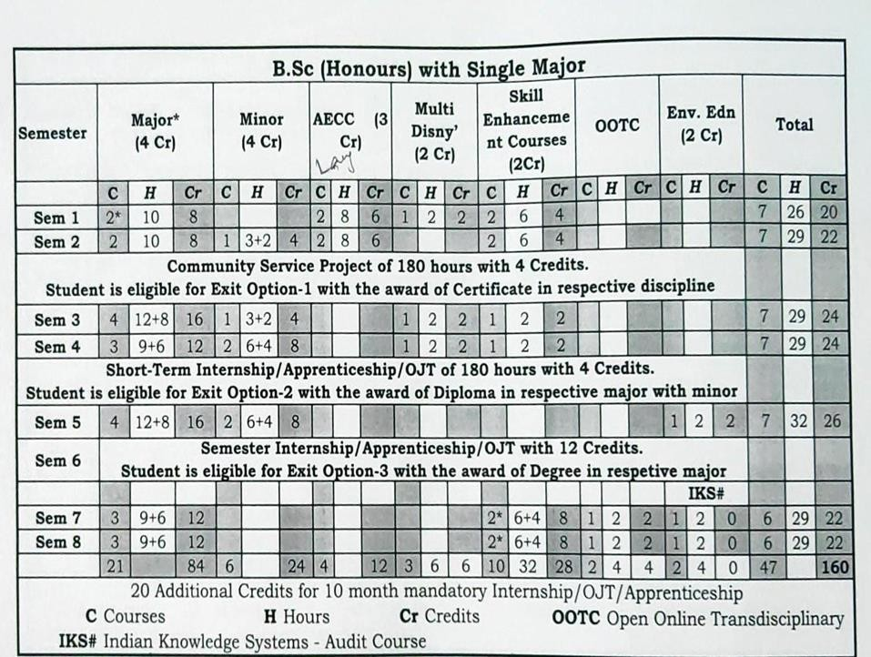


Andhra Pradesh State Council of Higher Education

B.Sc., Honours in AQUACULTURE: MAJOR
w.e.f AY 2023-24 onwards
COURSE STRUCTURE
SEMES TER | Co |  | de | Title of the paper |  |  |  |  |  | Hr /week |  | Credi ts
III | 5 |  |  | Basic Principles of Aquaculture- (T) |  |  |  |  |  | 3 |  | 3
III |  |  |  | Basic Principles of Aquaculture - (P) |  |  |  |  |  | 2 |  | 1
III | 6 |  |  | Capture Fisheries- (T) |  |  |  |  |  | 3 |  | 3
III |  |  |  | Capture Fisheries- (P) |  |  |  |  |  | 2 |  | 1
III | 7 |  |  | Fresh water Aquaculture- (T) |  |  |  |  |  | 3 |  | 3
III |  |  |  | Fresh water Aquaculture- (P) |  |  |  |  |  | 2 |  | 1
III | 8 |  |  | Brackish water Aquaculture- (T) |  |  |  |  |  | 3 |  | 3
III |  |  |  | Brackish water Aquaculture- (P) |  |  |  |  |  | 2 |  | 1
IV | 9  9 |  |  | Fish Health management- (T) |  |  |  |  |  | 3 |  | 3
IV |  |  |  | Fish Health management- (P) |  |  |  |  |  | 2 |  | 1
IV | 10  10 |  |  | Shrimp Health Management- (T) |  |  |  |  |  | 3 |  | 3
IV |  |  |  | Shrimp Health Management- (P) |  |  |  |  |  | 2 |  | 1
IV | 11  11 |  |  | Fish nutrition & Feed technology - (T) |  |  |  |  |  | 3 |  | 3
IV |  |  |  | Fish nutrition & Feed technology - (P) |  |  |  |  |  | 2 |  | 1
V |  | 12  12 |  |  | Extension, Economics & Marketing- (T) |  |  |  |  |  | 3 |  | 3
 |  |  |  |  | Extension, Economics & Marketing- (P) |  |  |  |  |  | 2 |  | 1
V |  | 13  13 |  |  | Ornamental Fishery- (T) |  |  |  |  |  | 3 |  | 3
 |  |  |  |  | Ornamental Fishery - (P | ) |  |  |  |  | 2 |  | 1
V |  | 14 |  |  | Fishery Engineering- (T) |  |  |  |  |  | 3 |  | 3
V |  | 14 |  |  | Fishery Engineering - (P) |  |  |  |  |  | 2 |  | 1
V |  | 15 |  |  | Fish Processing Technology- (T) |  |  |  |  |  | 3 |  | 3
V |  | 15 |  |  | Fish Processing Technology- (P) |  |  |  |  |  | 2 |  | 1
VI |  |  |  | Internship

PROGRAMME OUTCOMES
Aquaculture is a fascinating programme that provides a platform to the students to  learn about various types of culture, cultivable species, Aquatic ecosystems and
sustainable
Aquaculture practices
 This program enables them to understand Pathology and microbiology in fish and shrimp culture ponds .
Students can easily understand the concepts of Induced breeding, Bundh breeding, composite culture, Monoculture and Intensive culture practices to pursue either employability or entrepreneurship.
Aquaculture is an avenue of opportunities as well as challenges where one can explore the potential of huge water resources.

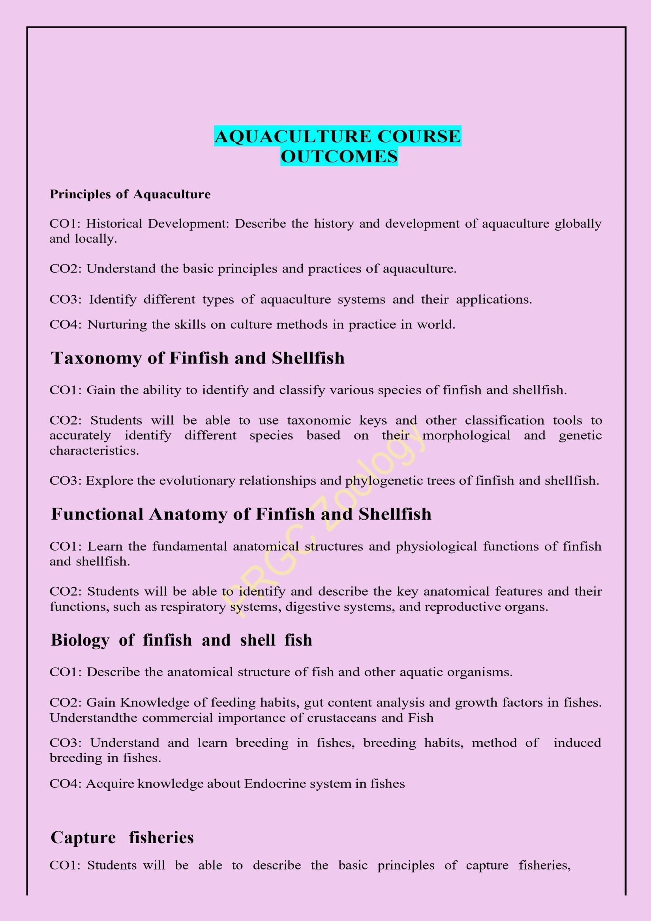

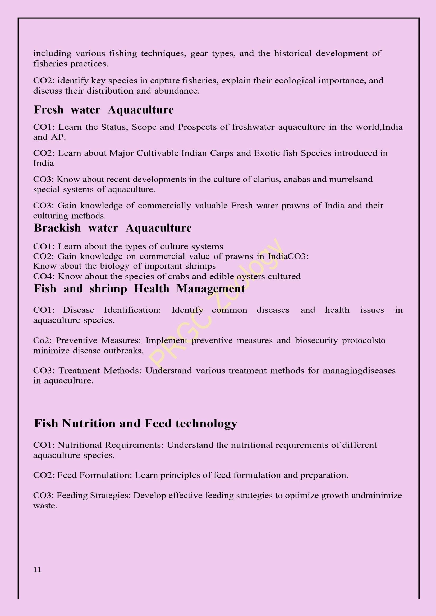

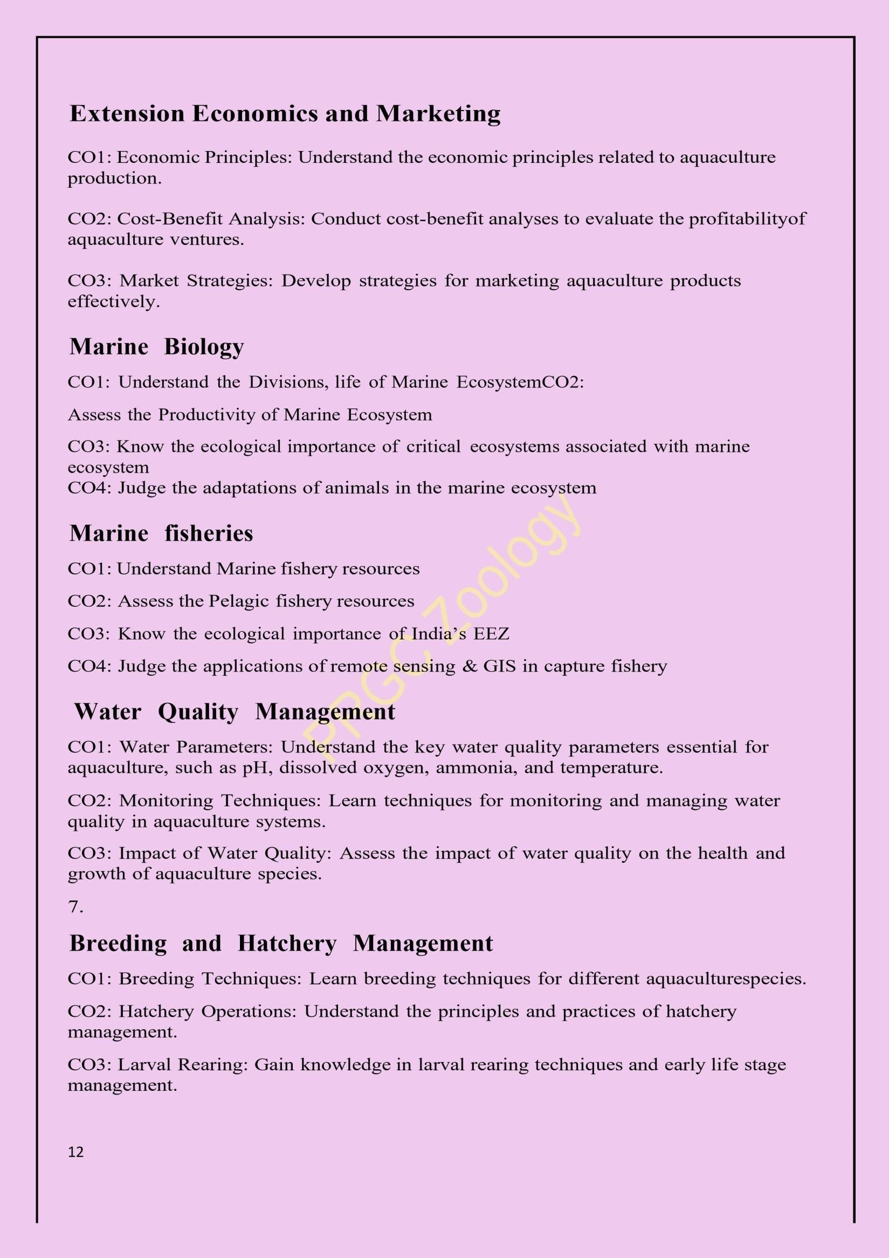

SEMESTER-III

 | Pithapur Rajah’s Govt. Degree College (A) Kakinada. | Program &  Semester  B.Sc. Honors in  Aquaculture (Major)  Semester-III
Course Code | TITLE OF THE COURSE  COURSE 5: BASIC PRINCIPLES OF AQUACULTURE
Teaching | Hours Allocated: 45 (THEORY)
Pre- requisites: | Basics of Aquaculture

Credits :3

COURSE OBJECTIVES

To understand the techniques involved in aquaculture practices
To get a detailed information about aquaculture
To provide a basic idea about the importance of live feed in culture system

On Completion of the course, the students will be able to-
CO1 | Gain knowledge on different types of aquacultures.
CO2 | Nurturing the skills on culture methods in practice in world
CO3 | Understand the various culture ponds
CO4 | Understand the establishment of fish farm
CO5 | Understand the various parameters of water and soil of a culture pond

SYLLABUS

UNIT I

1.1. Definition and History of Aquaculture

1.2. Concept of Blue Revolution and Pradhan Mantri Matsya Sampada Yojana (PMMSY)

1.3. Present status of Aquaculture at global level, India and Andhra Pradesh

1.4. Aquaculture versus Agriculture; Present day needs with special reference to Andhra Pradesh.

Activity: Assignment /Seminar /Quiz/Project/Peer teaching on the above Evaluation: Instructor supposed to prepare a detailed Rubrics for the evaluation of the above activity

UNIT-II (Types of Fish Ponds)

2.1. Lotic and lentic systems, streams and springs

2.2. Classification of ponds based on water resources – spring, rain water, flood water, well water and water course ponds
2.3. Functional classification of ponds – head pond, hatchery, nursery, rearing, production and stocking ponds; quarantine ponds, isolation ponds and wintering ponds
Activity: Assignment /Seminar /Quiz/Project/Peer teaching on the above Evaluation:
Instructor supposed to prepare a detailed Rubrics for the evaluation of the above activity

UNIT- III (Design and Construction of Aqua Farms)

3.1. Important factors in the construction of an ideal fishpond – site selection, topography, nature of the soil, water resources
3.2. Lay out and arrangement of ponds in a fish farm construction of an ideal fishpond – space allocation, structure and components of barrage Pond.
Activity: Assignment /Seminar /Quiz/Project/Peer teaching on the above Evaluation: Instructor supposed to prepare a detailed Rubrics for the evaluation of the above activity

UNIT-IV (Aquaculture Systems and Practices )

4.1. Types of aquaculture Fresh water aquaculture - Brackish water aquaculture - Mari culture

4.2. Aquaculture Systems – Pond, Raceways, Cage, Pen, Rafts, Running water, Water Recirculating Systems, Bio floc Technology and 3-C System
4.3. Pond culture practices- Traditional, Extensive, Modified Extensive, Semi-Intensive, Intensive & Super- intensive systems of fish and shrimp and their significance.
4.4. Fin fish culture methods - Monoculture, Poly culture and Monosex culture and Integrated fish farming.

Activity: Assignment /Seminar /Quiz/Project/Peer teaching on the above Evaluation: Instructor supposed to prepare a detailed Rubrics for the evaluation of the above activity

UNIT- V ( Management Factors of Culture Ponds, Pre-stocking Management

5.1. Dewatering, drying, ploughing/desilting.

5.2. Predators, weeds and weed fish in culture ponds - Advantages and disadvantages of weed plants; Toxins used for weeding control and control of predators. Liming and fertilization.
5.3. Algal blooms and their control

5.4. Stocking Management – Stocking density and stocking

5.5. Post-stocking Management Feeding: Role of nutrients

5.6. Water quality: Physico-chemical conditions of soil and water optimum for culture – temperature, depth, turbidity, light, water and shore currents, PH, DOD, CO2, NH3, NO2

Activity: Assignment /Seminar /Quiz/Project/Peer teaching on the above Evaluation: Instructor
supposed to prepare a detailed Rubrics for the evaluation of the above activity Text books:
Text books:

Text Book of Fishery science And Indian Fisheries : C.B. L. Shrivastava.

Reference books:
Handbook on diagnosis and control of bacterial diseases in finfish and shellfish culture.
@inproceedings{Pillai1984HandbookOD . Web Links: https://www.adfg.alaska.gov/index.cfm?Adfg=fishingpathologylab.pathology_management
https://www.gov.scot/collections/diseases-of-finfish-molluscs-and-crustaceans/ Https://www.routledge.com/Introduction-to-the-General-Principles-of- aquaculture

CO-PO MAPPING

CO-( 1: Slight [Low]; 2: Moderate[Medium]; 3: Substantial[High], '-' : No Correlation)

 | PO1 | PO2 | PO3 | PO4 | PO5 | PO6 | PO7 | PO8 | PO9 | PO10 | PSO1 | PSO2 | PSO3
CO1 | 1 | 2 | 2 | 1 | 2 | 1 | 3 | 2 | 3 | 2 | 1 | 2 | 2
CO2 | 2 | 1 | 3 | 2 | 1 | 1 | 2 | 3 | 1 | 1 | 2 | 2 | 2
CO3 | 1 | 1 | 2 | 3 | 3 | 1 | 1 | 1 | 2 | 3 | 1 | 2 | 1
CO4 | 2 | 2 | 3 | 2 | 2 | 2 | 1 | 2 | 1 | 2 | 2 | 1 | 2
CO5 | 1 | 2 | 1 | 1 | 1 | 2 | 2 | 1 | 1 | 1 | 1 | 1 | 2

QUESTION BANK
UNIT-I
ESSAY QUESTIONS

S.No. | QUESTION | BT  LEVE  L | CO | PO
1 | Describe the scope of aquaculture at global level | BT1 | CO1 | PO2
2 | Illustrate the various types of Aquaculture systems. | BT2 | CO1 | PO2
3 | Describe in detail the present day needs of Aquaculture with spl reference to A.P | BT1 | CO1 | PO2
4 | Explain the present status of Aquaculture in India | BT2 | CO1 | PO2
SHORT QUESTIONS
S.No. | QUESTION | BT  LEVEL | CO | PO
1 | PMMSY | BT1 | CO1 | PO2

2 | Concept of Blue revolution | BT2 | CO2 | PO2
3 | EEZ | BT2 | CO1 | PO1
4 | Continental shelf | BT1 | CO2 | PO2
5 | Capture ficheries | BT2 | CO2 | PO2

UNIT-II
ESSAY QUESTIONS

S.No. | QUESTION | BT  LEVEL | CO | PO
1 | Explain the functional classification of ponds | BT1 | CO1 | PO2
2 | Describe the importance of plankton and benthos in culture ponds | BT2 | CO1 | PO2
3 | Explain the lentic and lotic systems | BT1 | CO1 | PO2
SHORT QUESTIONS

S.No. | QUESTION | BT  LEVEL | CO | PO
1 | Springs | BT1 | CO1 | PO2
2 | Rain water | BT2 | CO1 | PO2
3 | Wintering ponds | BT1 | CO1 | PO2
4 | Quarantine ponds | BT1 | CO1 | PO2

UNIT-III
ESSAY QUESTIONS

S.No. | QUESTION | BT-  LEVEL | CO | PO
1 | Illustrate the importance of stocking and production ponds | BT1 | CO1 | PO2
2 | Describe the hatchery design and management | BT2 | CO1 | PO2
3 | Write an essay on the site selection criterion for Aquaculture | BT1 | CO1 | PO2
4 | Describe the lay out and arrangement of ponds in fish farm construction | BT1 | CO1 | PO2

SHORT QUESTIONS

S.No. | QUESTION | BT  LEVEL | CO | PO
1 | Topography | BT1 | CO1 | PO2
2 | Space allocation | BT2 | CO1 | PO2
3 | Barrage pond | BT1 | CO1 | PO2

UNIT-IV
ESSAY QUESTIONS

S.No  . | QUESTION | BT  LEVEL | CO | PO
1 | Give an account of the important factors in the construction of ideal pond. | BT1 | CO1 | PO2
2 | Describe in detail the layout and arrangements of ponds in a fish farm | BT2 | CO1 | PO2
3 | Describe the process of integrated fish farming | BT1 | CO1 | PO2
 | and its advantages
4 | Explain the Bio floc Technology and 3-C systems in Aquaculture
SHORT QUESTIONS

S.No. | QUESTION | BT  LEVEL | CO | PO
1 | Brackish water environment | BT1 | CO1 | PO2
2 | Water recirculation | BT2 | CO1 | PO2
3 | Pen culture | BT1 | CO1 | PO2
4 | Semi intensive system | BT1 | CO1 | PO2
5 | Mono sex culture | BT2 | CO1 | PO2
UNIT-V
ESSAY QUESTIONS

S.No. | QUESTION | BT  LEVEL | CO | PO
1 | Explain the need of fertilizers in culture pond | BT1 | CO1 | PO2
2 | Illustrate the methods in eradication of predators and weeds | BT2 | CO1 | PO2
3 | Describe in detail the various advantages and disadvantages of weed plants in culture systems | BT1 | CO2 | PO1
4 | Discuss the process of dewatering, drying and ploughing and their importance in culture | BT2 | CO1 | PO2
5 | Explain the impact of algal blooms in Aquaculture and their control | BT2 | CO2 | PO1

6 | Describe in detail the various Physio chemical conditions of soil required for culture | BT1 | CO2 | PO1

SHORT QUESTIONS
Unit |  | Essay |  | Short
 | I |  | 1 | 1
 | II |  | 1 | 1
 | III |  | 1 | 1
 | IV |  | 1 | 2

S.No. | QUESTION | BT  LEVE  L | CO | PO
1 | Ploughing | BT1 | CO1 | PO2
2 | Dewatering | BT2 | CO1 | PO2
3 | Liming | BT1 | CO1 | PO2
4 | Stocking density | BT1 | CO1 | PO2
5 | Turbidity | BT2 | CO1 | PO2
6 | Pre-stocking | BT1 | CO1 | PO2
7 | DOD | BT1 | CO1 | PO2

BLUE PRINT

Time: 2 1/2 hrs Max. Marks: 50

V | 2 | 2
Total | Out of 6, 3 questions should be answered 3X10=30M | Out of 7, 4questions should be answered 4X5=20M

Pithapur Rajah’s Government College (Autonomous), Kakinada
SEMESTER-III: COURSE 5:
BASIC PRINCIPLES OF AQUACULTURE
Model question Paper
Time: 2 Hrs. Max. Marks: 50

Answer any Three of the following choosing at least one question from part I and II Draw labeled diagrams wherever necessary 3x10=30M

SECTION – A
PART- I
1 | Describe in detail the present day needs of  Aquaculture with special reference to A. P | BT1 | CO1 | PO2
2 | Discuss the importance of plankton and benthos in culture ponds | BT1 | CO1 | PO2
3 | Explain key elements of construction of an ideal fish pond | BT1 | CO1 | PO2

PART- II
4 | Comment on any two aquaculture systems in detail | BT2 | CO1 | PO2
5 | Elucidate pre stocking management practices in culture ponds | BT1 | CO1 | PO2
6 | Discuss suitable physicochemical factors of water in culture ponds | BT2 | CO1 | PO2

SECTION - B

I. Answer any FOUR of the following:
Draw labeled diagrams wherever necessary 4x5=20 M

7 | Concept of blue revolution | BT1 | CO1 | PO2
8 | Quarantine ponds | BT1 | CO1 | PO2
9 | Site selection | BT1 | CO1 | PO2
10 | Water recirculation | BT1 | CO1 | PO2
11 | Integrated fish farming | BT1 | CO1 | PO2
12 | Algal blooms | BT1 | CO1 | PO2
13 | Liming | BT1 | CO1 | PO2

 | Pithapur Rajah’s Govt. Degree College (A) Kakinada. | Program &  Semester  B.Sc. Honors in  Aquaculture (Major)  Semester-III
Course Code | TITLE OF THE COURSE  COURSE 5: BASIC PRINCIPLES OF AQUACULTURE
Teaching | Hours Allocated: 30 (LAB)
Pre- requisites: | Basics of Aquaculture

List of Practicals :

- Estimation of Carbonates, Bicarbonates in water samples
- Estimation of Dissolved Oxygen
- Estimation of Ammonia in water.

- Estimation of Total Hardness of water sample.
- Study of beneficial and harmful algal species
- Collection, identification and isolation of zooplankton and phytoplankton

- Collection and study of aquatic weeds, aquatic insects, weed fish and larvivorous fish Field visit to hatchery, nursery, rearing and stocking ponds of aqua farms.

PRESCRIBED BOOKS:

Jhingran VG 1998. Fish and Fisheries of India. Hindusthan Publishing Corporation, New Delhi Pillay TVR, 1996.
Aquaculture Principles and Practices, Fishing News Books Ltd., London

REFERENCES:

Pillay TVR & M.A. Dill, 1979. Advances in Aquaculture. Fishing News Books Ltd., London Stickney RR 1979.
Principles of Warm Water Aquaculture. John Wiley & Sons Inc. 1981
Boyd CE 1982. Water Quality Management for Pond Fish Culture. Elsivier Scientific Publishing Bose AN et.al, 1991. Costal Aquaculture Engineering. Oxford & IBH Publishing Company.
Boyd CE. 1979. Water Quality in Warm Water FishPonds. Auburn University Boyd, CE. 1982. Water Quality Management for Pond Fish Culture. Elsevier Sci.
Publ. Co.
FAO. 2007. Manual on Freshwater Prawn Farming.
Supplementary Reading

Shepherd, J and Bromage, N. Intensive Fish Farming
Pillay, T.V.R. Advances in Aquaculture
Beveridge. Cage Culture

Advanced Reading

Stickney, R.R. Principles of Warmwater Aquaculture

Web resources

FAO http://www.fao.org/fishery/topic/4340/en NACA http://www.enaca.org/
VUAT http://www.vuatkerala.org/static/eng/advisory/fisheries/index.htm Aquaculture/Pond
Dynamics http://pdacrsp.oregonstate.edu/pubs/ Wikipedia http://en.wikipedia.org/wiki/Aquaculture Fish farming http://www.fishfarming.com/
ICAR http://www.icar.org.in/indiafishvoice/intro.html CIFA http://www.cifa.in/tech.htm Aquaculture articles: http://aquafind.com/articles/aquaculture.php Aquaculture Articles http://www.aquarticles.com/

Other Reference Books:

Friedrich, H.: Marine Biology
Raymont, J.E.C.: Plankton and productivity in the Oceans, Volume 1.
Balakrishna Nair. N. and D.M. Thampy: A textbook of Marine ecology
Broecker, W.S.: Chemical Oceanography
Sverdrup, H.V., M.W., Johnson and R.H. Fleming.: The Oceans -

Pithapur Rajah’s Govt. College (A) Kakinada.
PRACTICAL SYLLABUS
BASIC PRINCIPLES OF AQUACULTURE
MODEL question PAPER

Time: 2Hrs. Max. Marks: 50

- Estimation of dissolved oxygen in the given water sample. 1x10=10M

- Identify the following and draw the labelled diagrams and write notes on Zoo-phytoplankton.
5X5=25M
(A). (B) (C).
(D).
(E).

- Field Note Book 1x5=5M
- Viva voce 5M

- Practical Record. 1x5=5M

PR GOVERNMENT COLLEGE (A), KAKINADA

III SEMESTER

COURSE : 6 - CAPTURE FISHERIES

Course Outcomes
CO1: Understand the EEZ concept & its implementation in fisheries
CO2: Knowledge on Fish Distribution
CO3: Acquire Knowledge on the Riverine systems of India CO4:Gain Knowledge on Reservoir Fishery

Unit I : Fish Catch Statistics :-
1.1 Fish production of the world both inland and marine, contribution of different countries, position of India in the Fish Catches.
1.2 The EEZ concept & its implementation in fisheries. The Indian EEZ, Fishery survey in India Unit II : Fish Distribution .
2.1 General account of the distribution
2.2 Biology and fishery of important fishes and other aquatic animals of India,
2.3. Economically Important Fresh Water Fishes of Andhra Pradesh.
Unit-III Riverine Fishery
3.1 Important characters of Streams.
3.2 Different riverine systems in India, and their fishery: The Ganga River System, the
Brahmaputra river system,
Unit-IV Riverine Fishery
4.1 The East Coast River System.
4.2 The West Coast River System, River Jhelum of the Indus River System, Fisheries of trout and Mahseer, Problems and management.
Unit-V Reservoir Fishery (Lacustrine Fishery) :-
5.1 Definition of a Lake, Origin and classification of lakes.
5.2 Kolleru Lake and its fishery.
5.3 Different reservoirs of River systems in India with special reference to Nagarjuna Sagar

 | PO1 | PO2 | PO3 | PO4 | PO5 | PO6 | PO7 | PO8 | PO9 | PO10 | PSO1 | PSO2 | PSO3
CO1 | 1 | 2 | 2 | 1 | 2 | 2 | 3 | 2 | 3 | 2 | 2 |  | 2
CO2 | 2 | 1 | 2 | 2 | 1 | 1 | 2 | 3 | 1 | 2 | 2 | 2 | 2
CO3 | 1 | 1 | 2 | 3 | 2 | 1 | 1 | 2 | 2 | 2 | 1 | 2 | 1
CO4 | 2 | 2 | 3 | 2 | 2 | 2 | 2 | 2 | 2 | 2 | 2 | 2 | 2
CO5 | 2 | 2 | 1 | 1 | 1 | 2 | 2 | 1 | 1 | 1 | 1 | 1 | 2
Pithapur Rajah’s Govt. Degree College (A) Kakinada.
III SEMESTER

COURSE NO.: 6 - CAPTURE FISHERIES

BLUE PRINT
Time: 2 hrs Max. Marks: 50

Unit | Essay | Short | Marks allotted to the unit
I | 1 | 2 | 20
II | 1 | 1 | 15
III | 1 | 1 | 15
IV | 1 | 1 | 15
V | 2 | 2 | 30
Total | 6 | 7 | 95
 | Out of 6, 3 questions should be answered  3X10=30M | Out of 7, 4questions should be  answered  4X5=20M

Pithapur Rajah’s Govt. Degree College (A) Kakinada
MODEL QUESTION PAPER
III SEMESTER – AQUACULTURE
COURSE 6: CAPTURE FISHERIES

Time: 2 hrs Max. Marks:
50

I. Answer any THREE of the following. Choosing at least one from each part.
Draw labeled diagrams wherever necessary 3x10=30

SECTION - A
PART- I
- Write an essay on EEZ concept and its implementation in fisheries?

- Write the notes on Biology and fishery of important fishes in I

- Write an essay on Major River systems in India?

PART- II
- Write an essay on East Coast River systems in India?
- Write an essay on Kolleru lake and its fishery resources 6. Define Reservoir? Explain Major reservoirs in India?

SECTION – B

II. Answer any FOUR of the following: Draw labelled diagrams wherever necessary 4x5=20

- EEZ
- Coastal Fishery
- Pelagic resources
- Characters of streams
- Trout fisheries
- Reservoir fisheries
13.Lacustrine fisheries

III SEMESTER
Course No.: 6 - Capture Fisheries

PRACTICAL SYLLABUS
- Identification of Freshwater fishes based on colour, Pigmentation, morphometric and meristic characters and other characters relavent to the group.
- Identification of fry and fingerlings of Indian Major Carps.
- Examination of Commercially Important Freshwater fishes and prawns, from the point of view of ecology and fishery.
- Knowledge of common types of Freshwater craft and gear on models provided in the department. Field Work : Visit to fish landing centers of rivers, lakes and reservoirs

Reference Books :-
- Jhingram, V.G. Fish and Fisheries of India. Second edition 1983, Hindustan Pub.Co. Picker,
- W.E. Methods for assessment of Fish Production in Fresh Waters. Blackwell Scient. Publ. 1970
- Bal, D.V. and Veerabhadra Rao, K. Marine Fisheries, Tata MC Grawhill Publications, New Delhi.
- Srivastava, U.K. et.al. Freshwater aquaculture in India, Oxford and IBH Publ. Co. New Delhi 1980
- C.B.L. Srivastava – A text book of Fishery Science and Indian Fisheries. Kitab Mahal Agencies, Patna.
III SEMESTER
Course No.: 6 - Capture Fisheries
PRACTICALS
SEMESTER – III
MODEL QUESTION PAPER
Time: 3Hrs Max Marks: 50M

- Fish Morphometric and meristic characters- 10M
- Identify the following commercially important fishes & prawns
4X5=20 M
A)

B)
C)

D)
- Identification of fishing Craft & Gear

2X5=10M
A)
B)
- RECORD- 5M
- VIVA- 5M
Total: 50M
****
Pithapur Rajah’s Govt. Degree College (A) Kakinada.
DEPARTMENT OF ZOOLOGY III SEMESTER CODE : 7
FRESH WATER AQUACULTURE
B. B.Sc. HONOURS AQUACULTURE MAJOR

 | P .R.GOVERNMENT COLLEGE (A) KAKINADA | Program & Semester  SEMESTER - III code 7
CourseCode VII | TITLE OF THE COURSE  FRESH WATER AQUACULTURE
Teaching | Hours Allocated: 60 (Theory) | L | T | P | C
Pre-requisites: |  | 4 | 1 | 2 | 5

Course outcomes:
- Learn the Status, Scope and Prospects of fresh water aquaculture in the world, India and AP.
- Learn about Major Cultivable Indian Carps and Exotic fish Species introduced in India
- Know about recent developments in the culture of clarius, anabas and murrels and special systems of aquaculture.
- Gain knowledge of commercially valuable Fresh water prawns of India and their culturing methods.

CO - PO MAPPING

 | PO1 | PO2 | PO3 | PO4 | PO5 | PO6 | PO7 | PO8 | PO9 | PO10 | PSO1 | PSO2 | PSO3
CO1 | 1 | 2 | 2 | 1 | 2 | 2 | 3 | 2 | 3 | 2 | 2 | 2 | 2
CO2 | 2 | 1 | 2 | 2 | 1 | 1 | 2 | 3 | 1 | 2 | 2 | 2 | 2
CO3 | 1 | 1 | 2 | 3 | 2 | 1 | 1 | 2 | 2 | 2 | 1 | 2 | 1
CO4 | 2 | 2 | 3 | 2 | 2 | 2 | 2 | 2 | 2 | 2 | 2 | 2 | 2
CO5 | 2 | 2 | 1 | 1 | 1 | 2 | 2 | 1 | 1 | 1 | 1 | 1 | 2

UNIT-1: Introduction to Freshwater Aquaculture
1.1 Status, scope and prospects of fresh water aquaculture in the world, India and AP
1.2 Different fresh water aquaculture systems

UNIT-II: Carp Culture
2-1 Major cultivable Indian carps – Labeo, Catla and Cirrhinus & Minor carps
2-2 Exotic fish species introduced to India – Tilapia, Pangassius and Clarius sp. Unit-III: FISH CULTURE
3.1 Composite fish culture system of Indian and exotic carps
3.2 Impact of exotic fish, Compatibility of Indian and exotic carps and competition among them

UNIT-IV: Culture of air-breathing and cold water fish
4-1 Recent developments in the culture of clarius, anabas, murrels,
4-2 Advantages and constraints in the culture of air-breathing and cold water fishes- seed resources, feeding, management and production
4-3 Special systems of Aquaculture- brief study of culture in running water, re-circulatory systems, cages and pens, sewage-fed fish culture

UNIT-V: Culture of Prawn
5-1 Fresh water prawns of India - commercial value
5-2 Macrobrachium rosenbergii and M. Malcomsonii– biology, seed production, pond preparation,
5.3stocking management of nursery and grow-out ponds, feeding, mprpho types and harvesting
PITHAPUR RAJAH’S GOVT. DEGREE COLLEGE (A) KAKINADA.
DEPARTMENT OF ZOOLOGY
B.Sc HONOURS AQUACULTURE

III SEMESTER COURSE 7
FRESH WATER AQUACULTURE
BLUE PRINT

Unit | Essay | Short
I | 1 | 1
II | 1 | 1
III | 1 | 2
IV | 1 | 1
V | 2 | 2
TOTAL | Out of 6, 3 questions should be answered 3X10=30M | Out of 7, 4questions should be answered  4X5=20M

Pithapur Rajah’s Govt. Degree College (A) Kakinada.

III SEMESTER
Course VII
Fresh Water Aquaculture
MODEL PAPER
Time: 2 hrs. Max Marks: 50

Answer any THREE of the following. Choosing at least one from each part.
Draw labeled diagrams wherever necessary 3x10=30

SECTION -A
PART- I

- Describe the Status, Scope and Prospects of fresh water aquaculture in the India and AP
- Describe the Major cultivable Indian carps
3.Illustrate the Composite fish culture in India

PART- II

- Explain Feeding, management and production in fresh water
Aquaculture
- Describe the Fresh water prawns in India
- Discuss Biology of Malcomsonii

SECTION – B

Answer any FOUR of the following
Draw labeled diagrams wherever necessary 4x5=20

- Indian fish farming
- Exotic fish species in India
- Surface feeders
- Exotic carps
- Seed resources
- commercial value
- Pond preparation
QUESTION BANK

UNIT-I
ESSAY QUESTIONS

S.No. | QUESTION | BT  LEVE  L | CO | PO
1 | Explain present Status, Scope and Prospects of fresh water aquaculture in the world | BT1 | CO1 | PO2
2 | Describe the Status, Scope and Prospects of fresh water aquaculture in the India and AP. | BT2 | CO1 | PO2
3 | Write a note on Different fresh water aquaculture systems | BT1 | CO1 | PO2

SHORT QUESTIONS

S.No. | QUESTION | BT  LEVEL | CO | PO
1 | Fresh water aqua culture | BT1 | CO1 | PO2
2 | Scope of fresh water aquaculture | BT2 | CO1 | PO2
3 | Fresh water Aquatic animals | BT1 | CO1 | PO2
4 | Indian fish farming | BT1 | CO1 | PO2
UNIT-II ESSAY QUESTIONS

S.No. | QUESTION | BT  LEVEL | CO | PO
1 | Describe the Major cultivable Indian carps | BT1 | CO1 | PO2
2 | Explain Minor carps In india | BT2 | CO1 | PO2
3 | Describe the Exotic fish species in India | BT1 | CO1 | PO2

SHORT QUESTIONS

S.No. | QUESTION | BT  LEVEL | CO | PO
1 | Brood stock msintanance | BT1 | CO1 | PO2
2 | Carp seed rearing | BT2 | CO1 | PO2
3 | Fingerlings | BT1 | CO1 | PO2
4 | Culture practice | BT1 | CO1 | PO2
5 | Water quality in fresh water | BT2 | CO1 | PO2
6 | Labeo rohits | BT1 | CO1 | PO2
7 | Characteristics of Pangasius

UNIT-III
ESSAY QUESTIONS

S.No. | QUESTION | BT-  LEVEL | CO | PO
1 | Illustrate the Composite fish culture in india | BT1 | CO1 | PO2
2 | Write a note on different types of system of Indian and exotic carps | BT2 | CO1 | PO2
3 | Explsain Compatibility of Indian and exotic carps | BT1 | CO1 | PO2
4 | Illustrate the competition and Compatibility of Indian and exotic carps | BT1 | CO1 | PO2

SHORTQUESTION

 | S.No. |  | QUESTION |  | BT  LEVEL |  | CO |  | PO
 | 1 |  | Advantages of composite fish culture |  | BT1 |  | CO1 |  | PO2
 | 2 |  | What are composite fishes in India |  | BT2 |  | CO1 |  | PO2
3 |  | Surface feeders |  | BT1 |  | CO1 |  | PO2
4 |  | Bottom feeders |  | BT2 |  | CO1 |  | PO2
5 |  | Atributes of fish culture |  | BT2 |  | CO1 |  | PO2
6 |  | Exotic carps
UNIT-IV
ESSAY QUESTIONS

S.No  . | QUESTION | BT  LEVEL | CO | PO
1 | Recent developments in the culture of clarius, anabas | BT1 | CO1 | PO2
2 | Explain Advantages and constraints in the culture of air- breathing | BT2 | CO1 | PO2
3 | Explain Advantages and constraints in the culture of cold water fishes | BT1 | CO1 | PO2
4 | Describe Feeding, management and production in fresh water culture
5 | Write a note on study of culture in running water, re- circulatory systems, cages and pens
6 | Explsin the sewage-fed fish culture

SHORT QUESTIONS

S.No. | QUESTION | BT  LEVEL | CO | PO
1 | Advantages of air breathing fishes | BT1 | CO1 | PO2
2 | Functions of air breathing fishes | BT2 | CO1 | PO2
3 | Diffent types of air breathing fishes | BT1 | CO1 | PO2
4 | Seed resources | BT1 | CO1 | PO2
5 | Cage culture | BT2 | CO1 | PO2
6 | Aqua culture systems | BT1 | CO1 | PO2
UNIT-V ESSAY QUESTIONS

S.No. | QUESTION | BT  LEVEL | CO | PO
1 | Describe the Fresh water prawns in India | BT1 | CO1 | PO2
2 | Study of Macrobrachium rosenbergii | BT2 | CO1 | PO2
3 | Discuss on Biology of Malcomsonii
4 | Management of nursery and grow-out ponds

SHORT QUESTIONS

S.No. | QUESTION | BT  LEVE  L | CO | PO
1 | Seed production | BT1 | CO1 | PO2
2 | Pond preparation | BT2 | CO1 | PO2
3 | Harvesting | BT1 | CO1 | PO2
4 | commercial value | BT1 | CO1 | PO2
5 | stocking, management | BT2 | CO1 | PO2
6 | Prawn Nursery | BT1 | CO1 | PO2
7 | Green gland | BT1 | CO1 | PO2
Pithapur Rajah’s Govt College (A) kakinada

III SEMESTER

Course No.: 7 - Fresh water Aquaculture. credits :1

- Identification of important cultivable carps.
- Identification of important cultivable air-breathing fishes .
- Identification of important cultivable freshwater prawns.
- Identification of different life history stages of fish.
- Identification of different life history stages of fresh water prawn.
- Identification of commercially viable crabs – Scylla cerrata, Portunus pelagicus, P.sanguinolentus,
Neptunus pelagicus, N. Sanguinolentus .
- Identification of lobsters – Panulirus polyphagus, P.ornatus, P.homarus, P.sewelli, P.penicillatus.
- Identification of oysters of nutritional significance – Crossostrea madrasensis, C.gryphoides,
C. cucullata, C.rivularis , Picnodanta .
- Identification of mussels and clams.
- Identification of developmental stages of oysters.

PRESCRIBED BOOK(S):
1 Jhingran VG 1998. Fish and Fisheries of India. Hindusthan Publishing Corporation, New Delhi

REFERENCES:
- Santharam R, N Sukumaran and P Natarajan 1987. A manual of aquaculture, Oxford-IBH, New Delhi
- Srivatsava 1993. Fresh water aquaculture in India, Oxford-IBH, New Delhi Marcel H 1972.
Text book of fish culture.Oxford fishing news books.
Pithapur Rajah’s Govt. Degree College (A) Kakinada.
DEPARTMENT OF ZOOLOGY
III SEMESTER
B.Sc HONOURS IN AQUACULTURE : MAJOR PRACTICAL MODEL PAPER

MaxMarks50 |  | Time2hrs
Identify the following specimens and write a short notes on their |  | 6x5=30M
commercial importance  - Silver carp  - Fresh water prawn  - Paeneus monodon  4.Crab  5.Oyester  6.Mussel/clam |  | 6x5=30M
Record |  | 5marks
Viva voice  Field visit and field note book | 5+5=10 | 5 marks  10 M
Total |  | 50marks

P.R GOVT COLLEGE (A), KAKINADA
DEPARTMENT OF ZOOLOGY &AQUACULTURE
III SEMESTER

Course No.: 8 - Brackish water Aquaculture

 | P .R.GOVERNMENT COLLEGE (A) KAKINADA | Program & Semester III
Course Code : 08 | Brackish water Aquaculture
Teaching | Hours Allocated: 60 (Theory) | L | T | T
Pre-requisites : | Credits 3 | 4 | 2 | 2

OBJECTIVES | LEARNING OUT COME
To understand the development and present status of brackish water farming in India. To understand the types of culture  systems,commercial value of prawns in India, biology of important shrimps | Knowledge on development and present status of brackish water farming in India  Knowledge on the culture system  Know about the biology of important shrimps Know about the species of crabs and edible oysters cultured
Course Outcomes:
CO1:Knowledge on development and present status of brackish water farming in India. CO2::Learn about the types of culture systems
CO3:Gain knowledge on commercial value of prawns in India
CO4:Know about the biology of important shrimps
CO5:Know about the species of crabs and edible oysters cultured

Unit – I Introduction
1.1 Introduction, History, Development and present status of brackish water farming in India.
1.2 Brackish water as a medium for aquaculture, ecological factors – Abiotic and biotic factors. 1.3 Types of culture systems – Traditional, extensive, semi-intensive and intensive culture systems of shrimp, their management and economics.

Unit – II Culture of brackish water prawns
2.1 Culture practices of Penaeus monodon/ P.vannamei 2.2 Brackish water prawns of India – Commercial value.
2. Morphotypes and harvesting

Unit – III Biology of Shrimp
3.1 Biology of Penaeus monodon,
3.2 Biology of P.indicus
3.3 Biology of L.vannamei.

Unit – IV Management practices
4.1. Pond preparation, stocking, of Hatchery, Nursery, grow out ponds. and harvesting of shrimp.
4.2. Nutritional requirements of cultivable prawns.
4.3. Natural food and artificial feeds and their importance in shrimp culture Unit – V Culture of Brackish water species
5.1 Species of crabs cultured, biology and culture technique, prospects in India.
5.2 Species of edible oysters, culture techniques used for farming edible oysters.
5.3 Important species of pearl oysters and method of artificial pearl production.
CO-POMapping

 | PO1 O | PO2 O | PO3 O | PO4  O | PO5 O | PO6 O | PO7 O | PO8 O | PO9 O | PO10 | PSO1 | PSO2 | PSO3
CO1 | 1 | 2 | 2 | 1 | 2 | 2 | 3 | 2 | 3 | 2 | 2 | 2 | 2
CO2 | 2 | 1 | 2 | 2 | 1 | 1 | 2 | 3 | 1 | 2 | 2 | 2 | 2
CO3 | 1 | 1 | 2 | 3 | 2 | 1 | 1 | 2 | 2 | 2 | 1 | 2 | 1
CO4 | 2 | 2 | 3 | 2 | 2 | 2 | 2 | 2 | 2 | 2 | 2 | 2 | 2
CO5 | 2 | 2 | 1 | 1 | 1 | 2 | 2 | 1 | 1 | 1 | 1 | 1 | 2

P.R. Govt. College (Autonomous), Kakinada
DEPARTMENT OF ZOOLOGY AND AQUACULTURE
Major zoology Semester-III

Course No.: 8 TITLE: Brackish water Aquaculture
BLUE PRINT FOR QUESTION PAPER SETTER

MODUL  ENO. | ESSAY  QUESTIONS 10  MARKS | SHORT  ANSWERQUEST  IONS 5 MARKS | MARKS ALLOTE  DTO THE  UNIT
Module-  I | 01 | 02 | 20
Module-  II | 01 | 01 | 15
Module-  III | 01 | 01 | 15
Module- IV | 02 | 01 | 25
Module- V | 01 | 02 | 25
TOTAL | 06 Of which 3to be answered | 07Of which 5to be answered | 95 marks  including choice Of which 50marks to be answered
P.R. Govt. College (Autonomous), Kakinada
Aquaculture major Semester-III

Course 8: Brackish water Aquaculture
MODEL QUESTION PAPER
Time: 2 hrs Max. Marks :50
Section A
Note: Answer any THREE questions choosing at least one question from each part
.Draw diagrams wherever necessary 3 X10 = 30M
PART – 1
- Write an essay on types of culture systems BT 1 CO 2 PO 1
- Write about Commercial value of Brackish water prawn in India BT 1 CO 2 PO 1
- What are the biological features of Penaeus monodon ? BT 1 CO 2 PO 1 PART-II
- Discuss the management of Nursery Pond and grow out ponds BT 2 CO 2 PO 1
- Describe the importance of Natural and artificial feeds in shrimp culture BT 2 CO 2 PO 1
- Explain the culture techniques used for edible oysters farming BT 2 CO 2 PO 1
Section- B
Answer any Four questions  - Explain Development of brackish water farming BT 2 CO 2 PO 1  - What are Abiotic and biotic factors BT 1 CO 2 PO 1  - Morphotypes BT 1 CO 2 PO 1  - Describe Biology of L.vannamei. BT 2 CO 2 PO 1  - Explain Pre- stocking management BT 2 CO 2 PO 1  - write about crab culture BT 1 CO 2 PO 1  - Explain Importance of pearl oyester BT 2 CO 2 PO 1 | 4x5=20M

Question Bank

Course No.: 8 Brackish water Aquaculture

MODULE-I Essays
S. NO | Question | BT level | C O | P O
1 | Explain History Development and present status of brackish water farming in india | BT 1 | C O 2 | P O 1
2 | Write an essay on types of culture systems | BT 1 | C O 2 | P O 1
3 | Write about Commercial value of Brackish water prawn in india | BT 1 | C O 2 | P O 1

Shorts
 | Question | BT  level | CO | PO
1 | Biotic Abiotic factors | BT1 | CO1 | PO1
2 | Traditional culture | BT1 | CO1 | PO1
3 | Intensive culture | BT1 | CO1 | PO1
4 | Semi intensive culture | BT1 | CO1 | PO1

Module II
Essays
S. No | Question | BT level | CO | PO
1 | Write about Commercial value of Brackish water prawn in india | BT1 | CO2 | PO1
2 | Write about Culture practices of Penaeus monodon/ P.vanname | BT1 | CO1 | PO1
3 |  | BT1 | CO1 | PO1
Shorts
S. No | Question | BT level | CO | PO
5 | Morphotypes | BT1 | CO2 | PO1
6 | Comarcial value of brakish water prawn | BT1 | CO2 | PO1

Module III
S. No | Question | BT level | CO | PO
1 | What are the biological features of Penaeus monodon  ? | BT1 | CO2 | PO1
2 | What are the biological features of P.indicus ? | BT1 | CO1 | PO1
3 | What are the biological features of L.vannamei ? | BT1 | CO1 | PO1

Shorts

S. No | Question | BT level | CO | PO
1 | P. monodon ? | BT1 | CO2 | PO1
2 | P.indicus ? | BT1 | CO1 | PO1
3 | L.vannamei ? | BT1 | CO1 | PO1

Module IV
S. No | Questions | BT  Levels | CO | PO
1 | Nursery pond | BT1 | CO1 | PO1
2 | Stocking pond | BT2 | CO1 | PO1
3 | Artificial feed | BT1 | CO1 | PO1
4 | Natural feed
5 | Wet feed and Dry feed

Shorts
S. No | Question | BT level | CO | PO
1 | Discuss the management of Nursery Pond and grow out ponds | BT2 | CO2 | PO1
2 | Discuss the management of Hatchery pond and Stocking pond | BT2 | CO1 | PO1
3 | Nutritional requirements of cultivable prawns. | BT 2 | CO1 | PO1
4 | Natural food and artificial feeds and their importance in shrimp culture | BT1 | CO1 | PO1
5 | Discuss about Pre Stocking snd Post Stocking management | BT2 | CO1 | PO1
Module - V Essays

S. No | Question | BT  level | CO | PO
1. | Explain the culture techniques used for crab farming in india | BT2 | CO2 | PO1
2. | Explain the culture techniques used for edible oysters farming india | BT2 | CO1 | PO1
3. | Explain the culture techniques used for pearl oysters farming | BT1 | CO1 | PO1

SAQ

S. No |  | Question | BT  level | CO | PO
1 |  | Crab culture
2 |  | Edible oyster forming | BT2 | CO2 | PO1
3 |  | Artificial pearl production | BT2 | CO1 | PO1
 | 4 | Techniques used in edible oyster forming

III SEMESTER
Course No.: 8 - Brackish water Aquaculture

Practicals
Time 2 hrs Max, Marks 50

1.Identification of cultivable fresh water and marine water prawns (any 3 each) 2.Identification of marine crabs and oysters of commercial importance (any 2 each).
- Identification of Phytoplankton and Zooplankton (any 5 each).

- Identification of different live feed organisms for shrimp larvae (any 4)

- Identification of larval stages of prawn.

- Demonstration of eye stalk ablation in penaeus monodon.

Practical model paper
Course No.: 8 - Brackish water Aquaculture credits :1

PRACTICALMODELPAPER

- Demonstration of eye stalk ablation in Penaeus  - Identification of live feed |  | 12M  8M
1.Identification of spotters /Slides |  | 5X4=20M
A. Fresh water Prawn B. Marine crab
C .Phytoplankton
D.Larval stages of prawn
2. Record |  | 05M
Viva |  | 05M
Total |  | 50M

P.R GOVT COLLEGE (A),KAKINADA
DEPARTMENT OF ZOOLOGY &AQUACULTURE

MAJOR AQUACULTURE SEMESTER IV

COURSE 9: FISH HEALTH MANAGENENT

OBJECTIVES | LEARNING OUT COME
To understand the various types of diseases among the cultivable fishes, to learn and apply methods of control and precaution of diseases.  To understand the tools for diagnosis, and disease management strategiesavailable today. | Knowledge on the diseases will be learnt.  Precautionary measures will be known to prevent the spread of the disease.  Knowledge on the diagnostic tools will be learnt.  Environmental quality disease free practice will be learnt.
Course outcomes:
- Provide students with knowledge about fish diseases and pathological aspects of diseases.
- Learn about Fungal, Viral and Bacterial diseases of finfish.
- Gain knowledge of Nutritional deficiency related diseases and antibiotic and chemotherapeutics. 4.Understand and learn the importance of diagnostic tools in identification of diseases and application and development of vaccines.

SYLLABUS

UNIT I: Pathology and parasitology

1-1 Introduction to fish diseases –Definition and categories of diseases – Disease and environment
1-2 Disturbance in cell structure – changes in cell metabolism, progressive and retrogressive tissue changes, types of degeneration, infiltration, necrosis, cell death and causes
1-3 Atrophy, hypertrophy, neoplasms, inflammation, healing and repair
UNIT II: Fungal and viral Diseases of fin fish.
2-1 Fungal diseases (both of shell and finfish) – Saprolegniosis, brachiomycosis,ichthyophorus diseases – Lagenidium diseases – Fusarium disease, prevention and therapy
2-2 Viral diseases – Emerging viral diseases in fish, haemorrhagic scepticemia, spring viremia of carps, infectious hematopoietic necrosis in trout, infectious pancreatic necrosis in salmonids, swim-bladder inflammation in cyprinids, channel cat fish viral disease,prevention and therapy

UNIT III: bacterial Diseases of fin fish.
3.1 Baterial diseases – Emerging bacterial diseases, aeromonas, pseudomonas and vibrio infections, columnaris, furunculosis, epizootic ulcerative syndrome, infectious abdominal dropsy, bacterial gill disease, enteric red mouth, bacterial kidney disease, proliferative kidney disease, prevention and therapy

UNIT IV: Protozoan Diseases of fin fish.
4.1 Protozoan diseases: Ichthyophthiriasis( White spot Disease),Costiasis,Whirling disease

UNIT V: Nutritional diseases
5.1 Nutritional pathology – lipid liver degeneration, Vitamin and mineral deficiency diseases. Aflatoxin and dinoflagellates.
5.2 Antibiotic and chemotherapeutics. Nutritional cataract. Genetically and environmentally induced diseases.
CO-POMapping:

(1:Slight[Low];2:Moderate[Medium];3:Substantial[High], -':No Correlation)

 | PO1 | PO2 | PO3 | PO4 | PO5 | PO6 | PO7 | PO8 | PO9 | PO10 | PSO1 | PSO2 | PSO3
CO1 | 1 | 2 | 2 | 1 | 2 | 2 | 3 | 2 | 3 | 2 | 2 | 2 | 2
CO2 | 2 | 1 | 2 | 2 | 1 | 1 | 2 | 3 | 1 | 2 | 2 | 2 | 2
CO3 | 1 | 1 | 2 | 3 | 2 | 1 | 1 | 2 | 2 | 2 | 1 | 2 | 1
CO4 | 2 | 2 | 3 | 2 | 2 | 2 | 2 | 2 | 2 | 2 | 2 | 2 | 2
CO5 | 2 | 2 | 1 | 1 | 1 | 2 | 2 | 1 | 1 | 1 | 1 | 1 | 2

Name of the Department | Semester,  Program, Paper Number& Title  of the Paper, | Titles ofTopics deleted | Topic added in 2025 bos | Percentageof changesmade in syllabus | Justification per deleted/ added | each | topic
Zoology  &Aquaculture | Sem IV , Major  Aquaculture Paper-9 fish health  management | Nil | General preventive methods and prophylaxis. Methods of pathological examinationof fish and infectious  diseases, BMP in  Aquacultue | 20% | Useful for Competitiveexams  Useful for competitiveexams

P.R. Govt. College (Autonomous), Kakinada Major Aquaculture Semester-IV
TITLE: fish health management – PAPER 9
BLUE PRINT FOR QUESTION PAPER SETTER

MODULE  NO. | ESSAY  QUESTIONS10  MARKS | SHORT  ANSWER  QUESTIONS  5 MARKS | MARKS  ALLOTEDTO  THE UNIT
Module -I | 01 | 03 | 20
Module -II | 02 | 01 | 25
Module -  III | 01 | 02 | 20
Module - IV | 02 | 01 | 15
TOTAL | 06 Of which 3to be answered | 07Of which 5 to be answered | 95 marks includingchoice  Of which 50 marks to be answered

P.R. Govt. College (Autonomous), Kakinada
Aquaculture major
Semester-IV paper 9
Fish Health Management
MODEL QUESTION PAPER

Time: 2 hrs Max. Marks :50

SECTION- A

Note: Answer any THREE questions choosing at least one question from each section.
Draw the diagrams wherever necessary 3 X10 = 30M

PART I
- Explain about the progressive and retrogressive tissue changes BT3
- Write an essay on different fungal diseases in fin fish BT2
- Explain different viral diseases and its prevention methods in fin fish BT1

PART II
4, Explain columnaris, diseases and its prevention
- Write an essay on Protozoan diseases
- Illustrate Antibiotic and chemotherapeutic practices

SECTION- B

Answer any Four questions 4x5=20M
7, Differentiate infiltration and necrosis BT2
8. Types of degeneration BT1
9.Neoplasms BT1
10 Define IHN BT1
- Epizootic ulcerative syndrome and their symptoms BT2
- Dinoflagellates BT2
- Nutritional cataract BT2
QUESTION BANK

FISH HEALTH MANAGEMENT
MAJOR AQUACULTURE MODULE -I

Essay Questions

S.NO | QUESTION | BT LEVEL | CO | PO
1 | Describe the different categories of diseases | BT 1 | co 1 | Pso 1
2 | Explain about the progressive and retrogressive tissue changes | BT 3 | co 2 | Pso1
3 | Write an essay on Atrophy, hypertrophy | BT 1 | co 1 | Pso 1
Short Answer Question

S.NO | QUESTION | BT LEVEL | CO | PO
1 | Types of degeneration | BT 1 | CO 2 | PSO 3
2 | Difference between infiltration, necrosis | BT 1 | CO 1 | PSO 2
3 | Neoplasms | BT 2 | CO 3 | PSO 3
4 | Environmental diseases in fishes | BT 2 | CO 3 | PSO 3
5 | healing Mechanism of cell | BT 1 | CO 1 | PSO 2

MODULE II Essay Questions

S.NO | QUESTION | BT  LEVEL | CO | PO
1 | Explain about Fusarium disease, prevention andtherapy | BT 1 | CO 3 | PSO
2 | Write an essay on different fungal diseases in finfish | BT 2 | CO3 | PSO 5
3 | Explain the different viral diseases and itsprevention methods in fin fish | BT 1 | CO3 | PSO 5

Short Answer Questions

S.NO | QUESTION | BT LEVEL | CO | PO
1 | infectious pancreatic necrosis in salmonids, | BT 1 | CO3 | PSO 5
3 | Define IHN | BT 2 | CO3 | PSO 5

Essay Questions MODULE III

S.NO |  | QUESTION
1 |  | Describe the aeromonas, pseudomonas and vibrio infections, columnaris, diseases and their prevent methods
2 |  | Summarize the infectious abdominal dropsy, bacterial gill disease, enteric red mouth, bacterialkidn disease their symptoms
3

Short Answer Questions

S. NO | QUESTION | BT LEVEL | C O | P O
1 | Furunculosis disease symptoms and prevention | BT 2 | C O3 | P S O 2
2 | epizootic ulcerative syndrome and their symptoms | BT 1 | C O4 | P S O 5

Essay Question MODULE -V

S.NO | QUESTION | BT  LEVEL | CO | PO
1 | Write an essay on Protozoan diseases: Ichthyophthiriasis  Costiasis,Whirling disease and their symptoms in fin fish | BT 3 | CO3 | PSO2

3 | Illustrate the Antibiotic and chemotherapeutics | BT 1 | CO1 | PSO2
 | Explain about environmentally induced diseases in fishes.
4 | Describe the Vitamin and mineral deficiency diseases in fin fish | BT 1 | CO1 | PSO2

Short Answer Questions

S.NO | QUESTION | BT LEVEL | CO | PO
1 | Aflatoxin | BT 2 | CO1 | PSO3
2 | Dinoflagellates | BT 1 | CO2 | PSO2
3 | Nutritional cataract | BT 1 | CO2 | PSO2
4 | Lipid liver regeneration | BT 1 | CO3 | PSO1

IV SEMESTER

Course No.: 9 - Fish Health Management Practical syllabus
credits :1
- Enumeration of Bacteria by TPC Method
- Enumeration of total Coli forms
- Observation of gross pathology and external lesions of fish with reference to the common diseases in aquaculture
- Examination of pathological changes in gills and gut lumen, lymphoid organ, muscles and nerves offish
- Collection, processing and analysis of data for epidemiological investigations of viral diseases
- Bacterial pathogens – isolation, culture and characterization
- Identification of parasites in fishes: Protozoan, Helminths, Crustaceans
- Estimation of dose, calculation of concentration, methods of administration of variouschemotherapeutics to fish and shell fish
- Estimation of antibiotics used in aquaculture practices

PRESCRIBED BOOK(S):
Shaperclaus W. 1991 Fish Diseases- Vol.I & II. Oxonian Press Pvt.ltd
Roberts RJ 1989. Fish pathology. Bailliere Tindall, New York
Lydia Brown 1993. Aquaculture for veterinarians- fish husbandray and medicine. PergamonPress. Oxford
REFERENCES:
Shankar KM & Mohan CV. 2002. Fish and Shellfish Health Management. UNESCO Publ.Sindermann CJ. 1990 Walker P & Subasinghe RP. (Eds.). 2005 Principal Diseases of Marine Fish and Shellfish.Vols.
I, II. 2nd Ed.
Academic Press
DNA Based Molecular Diagnostic Techniques: Research Needs for Standardization and Validation ofthe Detection of Aquatic Animal Pathogens and Diseases. FAO Publ. Wedmeyer
G, Meyer FP & Smith L. 1999.
Bullock G et.al., 1972 Bacterial diseases of fishes. TFH publications, New Jersey
Post G 1987. Text book of Fish Health. TFH publications, New Jersey
Johnson SK 1995. Handbook of shrimp diseases. Texas A & M University, Texas

PRACTICAL MODEL PAPER FISH HEALTH MANAGEMENT

PRACTICAL MODEL PAPER

1. Enumeration of Bacteria by TPC Method | 12M
2. Estimation of antibiotics used in aquaculture practices | 8 M
3. Identification of Parasites in fishes  - Protozoan,  - Protozoan,  - Helminths  - Helminths  - Crustaceans | 5X4=20M
4. Record | 05 M
5. Viva | 05 M
Total | 50M

P.R GOVT COLLEGE (A),KAKINADA DEPARTMENT OF ZOOLOGY &AQUACULTURE MAJOR AQUACULTURE IV SEMESTER

COURSE :10-SHRIMP HEALTH MANAGEMENT

 | P .R.GOVERNMENT COLLEGE (A) KAKINADA | SEMESTER – IV  PAPER- X
TITLE | Shrimp Health Management Core: X
Course C ode
Teaching | Hours Allocated: 60 (Theory)
Pre-requisites: | Credits 3

SYLLABUS

OBJECTIVES | LEARNING OUT COME
To understand the various types of diseases effects the shrimps to learn and apply methods of control and precaution of diseases.  To understand the tools for diagnosis, and disease management strategies available today. | Knowledge on the diseases will be learnt.  Precautionary measures will be known to prevent the spread of the disease.  Knowledge on the diagnostic tools will be learnt.  Environmental quality disease free practice will be learnt.
Course outcomes:
- Provide students with knowledge about shrimp diseases and pathological aspects of diseases.
- Learn about Fungal, Viral and Bacterial diseases of shellfish.
- Gain knowledge of Nutritional deficiency related diseases and antibiotic and chemotherapeutics
- Understand and learn the importance of diagnostic tools in identification of diseases and application and development of vaccines.
- To know about production of disease-free seeds and good feed management.
SYLLABUS

UNIT I: Viral Diseases of shell fish (Symptoms, Treatment and Prophylaxis)
1.1 Major shrimp viral diseases –Bacculovirus penaeii, Monodon Bacculovirus,
1.2 Bacculoviral midgut necrosis, Infectious hypodermal and haematopoietic necrosis
virus,Hepatopancreatic parvo like virus,
1.3 Yellow head bacculovirus, white spot bacculovirus.

UNIT II: Bacterial Diseases of shell fish(Symptoms, Treatment and Prophylaxis)
2.1 Bacterial diseases of shell fish –aeromonas, pseudomonas and vibrio infections,
2.2 Luminous bacterial disease, filamentous bacterial disease. Prevention and therapy

UNIT III:Protozoan Diseases of shell fish (Symptoms, Treatment and Prophylaxis)
3-1 Protozoan diseases-Ichthyophthiriasis, Costiasis,
3-2 Whirling diseases, trypanosomiasis UNIT IV: Health management
4.1 Diagnostic tools –immune detection-DNA/RNA techniques, General preventive methods and prophylaxis. Application and development of vaccines.
4.2 Quarantine –Significance, methods and regulations for transplants.

UNIT V: Production of disease-free seeds.
5.1 Production of disease-free seeds. Evaluation criteria of healthy seeds.
5.2 Good Feed management for healthy organisms, Zero water exchange, Probiotics 5.3General preventive methods and prophylaxis. Methods of pathological examination of Shrimp and infectious diseases.

List of Additions and deletions

Name of  thDepartm ent | Semester,  Program,  Paper  Number &  Title of the Paper, | Titles of Topics deleted | Topics added during  BOS  meeting November,  2022 | Percentage of changes made in  syllabus | Justification per each topic deleted/ added
Zoology &  Aquacul ture | Sem IV ,  Major  Aquaculture Paper-10 Shrimp  health  management | Nil | General preventive methods and prophylaxi  s. Methods of pathologic al examinatio n of Shrimp and infectious diseases. | 20% | Useful for Competitive exams  Useful for competitive exams
CO-PO Mapping:

(1:Slight[Low];2:Moderate[Medium];3:Substantial[High], -':No
Correlation

 | PO1 | PO2 | PO3 | PO4 | PO5 | PO6 | PO7 | PO8 | PO9 | PO10 | PSO1 | PSO2 | PSO3
CO1 | 1 | 2 | 2 | 1 | 2 | 2 | 3 | 2 | 3 | 2 | 2 | 2 | 2
CO2 | 2 | 1 | 2 | 2 | 1 | 1 | 2 | 3 | 1 | 2 | 2 | 2 | 2
CO3 | 1 | 1 | 2 | 3 | 2 | 1 | 1 | 2 | 2 | 2 | 1 | 2 | 1
CO4 | 2 | 2 | 3 | 2 | 2 | 2 | 2 | 2 | 2 | 2 | 2 | 2 | 2
CO5 | 2 | 2 | 1 | 1 | 1 | 2 | 2 | 1 | 1 | 1 | 1 | 1 | 2

P.R. GOVT. COLLEGE (AUTONOMOUS), KAKINADA
SEMESTER-IV
MODUL  E NO. | ESSAY  QUESTIONS  10 MARKS | SHORT  ANSWER  QUESTION  S  5 MARKS | MARKS ALLOTE  D TO THE  UNIT
Module -  I | 02 | 01 | 25
Module -  II | 01 | 02 | 20
Module -  III | 01 | 01 | 15
Module - IV | 01 | 01 | 15
Module - V | 01 | 02 | 20
 | 06  Of which 3 to be answered | 07  Of which 5 to be answered | 95 marks including choice
 |  |  | Of which 50 marks to be answered

TITLE: SHRIMP HEALTH MANAGEMENT –PAPER :10
BLUE PRINT

P.R. GOVT. COLLEGE (AUTONOMOUS), KAKINADA
AQUACULTURE MAJOR
SEMESTER-IV

TITLE: SHRIMP HEALTH MANAGEMENT –
CORSE: X

MODEL QUESTION PAPER
Time: 2 hrs Max. Marks :50

SECTION- A

Note: Answer any THREE questions choosing at least one question from each section.

Draw diagrams wherever necessary 3X10 = 30
PART – 1

- Write an essay on Major shrimp viral diseases.BT1
- Explain Yellow head and white spot bacculoviral diseases.BT1
- Describe the common bacterial diseases and their treatment in shell fish. BT2
PART – II

- Describe the Discussion about the Ichthyophthiriasis, Costiasis.BT2
- Write an essay on vaccines development and their Applications.BT2
- Discuss about the Production of disease-free seeds.BT2

SECTION-B

Answer any Four questions 4x5=20
- Bacculoviral midgut necrosis BT2
- Prevention and therapy of Bacterial diseases. BT1
9.filamentous bacterial disease
- trypanosomiasis. BT1
- Good Feed management BT2
- Quarantine. BT2
- Disease Diagnostic tools(PCR) BT2
- Probiotics BT1

P.R. Govt. College (Autonomous), Kakinada
Aquaculture major
Semester-IV
TITLE: Shrimp health management - Course: X
QUESTION BANK

UNIT:I ESSAY QUESTIONS

- .Write an essay on Major shrimp viral diseases.BT1
- Discuss the Yellow head and white spot bacculoviral diseases.BT2
- Describe the Bacculoviral midgut necrosis, Infectious hypodermal and haematopoietic necrosis virus.BT2 Shorts
- Bacculoviral midgut necrosis
- Hepatopancreatic parvo like virus.
3.Treatment and propholaxies of viral diseases.

UNIT:II ESSAY QUESTIONS

- Describe the common bacterial diseases and treatment in shell fish. BT2
- Describe the aeromonas, pseudomonas and vibrio infections and their prevention.BT2
3.Prevention and therapy of bacterial diseases.

Shorts
1 Luminous bacterial disease.
2.filamentous bacterial disease 3.aeromonas, pseudomonas infections 4
Vibrio infections.

UNIT:III ESSAY QUESTIONS

- Describe the Discussion about the Ichthyophthiriasis, Costiasis.BT2
- Write an essay on Whirling diseases and trypanosomiasis.BT1 3. Describe the protozoan diseases and their treatment in shell fish .BT2 Shorts 1. Ichthyophthiriasis.
2.Costiasis.
3.Whirling diseases 4.trypanosomiasis.
5. Preventions of protozoan diseases.

UNIT:IV ESSAY QUESTIONS

- Write an essay on vaccines development and their Applications.BT2
- Discuss about the Immunological techniques used in disease diagnosis.BT2

Shorts
- Quarantine.
- Disease Diagnostic tools.
- Vaccines

UNIT:IV ESSAY QUESTIONS

- Discuss about the Production of disease-free seeds.BT2
- Explain Good Feed management for healthy organisms.
- Define probiotics.Eloborate probiotics used for shell fish growth. Shorts:
1. . Probiotics.
2 .Good feed management for shell fish growth.
- Diseases -free seeds.
- Evaluation criteria of healthy seeds.

IV SEMESTER

Course No.:10 - Shrimp Health Management
PRACTICAL SYLLABUS
credits :1
- Enumeration of Bacteria by TPC Method
- Observation of gross pathology and external lesions of fish and prawn with reference to the common diseases in aquaculture
- Examination of pathological changes in gut lumen, hepatopancreas, lymphoid organ, muscles and nerves of prawn and shrimp
- Collection, processing and analysis of data for epidemiological investigations of viral diseases
- Bacterial pathogens – isolation, culture and characterization
- Antibiograms – preparation and evaluation
- Molecular and immunological techniques; Biochemical tests; PCR; ELISA;
Agglutination test; Challenge tests; Purification of virus for development of vaccines (Demonstration at institutes/labs) 8. Estimation of dose, calculation of concentration, methods of administration of various chemotherapeutics to fish and shell fish
- Estimation of antibiotics used in aquaculture practices
- Estimation of probiotics used in aquaculture
PRACTICAL MODEL PAPER

SHRIMP HEALTH MANAGEMENT
PRACTICAL MODEL PAPER
1. Enumeration of Bacteria by TPC Method | 12 M
2. Estimation of antibiotics used in aquaculture practices | 8 M
- Identification of Parasites in fishes  - Protozoan, Protozoan, Helminths Helminths Crustaceans  Record  05 M  Viva  05 M  Total 50M | 5X4=20M

P.R. Govt. College (Autonomous), Kakinada
Aquaculture major
Semester-IV
Course .: 11
Fish nutrition & Feed technology
credits :3
Course outcomes:
- Understand Nutritional requirements of cultivable fishes and factors affecting energy partitioning and feeding.
- Know different types of feed and FCR and different types of feeders
- Gain Knowledge of Feed manufacture and storage methods of feeds 4. Understand the value of Feed additives and non-nutrient ingredients.
- To create awareness of different nutritional deficiency and importance of natural and supplementary feeds and balanced diet.

UNIT-I: Nutritional requirements of cultivable fish
1.1 Requirements for energy, proteins, carbohydrates, lipids, fiber, micronutrients for different stages of cultivable fish and prawns 1-2 Essential amino acids and fatty acids, protein to energy ratio, nutrient interactions and protein sparing effect
1.3 Dietary sources of energy, effect of ration on growth, determination of feeding rate, check tray

UNIT-II: Forms of feeds & Feeding methods
2-1 Fed conversion efficiency, feed conversion ratio and protein efficiency ratio 2-2 Wet feeds, moist feeds, dry feeds, mashes, pelleted feeds, floating and sinking pellets, advantages of pelletization
2-3 Manual feeding, demand feeders, automatic feeders, surface spraying, bag feeding and tray feeding

UNIT-III: Feed manufacture & Storage
  - Feed ingredients and their selection, nutrient composition and nutrient availability of feed ingredients
  - Feed formulation – extrusion processing and steam pelleting, grinding, mixing and drying,
pelletization, and packing
  - Water stability of feeds, farm made aqua feeds, micro-coated feeds, micro-encapsulated feeds and micro-bound diets
  - Microbial, insect and rodent damage of feed, chemical spoilage during storage period and proper storage methods.

UNIT-IV: Feed additives & Non-nutrient ingredients
  - Binders, anti-oxidants, probiotics
  - Feed attractants and feed stimulants
  - Enzymes, hormones, growth promoters and pigments 4-4 Anti- metabolites, afflatoxins and fiber.
UNIT-V: Nutritional Deficiency in Cultivable fish
  - Protein deficiency, vitamin and mineral deficiency symptoms
  - Nutritional pathology and ant-nutrients
  - Importance of natural and supplementary feeds, balanced diet.
REFERENCE BOOK(S):
- HALVER JE 1989. Fish nutrition. Academic press, San diego
- Lovell rt 1998. Nutrition and feeding of fishes, Chapmann& Hall, NewYork 3. Sena de silva, trevor a anderson 1995. Fish nutrition in aquaculture. Chapmann&Hall,
- Guiland J.A (ed) 1984. Penaeid shrimps- Their Biology andManagement.
- Jhingran VG 1998. Fish and Fisheries of India. Hindusthan Publishing Corporation, NewDelhi

CO-PO Mapping:

(1:Slight[Low];2:Moderate[Medium];3:Substantial[High], -':No Correlation

 | PO1 | PO2 | PO3 | PO4 | PO5 | PO6 | PO7 | PO8 | PO9 | PO10 | PSO1 | PSO2 | PSO3
CO1 | 1 | 2 | 2 | 1 | 2 | 2 | 3 | 2 | 3 | 2 | 2 | 2 | 2
CO2 | 2 | 1 | 2 | 2 | 1 | 1 | 2 | 3 | 1 | 2 | 2 | 2 | 2
CO3 | 1 | 1 | 2 | 3 | 2 | 1 | 1 | 2 | 2 | 2 | 1 | 2 | 1
CO4 | 2 | 2 | 3 | 2 | 2 | 2 | 2 | 2 | 2 | 2 | 2 | 2 | 2
CO5 | 2 | 2 | 1 | 1 | 1 | 2 | 2 | 1 | 1 | 1 | 1 | 1 | 2

P.R. GOVERNMENT COLLEGE (A), KAKINADA
FISH NUTRITION & FEED TECHNOLOGY
SEMESTER - IV, PAPER-III
QUESTION BANK

MODULE - I
ESSAY QUESTIONS

S.No | Question | BT Level | CO | PO
1 | Nutritional requirements for different stages of cultivable fish | BT 1 | CO1 | PO2
2 | Nutritional requirements for different stages of cultivable Prawns | BT2 | CO1 | PO1
3 | Explain the dietary factors effecting the ratio on growth | BT1 | CO2 | PO2

SHORT QUESTIONS

S.No | Question | BT Level | CO | PO
1 | Essential Amino acids | BT 1 | CO1 | PO2
2 | Fatty acids | BT2 | CO1 | PO1
3 | Protein to energy ratio | BT1 | CO2 | PO2

MODULE - II
ESSAY QUESTIONS

S.No | Question | BT Level | CO | PO
1 | Write a essay on types of dry feeds | BT 1 | CO1 | PO2
2 | Explain Feed conversion ratio (FCR) in Aquaculture | BT2 | CO1 | PO1
3 | Decribe non dry feeds in Aquaculture | BT1 | CO2 | PO2

SHORT QUESTIONS

S.No | Question | BT Level | CO | PO
1 | Dry Feeds | BT 1 | CO1 | PO2
2 | Automatic feeders | BT2 | CO1 | PO1
3 | Mechanised feeding | BT1 | CO2 | PO2

MODULE - III
ESSAY QUESTIONS

S.No | Question | BT Level | CO | PO
1 | Write a essay on feed ingredients and their selection. | BT 1 | CO1 | PO2
2 | Explain nutrient composion & nutrient availability of feed ingredients. | BT2 | CO1 | PO1
3 | Decribe the process of feed formulation | BT1 | CO2 | PO2

SHORT QUESTIONS

S.No | Question | BT Level | CO | PO
1 | Water stability of feeds | BT 1 | CO1 | PO2
2 | Farm made feeds | BT2 | CO1 | PO1
3 | Causes of spoilage | BT1 | CO2 | PO2

MODULE - IV
ESSAY QUESTIONS

S.No | Question | BT Level | CO | PO
1 | Write a essay on Binders & anti oxidents | BT 1 | CO1 | PO2
2 | Explain feed attractants and feed stimulants. | BT2 | CO1 | PO1
3 | Decribe the Groth promortes & pigments | BT1 | CO2 | PO2

SHORT QUESTIONS

S.No | Question | BT Level | CO | PO
1 | Probiotics | BT 1 | CO1 | PO2
2 | Anti-metabolites | BT2 | CO1 | PO1
3 | Fiber | BT1 | CO2 | PO2

MODULE - V
ESSAY QUESTIONS

S.No | Question | BT Level | CO | PO
1 | Write a essay on protein deficiency symptoms in cultivable fishes | BT 1 | CO1 | PO2
2 | Write a essay on vitamin deficiency symptoms in cultivable fishes | BT2 | CO1 | PO1
3 | Explain the importance of natural & supplimentary feeds & balanced diet. | BT1 | CO2 | PO2

SHORT QUESTIONS

S.No | Question | BT Level | CO | PO
1 | Mineral deficiency symptoms | BT 1 | CO1 | PO2
2 | Alkaloiods | BT2 | CO1 | PO1
3 | Benefits of using supplimentary feed | BT1 | CO2 | PO2

P.R. GOVERNMENT COLLEGE (A), KAKINADA
FISH NUTRITION & FEED TECHNOLOGY
SEMESTER - IV, PAPER-III
MODEL QUESTION PAPER
TIME: 2Hrs Max. Marks: 50
Section - A
Answer any three questions choosing atleast one question from each section. Draw diagrams where ever necessary.
Marks: 3X10=30
Part - I
- Nutritional requirements for different stages of cultivable Prawns
- Explain Feed conversion ratio (FCR) in Aquaculture
- Write a essay on feed ingredients and their selection.
Part - II
- Decribe the process of feed formulation.
- Write a essay on Binders & anti oxidents
- Explain the importance of natural & supplimentary feeds & balanced diet.

Section - B
Answer any four of the following questions. Draw diagrams where ever necessary.
Marks: 4X5=20
- Essential Amino acids
- Protein to energy ratio
- Automatic feeders
- Dry Feeds
- Causes of spoilage
- Fiber
- Alkaloiods

P. R. GOVERNMENT COLLEGE (A) KAKINADA FISH NUTRITION & FEED TECHNOLOGY
SEMESTER - IV COURSE-XI
Time: 2 hrs. Max Marks: 50
BLUE PRINT
MODULE NO. | ESSAY  QUESTIONS  10 MARKS | SHORT ANSWER  QUESTIONS  5 MARKS | MARKS  ALLOTTED TO  THE UNIT
MODULE – I | 01 | 02 | 20
MODULE – II | 01 | 02 | 20
MODULE – III | 02 | 01 | 25
MODULE – IV | 02 | 02 | 30
Total number of Questions | 06  Of which 3 to be answered | 07  Of which 4 to be answered | 95 marks including choice  Of which 50 marks  to be  Answered

Note: The question paper setters are requested to kindly adhere to the format given in the above table

Course No.:11 –

Fish nutrition & Feed technology
Practical syllabus credits :1
- Estimation of protein content in aquaculture feeds
- Estimation of carbohydrate content in aquaculture feeds
3 Estimation of lipid content in aquaculture feeds
- Estimation of ash in aquaculture feed
- Study of water stability of pellet feeds
- Feed formulation and preparation in the lab
- Study of binders used in aquaculture feeds
- Study of feed packing materials
- Study of physical and chemical change during storage 10. Study on physical characteristics of floating and sinking feeds
11.Visit to a aqua-feed production unit

PRESCRIBED BOOK(S):
- HALVER JE 1989. Fish nutrition. Academic press, San diego
REFERENCES:
1.1 Lovell rt 1998. Nutrition and feeding of fishes, Chapmann & Hall, New York 1.2 Sena de silva, trevor a anderson 1995. Fish nutrition in aquaculture. Chapmann & Hall, New York.

Fish nutrition & Feed technology
Practical Model question paper

- Estimate protein content in the given feed sample 1X 15= 15 M
- Feed formulation in the lab 1X10=10 M
- Preparation of floating feed 1X10=10M
- Field note book 5M
- Viva voce 5M
- Record 5M

Semester V

 |  | PITHAPUR RAJAH’S GOVT. DEGREE |  |  |  | PROGRAM & SEMESTER B.SC. HONOURS IN AQUACULTURE  (MAJOR) SEMESTER-V
 |  |  | COLLEGE (A) KAKINADA.
COURSECODE:  12 | EXTENSION, ECONOMICS & MARKETING
THEORY | CREDITS:3 |  |  |  |  | 3 HRS/WEEK
TEACHING | HOURS ALLOCATED:60 (THEORY) |  |  |  |  | L | T | P | C
PRE-  REQUISITES: | MARKETING |  |  |  |  | 4 | 0 | 2 | 4

HOURS:60 Max.Marks: 50

COURSE OUTCOMES
- CO1: Gain Knowledge of basic concepts of economics with reference to fisheries and various factors influencing the fishery products price.
- CO2: Know about fisheries marketing, methods of economic analysis of business organizations and preparation of project and project appraisal.
- CO3: To know about application of economic principles to aquaculture operations
- CO4: 4.Get the broad knowledge of scope and objectives, principles of fisheries extension.
- CO5: Understand the importance of transfer technology of ICAR programmes and training at DAATT Centers and their role in education of aqua farmers through print and electronic media.

Learning outcomes
Some of the learning outcomes for a course in EXTENSION, ECONOMICS & MARKETING

Students at the successful completion of this course will be able to
- Evaluate the status of Fish marketing
- Explain the economics & elasticity demand
- Learn the theories of production, functions, price and demand of fish and fisheries
- Get knowledge on various training and education systems
- Inspect the different methods fishery extenstion

SYLLABUS
UNIT – 1 Introduction
  - Meaning and scope of economics with reference to fisheries
  - Basic concepts of economics – goods, services, wants and utility, demand and supply, value price, market demand and individual demand, elasticity of demand.
  - Theory of production, production function in fisheries
  - Various factors influencing the fishery product’s price

UNIT – I1 Fisheries marketing
  - Basic marketing functions, consumer behavior and demand, fishery market survey and test marketing a product
  - Fish marketing – prices and price determination of fishes
  - Marketing institutions- primary( producer fishermen, fishermen cooperatives, and fisheries corporations) and secondary (merchant/agent/speculative middlemen) 2-4 Preparation of project and project appraisal

UNIT-III Fisheries economics
3-1 Aquaculture economics- application of economics principles to aquaculture operations 3-2 Cost and earnings of aquaculture systems – carp culture, shrimp farming systems, hatcheries, Cost and earnings of fishing units and freezing plants
3-3 Socio-economic conditions of fishermen in Andhra Pradesh, Role of Matsyafed and
NABARD in uplifting fishermen’s conditions, fishermen cooperatives 3-4 Contribution of fisheries to the national economy

UNIT-IVFisheries extension
4-1 Fisheries extension – scope and objectives, principles and features of fisheries extension education
4.2 Fisheries extension methods and rural development 4-3 Adoption and diffusion of in novations

UNIT-V Transfer of technology
  - ICAR programs – salient features of ORP, NDS, LLP, IRDP, ITDA, KVK,
FFDA, FCS, FTI, TRYSEM
  - Training – meaning, training vs. education and teaching
  - DAATT centres and their role in tot programs, video conferencing, education of farmers through print and electronic media

Activity: Assignment /Students Seminar/Quiz/Project/Peer teaching/Report writing after watching any video on the above
REFERENCES:
1. Dewwett KK and Varma JD 1993. Elementary economic theory. S.chand, New Delhi 2. Korakandy R 1996. Economics of Fisheries Mangement. Daya Publishing House, Delhi
- Tripathi SD 1992. Aquaculture Economics. Asian Fisheries Society, Mangalore.
- Adivi Reddy sv 1997. An introduction to extension education. Oxford & IBH Co.Pvt. Ltd. New Delhi 2. Jayaraman R 1996. Fisheries Economics. Tamilnadu Veterinary and Animal Science University. Tuticorn
- 5. Subba Rao N 1986. Economics of Fisheries. Daya publishing house, Delhi

Co-Curricular Activities Mandatory:
- For Teacher: Training of students by the teacher to get data steps of extension, economics, marketing procedures of Aquaculture – Training of students on other employability skills in the fishery sector.
- For Student: Students shall (individually) visit – various types of fishery extension systems. Observe the different education modules and make observations on procedures practiced there and submit a brief handwritten Fieldwork/Project work Report with pictures and data /survey in 10 pages.
- Max marks for Fieldwork/Project work Report: 05.
- Suggested Format for Fieldwork/Project work: Title page, student details, index page, details of place visited, observations made, findings and acknowledgements

 |  |  |  | PO1 |  |  | PO2 |  |  | PO3 |  |  | PO4 |  |  | PO5 |  |  | PO6 |  |  | PO7 |  |  | PO8 |  |  | PO9 |  |  | PO10 |  |  | PSO1 |  |  | PSO2 |  |  | PSO3
 | CO1 |  | 1 |  |  | 2 |  |  | 2 |  |  | 1 |  |  | 2 |  |  | 2 |  |  | 3 |  |  | 2 |  |  | 3 |  |  | 2 |  |  | 2 |  |  | 2 |  |  | 2
 | CO2 |  | 2 |  |  | 1 |  |  | 2 |  |  | 2 |  |  | 1 |  |  | 1 |  |  | 2 |  |  | 3 |  |  | 1 |  |  | 2 |  |  | 2 |  |  | 2 |  |  | 2
 | CO3 |  | 1 |  |  | 1 |  |  | 2 |  |  | 3 |  |  | 2 |  |  | 1 |  |  | 1 |  |  | 2 |  |  | 2 |  |  | 2 |  |  | 1 |  |  | 2 |  |  | 1
 | CO4 |  | 2 |  |  | 2 |  |  | 1 |  |  | 2 |  |  | 1 |  |  | 2 |  |  | 2 |  |  | 2 |  |  | 2 |  |  | 2 |  |  | 2 |  |  | 2 |  |  | 2
 | CO5 |  | 2 |  |  | 2 |  |  | 1 |  |  | 1 |  |  | 1 |  |  | 2 |  |  | 2 |  |  | 1 |  |  | 1 |  |  | 1 |  |  | 1 |  |  | 1 |  |  | 2
P.R. GOVT. COLLEGE (AUTONOMOUS), KAKINADA
TITLE: COURSE 12: EXTENSION, ECONOMICS & MARKETING
BLUE PRINT FOR QUESTION PAPER SETTER

 | MODULENO. |  |  | . ESSAY QUESTIONS |  |  |  |  |  | SHORT |  |  |  | MARKS ALLOTEDT O
 |  |  |  |  | 10 |  |  |  | ANSWERQUESTIONS 5 |  |  |  |  |  | THE UNIT
MODULE-1 |  |  | 1 |  |  |  |  | 1 |  |  |  |  | 15
MODULE-2 |  |  | 1 |  |  |  |  | 1 |  |  |  |  | 15
MODULE-3 |  |  | 2 |  |  |  |  | 2 |  |  |  |  | 30
MODULE-4 |  |  | 1 |  |  |  |  | 2 |  |  |  |  | 20
MODULE-5 |  |  | 1 |  |  |  |  | 1 |  |  |  |  | 15
TOTAL |  |  | Out of 06 questions 3 should be answered 3X10=30 |  |  |  |  | Out of 07 questions 4 should be answered 4X5=20 |  |  |  |  | 95

PITHAPUR RAJA’S GOVT. COLLEGE (AUTONOMOUS),
KAKINADA
DEPARTMENT OF ZOOLOGY AND AQUACULTURE
MAJOR ZOOLOGY SEMESTER-V-
EXTENSION, ECONOMICS & MARKETING
MODEL QUESTION PAPER Time: 2 hrs. Max Marks: 50
SECTION - I 3X10= 30M
Answer Any THREE of the following questions by choosing at least one question in each section (Draw labelled diagrams wherever necessary) PART- I

S.No | Questions | BT  Level | CO | PO | Marks
1 | Write a detailed note on Market demand, individual demand & elasticity demand | BT2 | 1 | 2 | 10
2 | Give a clear picture on preparation of project & project appraisal. | BT3 | 2 | 0 | 10
3. | Describe the cost & earning system in aquaculture with spl ref to shrimp farmin systems. | BT2 | 2 | 0 | 10

PART – II

S.No | Questions | BT  Level | CO | P O | Mark s
4 | Give a detailed note on contribution of fisheries to national economy. | BT2 | 1 | 2 | 05
5 | IGive a detailed note on various Fishries extension methods and their role in rural development. | BT2 | 2 | 2 | 05
6 | Write a detailed note on DAATT centres and role in TOT programes | BT1 | 1 | 2 | 05
SECTION - II

Answer any FOUR of the following: 4x5=20 M
Draw labeled diagrams wherever necessary

S.No | QUESTION | BT LEVEL | CO | PO | MARKS
7 | Demand & supply | BT2 | 2 | 1 | 01
8 | Midddlemen | BT3 | 0 | 1 | 01
9 | NABARD | BT3 | 1 | 2 | 01
10 | Freezing plant | BT2 | 2 | 2 | 01
11 | Fisheries extension | BT1 | 2 | 1 | 01
12 | Rural development | BT3 | 0 | 1 | 01
13 | ITDA & KVK. | BT1 | 1 | 2 | 01

P.R. Govt. College (Autonomous),
Kakinada
Semester-IV
TITLE: EXTENSION, ECONOMICS & MARKETING
PAPER: 12 - Question Bank
UNIT: I
ESSAY QUESTIONS

1. Discuss the basic concepts of fish economics in detail. BT1

- Write a detailed note on Market demand, individual demand & elasticity demand- BT2

- Explain the theories of production and its function in fisheries. BT1
- Describe the various factors influencing the fishery products price. –BT1

SHORT ANSWER QUESTIONS:
- Scope of economics - BT1
- Goods - BT2
- Elasticity demand - BT1
- Price BT3
- Demand & supply BT2
UNIT-II
Essay questions

- Write an essay on consumer behaviour & demand in relation to fishery marketing. -BT1
- Discuss the importance of price & price determination of fish marketing. - BT2
- Give a clear picture on preparation of project & project appraisal.-BT3
- Describe various types of marketing institutions in fishery sector with special reference to primary & secondary institutions.
SHORT ANSWER QUESTIONS
  - Producer fishermen – BT1
  - Fish market survey – BT2
  - Fishermen cooperatives – BT2
  - Merchant – BT2
  - Agent - BT1
  - Midddlemen BT3

UNIT – III
Essay questions
  - Write an essay application of economic principles to aquaculture operations.-BT1
  - Describe the cost & earning system in aquaculture with spl ref to shrimp farmin systems.BT2
  - Describe the socio-economic conditions of fisher men in AP.-BT1
  - Write an essay on emu farming and its economic importance – BT2
  - Give a detailed note on contribution of fisheries to national economy. – BT2

SHORT ANSWER QUESTIONS:
- Aquaculture operations.-BT1
- Carp culture – BT2
- Freezing plants.- BT2
- Matsyafed –BT2
5 NABARD-BT3
6. Hatchery - BT2

UNIT – IV
Essay questions
1. Write an essay on the scope, objectives, principles and features of fisheries extention. BT1 2. 2. Give a detailed note on various Fishries extension methods and their role in rural development .BT2
3. 3. List out the various innovations in adoption & diffusion ?BT1
SHORT ANSWER QUESTIONS:

- Fisheries extention - BT1
- Fishery education. BT2
- Adoption.BT2
- Diffusion. BT1
- Rural development. BT3

UNIT – V
Essay questions
- Define ICAR and list out the various types of activities carried out by ICAR. BT1.
- Differentiate Training & education with spl reference to teaching. –BT1
- Write a detailed note on DAATT centres and role in TOT programes-BT1

SHORT ANSWER QUESTIONS:

- ORP & NDS. BT 2
- ITDA & KVK. BT1
- FFDA & FCS. BT3
- Video conferencing BT2
- Print & electronic media. BT 1

SEMESTER-V
MAJOR AQUACULTURE PAPER – 12 –
EXTENSION, ECONOMICS & MARKETING
PRACTICALS 2 HRS/WEEK
CREDITS-1
SYLLABUS
- Basic marketing functions
- Prices and price determination of fishes
- Fisheries extension
- Education of Fish farmers
- Field notes and necessary inputs –should be focused in the practicals

Prescribed Books:
1. Adivi Reddy sv 1997. An introduction to extension education. Oxford & IBH Co.Pvt. Ltd.
New Delhi 2. Jayaraman R 1996. Fisheries Economics. Tamilnadu Veterinary and Animal Science University. Tuticorn
3. Subba Rao N 1986. Economics of Fisheries. Daya publishing house, Delhi

References:
1. Dewwett KK and Varma JD 1993. Elementary economic theory. S.chand, New Delhi 2. Korakandy R 1996. Economics of Fisheries Mangement. Daya Publishing House, Delhi
3. Tripathi SD 1992. Aquaculture Economics. Asian Fisheries Society, Mangalore.

PR GOVT COLLEGE AUTONOMOUS
KAKINADA
MAJOR AQUACULTURE
PAPER -12
EXTENSION, ECONOMIS & MANAGEMENT
PRACTICAL MODEL QUESTION PAPER - MAX MARKS-50

Part A — Major Experiment  1. Different types of basic marketing functions. | 20 Marks
Part B —Minor Experiment  1. Role of fishery education in rural development - case study | 15 Marks
Part C — Field visit report | (5 Marks)
Part D — Viva Voce | (5 Marks)
Part E — Record and Observation Book | (5 Marks)
TOTAL- | 50 MARKS
Pithapur Rajah’s Govt. Degree College (A) Kakinada.

DEPARTMENT OF ZOOLOGY & AQUACULTURE

V SEMESTER

Course No.: 13 - Ornamental Fishery
credits :3

Course outcomes:
CO1: Gain Knowledge on Aquarium Fishes
CO2: Have Knowledge on fresh water and marine water Ornamental Fishes
CO3: Have Practical knowledge on the setting up of aquarium
CO4: gain knowledge on water quality management for different types of aquariums CO5: Apply the knowledge for self-employment

SYLLABUS
UNIT I: Introduction
1-1 Aquarium and ornamental fishes – introduction
1-2 Present status of Aquarium trade in the world and India
1-3 Aquarium accessories – aerators, filters, lighters and heaters
1-4 Water quality needs and different kinds of feeds
UNIT II: Fresh water ornamental fishes
2-1 Live bearers, gold fish, koi, gourami, barbs abd tetras, angel fish and cichlid fish
2-2 Brood stock development, breeding, larval rearing and grow out
2-3 Larval feeds and feeding

UNIT III: Marine ornamental fishes
3-1 Varieties and habitat of marine ornamental fishes
3-2 major marine ornamental fish resources of India
3-3 Collection and transportation of live fish, use of anaesthetics
3-4 Breeding of marine ornamental fish
3-5 Other aquarium animals – sea anemones, lobsters, worms, shrimps, octopus and starfish
UNIT IV: Aquarium management
4-1 Setting up fresh water, marine and reef aquariums
4-2 Water quality management for different types of aquariums 4-3 Common diseases of aquarium fish, diagnosis and treatment
4-4 Temperature acclimatization and oxygen packing for aquarium fish
UNIT V: Commercial production of aquarium fish and plants
5-1 Commercial production units of ornamental fish- requirements and design
5-2 Commercial production of goldfish, live bearers, gourami’s, barbs, angels and tetras
5-3 Mass production of aquarium plants
5-4 Retail marketing and export of ornamental fish
CO-POMapping:
(1:Slight[Low];2:Moderate[Medium];3:Substantial[High], -':No Correlation)

 | PO1 | PO2 | PO3 | PO4 | PO5 | PO6 | PO7 | PO8 | PO9 | PO10 | PSO1 | PSO2 | PSO3
CO1 | 1 | 2 | 2 | 1 | 2 | 2 | 3 | 2 | 3 | 2 | 2 | 2 | 2
CO2 | 2 | 1 | 2 | 2 | 1 | 1 | 2 | 3 | 1 | 2 | 2 | 2 | 2
CO3 | 1 | 1 | 2 | 3 | 2 | 1 | 1 | 2 | 2 | 2 | 1 | 2 | 1
CO4 | 2 | 2 | 3 | 2 | 2 | 2 | 2 | 2 | 2 | 2 | 2 | 2 | 2
CO5 | 2 | 2 | 1 | 1 | 1 | 2 | 2 | 1 | 1 | 1 | 1 | 1 | 2
Pithapur Rajah’s Govt. Degree College (A) Kakinada.
DEPARTMENT OF ZOOLOGY & AQUACULTURE
Semester-V
COURSE 13, TITLE : ORNAMENTAL FISHERY
MODEL QUESTION PAPER
Time: 2 hrs Max. Marks :50
SECTION- A
Note: Answer any THREE questions choosing at least one question from each section. Draw
the diagrams wherever necessary 3 X10 = 30
PART – I

- Write an essay on the present status of Aquarium trade in the world and India
- Write about brood stock development of aquarium fishes and their breeding 3. Explain breeding of marine Ornamental fish Part – II

- Explain the management of water quality for different types of Aquariums
- What are the common diseases affecting aquarium fishes? Write their diagnosis and treatment.
- What are the requirements and design for the commercial production units of ornamental fish?
SECTION-B
Answer any Four of the following. 4x5=20
- Kinds of Aquarium feeds
- Gold Fish & Gourami
- Lobsters
- Oxygen packing for Aquarium fish
- Reef Aquariums
- Aquarium plants
- Export of Ornamental fish
****

Pithapur Rajah’s Govt. Degree College (A) Kakinada. DEPARTMENT OF ZOOLOGY & AQUACULTURE
BLUE PRINT FOR QUESTION PAPER
V SEMESTER Course No.: 13 - Ornamental Fishery

Time: 21/2 hrs Max. Marks: 50
Unit | Essay | Short
I | 1 | 1
II | 1 | 1
III | 1 | 1
IV | 2 | 2
V | 1 | 2
 | Out of 6, 3 questions should be answered  3X10=30M | Out of 7, 4questions should be answered  4X5=20M

*****
Pithapur Rajah’s Govt. Degree College (A) Kakinada.

DEPARTMENT OF ZOOLOGY & AQUACULTURE
V SEMESTER Course No.: 13 - Ornamental Fishery

QUESTION BANK
I. ESSAY TYPE QUESTIONS
- Write an essay on the present status of Aquarium trade in the world and India
- Write an essay on various aquarium accessories
- Write about brood stock development of aquarium fishes and their breeding
- Explain the features of any 5 live bearers
- Explain breeding of marine Ornamental fish
- Write an essay on Collection and transportation of live ornamental fish
- Explain the management of water quality for different types of Aquariums
- What are the common diseases affecting aquarium fishes? Write their diagnosis and treatment.
- Explain the setting up of a fresh water aquarium
- What are the requirements and design for the commercial production units of ornamental fish?
- Write an essay on Retail marketing and export of ornamental fish

II. SHORT ANSWER TYPE
- Kinds of Aquarium feeds
- Aquarium aerators & heaters
- Angel fish
- Koi & Abdominal Tetras
- Larval feeds
- Gold Fish & Gourami
- Lobsters
- Sea anemone
- Anaesthetics in ornamental fish transport
- Fin rot and tail rot
- Abdominal dropsy
- Oxygen packing for Aquarium fish
- Temperature acclimatization
- Reef Aquariums
- Aquarium plants
- Export of Ornamental fish
****

Pithapur Rajah’s Govt. Degree College (A) Kakinada. DEPARTMENT OF ZOOLOGY & AQUACULTURE

V SEMESTER
Course No.: 13 - Ornamental Fishery credits :1
PRACTICALS:
- Study of aerators – types and structures
- Water circulation methods in aquarium and filtration
- Collection and identification of aquarium plants
- Identification of common marine aquarium fishes
- Identification of common fresh water aquarium fishes
- Breeding of egg layers
- Breeding of live bearers
- Evaluation of significance of aquaria for commercial and domestic use.
PRESCRIBED BOOK(S):
1. Dick Mills 1998. Aquarium fishes, Dorling Kindersly Ltd, London 2. Van Ramshort JD 1978. The complete aquarium encyclopedia, Elsevier
REFERENCES:
- Jameson JD and Santhanan R 1996. Manual of ornamental fishes and farming technologies, Fisheries College and research institute, Tuticorn
- Stephen Spotte 1993. Marine aquarium keeping. John wiley and sons, USA
Pithapur Rajah’s Govt. Degree College (A) Kakinada.

DEPARTMENT OF ZOOLOGY & AQUACULTURE
V SEMESTER
Course No.: 13 - Ornamental Fishery credits :1
PRACTICALS:
MODEL PAPER
Time: 2hrs Max Marks: 50

1. Identification and write notes on the following with a neat labelled diagram
4X5=20M
- Aquarium Plant
- Marine Aquarium Fish
- Freshwater Aquarium Fish
- Marine/Fresh water Aquarium Fish

2. Breeding of egg layers/live bearers | 10M
3. Types of aerators or water circulation methods in Aquarium | 10M
4. Record | 05M
5. Viva | 05M
Total | 50M

****
 | P.R. Government Degree College (A) Kakinada | Program &  Semester  III B.Sc., (V SEM)
Course Code | TITLE OFTHECOURSE  Subject: AQUACULTURE MANAGEMENT  Semester –V  Course 14: FISHERY ENGINEERING
Teaching | Hours Allocated: 50 (Theory) | L | T | P | C
Pre-requisites: |  | 3 | 1 | - | 3

CourseOutcomes:

CO1: Have knowledge on traditional, motorized and mechanized fishing crafts of India
CO2: Gain Knowledge on Design of fishing gear and fish catching methods
CO3: Learn about the type of anchors and Navigation equipment
Co4: Gain Knowledge on Remote sensing applications in fish finding and catching CO5: Learn about the Fish Processing Equipment

SYLLABUS

UNIT I: Fishing crafts
1-1 Different types of fishing crafts in India- inland and marine– traditional, motorized and mechanized.
1-2 Classification of fishing craft.
1-3 Boat building materials - wood, steel, FRP, ferro-cement, aluminum etc., 1-4 Mechanization of fishing craft and its impact UNIT II: Fishing gear
2-1 Design of fishing gear and fish catching methods
2-1 Fishing accessories, Netting materials – natural and synthetic fishing gear materials and yarn numbering system
2.3 Active fishing gear - classification and description of modern fishing gears.-
2.4Design and operation of –trawls, purse seines, ring seines, beach / shore seine, boat seine, pole and line,squid jigs, trolling.

UNIT III: Anchors, Fish Finding & Navigational Equipment(Introductory)
3-1 Types of Anchors – Chains, ropes, blocks, leads and drogues
3-2 Echo sounders, fish finders, sonar and net sonde
3-3 Chronometer, gyro compass, radar, Decca, omega etc. UNIT IV: Exploration of fish and Conservation
4.2 Remote sensing applications in fish finding and catching.
4-2 Turtle exclusion devices
4.3 By-catch reduction devices
4.4 Destructive and prohibited fishing practices

UNIT V: Fish Processing Equipment

5-1 Ice making machinery, Brine tank

5-2 Arrangements for leak detection
5-3 Operationofvariousfreezingmachiner
5.4 Special equipment for freez rying, irradiation and cryogenics

Reference Books

- Fridman Al 1992. Calculations for fishing gear designs. FAO, USA. Fishing news books Ltd, England
- Gerhard Klust 1982. Netting material for fishing gears. FAO, USA. Fishing news books Ltd, England
- Jan-Olf- Traung 1992. Fishing boats of the world- Volumes – 1, 2, & 3. FAO, USA. Fishing news books Ltd, England

CO-PO Mapping:

(1: Slight [Low]; 2: Moderate [Medium]; 3: Substantial [High], 0: No Correlation)

O1 O2 O3 O4 O5 O6 O7 O8 O9 O10 SO1 SO2 SO3

O1 | 2 | 2 | 2 | 1 | 2 | 1 | 3 | 2 | 3 | 2 | 1 | 2 | 2
O2 | 2 | 1 | 3 | 2 | 1 | 2 | 2 | 3 | 1 | 3 | 2 | 2 | 2
O3 | 1 | 2 | 2 | 3 | 3 | 1 | 2 | 1 | 2 | 3 | 2 | 2 | 1
O4 | 2 | 2 | 3 | 2 | 2 | 2 | 1 | 2 | 1 | 2 | 2 | 1 | 2
O5 | 2 | 2 | 1 | 3 | 2 | 2 | 2 | 1 | 2 | 1 | 2 | 2 | 2

Blue Print

ModuleName | PART I  EssayTypeQuestions10 marks each | PartIIShortAnswer Questions  5markseach | MarksAllottedtothe Chapter
UNIT I | 1 | 01 | 15
UNIT II | 1 | 02 | 20
UNIT III | 2 | 01 | 25
UNIT IV | 1 | 02 | 20
UNIT V | 1 | 01 | 15
5.Total | 06  Ofwhich3tobe answered | 07  Of which4 to be answered | 95Marksincluding  choice.  Ofwhich60Marksto be answered

NOTE: The question paper setters are requested to kindly adhere to the format given in the table
P.R.GOVERNMENTCOLLEGE(A),KAKINADA
CHOICEBASEDCREDITSYSTEM
Four– year B.Sc.(Hons) Domain Subject: ZOOLOGY
Course14 : FISHERY ENGINEERING MODELPAPER

Note: Answer any THREE questions choosing at least one question from each section. Draw the
diagrams wherever necessary 3X10 =30

SECTION-A
PART-I

- Describe the different types of fishing crafts used in India, both in inland and marine fisheries
- Describe the design of fishing gear and discuss various fish catching
- Explain the different types of anchoring equipment used in fishing operations. Part–II
- Describe the working principles and uses of modern fish detecting equipment

- Explain the applications of remote sensing in fish finding and fishing operations

- Explain the working of ice-making machinery and describe the function of a brine tank.

SECTION-B

Answer any 4 questions 4x5=20

- List any four materials commonly used in boat building

- Explain in detail about different fishing accessories and netting

- Mention the difference between natural and synthetic materials

- Anchoring Equipments

- How does a TED work?

- Mention any two advantages of TEDs.

- Name any two methods of detecting gas leaks in cold storage units

P.R. GOVERNMENTCOLLEGE(A), KAKINADA CHOICE BASED CREDIT SYSTEM
Four– year B.Sc. (Hons)
Domain Subject: AQUACULTURE

Course 14: FISHERY ENGINEERING

QUESTION BANK FOR FISHERY ENGINEERING

ModuleI I

Essay Questions

- Describe the different types of fishing crafts used in India, both in inland and marine fisheries.
- Explain the classification of fishing crafts with suitable examples 3. Discuss various materials used in the construction of fishing boats.
- Explain the concept of mechanization of fishing crafts.
- Evaluate its impact on fishing efficiency, fish stock sustainability, and the socio-economic conditions of fishermen.
Short Answer Questions
- Differences between traditional and mechanized fishing crafts?
- List any four materials commonly used in boat building.
- Define motorized fishing crafts and give two examples.
- What is FRP, and why is it popular in modern boat construction?
Module II

Essay Questions
- Describe the design of fishing gear and discuss various fish catching
- Explain in detail about different fishing accessories and netting
- Mention the difference between natural and synthetic materials.
- Classify active fishing gears and describe the modern fishing gears used in the present fishing industry.
- Explain the design and operation of the fishing gears and its types Short Questions
- Write any two commonly used fish catching methods.
- Brief note on natural and synthetic netting materials.
- What is the purpose of yarn numbering in net making?
- Mention two modern fishing gears used in marine fisheries.
- What is a trawl net? How does it operate?
- Differentiate between purse seine and ring seine.
- Write a short note on squid jigs and their use in squid fishing.
- What is trolling in fishing? How is it operated?

ModuleIII

Essay Questions:
- Explain the different types of anchoring equipment used in fishing operations.
- Describe the working principles and uses of modern fish detecting equipment.
- Discuss the role and importance of navigational instruments in marine fishing.
Short Questions:
- Anchoring Equipment’s
- What is the function of drogues in fishing?
- Define the role of chain and rope in anchoring.
- What are blocks and leads used for in gear operation?
- What is the principle of an echo sounder?
- How does a fish finder help in locating fish shoals?
- Differentiate between sonar and net sonde.
- Name two advantages of using sonar in deep sea fishing.
- What is the function of a gyro compass in marine navigation?
- Mention any two differences between radar and sonar.
- What is the use of Decca navigation system in fishing vessels?

MODULE IV
Essay Questions:
  - Explain the applications of remote sensing in fish finding and fishing operations.
  - Describe the working, design, and importance of Turtle Exclusion Devices (TEDs).
  - What are By-Catch Reduction Devices (BRDs)? Explain their significance in fisheries.
  - Discuss various destructive and prohibited fishing practices.
Short Questions:
  - How is sea surface temperature useful in fish finding?
  - Name two satellites used for fishery remote sensing.
  - What does chlorophyll concentration indicate in fishing?
  - Why are TEDs used in trawl fisheries?
  - How does a TED work?
  - Mention any two advantages of TEDs.
  - Define by-catch in fisheries.
  - Why is poisoning water to catch fish banned?
  - Mention any two prohibited fishing methods in India.
MODULE V
  - Explain the working of ice-making machinery and describe the function of a brine tank.
  - Describe different arrangements for detecting leaks in refrigeration systems.
  - Explain the operation of various types of freezing machinery used in fish preservation.
  - Write a detailed note on special equipment used for freeze-drying, irradiation, and cryogenic preservation.

Short Questions:

    - What is the role of ice in fish preservation?
    - Name two types of ice-making machines.
    - What is a brine tank used for?
    - Mention one advantage of flake ice over block ice
    - What is the importance of leak detection in refrigeration?
    - Name any two methods of detecting gas leaks in cold storage units.
    - What is the soap bubble method?
    - Mention one electronic device used for refrigerant leak detection.
    - Differentiate between blast freezing and tunnel freezing.
    - What is the working principle of a spiral freezer?
    - What is freeze-drying?
    - Name any one advantage of cryogenic freezin

P.R.GOVERNMENTCOLLEGE(A),KAKINADA
CHOICEBASEDCREDITSYSTEM
Four– year B.Sc.(Hons) Domain Subject: ZOOLOGY
Course14 : FISHERY ENGINEERING PRACTICALSYLLABUS

Learning Outcomes:
On successful completion of this practical course, student shall be able to:
- Identify the characters of Ornamental water cultivable species
- Estimate physico chemical characteristics of water used for aquaculture • Examine the diseases of fin and shellfish
- Suggest measures to prevent diseases in aquaculture
PRACTICALS:
  - Site survey: preparation of site map and contour map
  - Ice making and harvesting
  - Testing different netting materials- natural and synthetic
  - Estimation of buoyancy and de-buoyancy of different floating and sinking materials
  - Designing trawl net by conducting survey
  - Solving problems on finding position of gravity, flotation and buoyancy
  - Visit to fishing harbor to study deck machinery
  - Visit to fishing harbor to study hull equipment
  - Visit to boat building yard and dry docking yard
  - Visit to a fish processing unit to study the equipment used in fish processing
PRESCRIBED BOOKS:
  - Fridman Al 1992. Calculations for fishing gear designs. FAO, USA. Fishing news books Ltd, England
  - Gerhard Klust 1982. Netting material for fishing gears. FAO, USA. Fishing news books Ltd, England
  - Jan-Olf- Traung 1992. Fishing boats of the world- Volumes – 1, 2, & 3. FAO, USA. Fishing news books Ltd, England
REFERENCES:
1. Dag Pike 1992. Fishing boats and their equipment. FAO, USA. Fishing news books
Ltd, England

I. Co-CurricularActivities

a) Suggested Co-Curricular Activities

P.R.GOVERNMENTCOLLEGE(A),KAKINADA
CHOICEBASEDCREDIT SYSTEM
Four– year B.Sc. (Hons) Domain Subject: ZOOLOGY
Course14 : FISHERY ENGINEERING PRACTICALMODEL PAPER

Model paper for Practical semester end Examination

Max. Marks 50 Time: 2Hours

Identify the following spotters/Charts/Photographs (6x5) 30M

- Site survey: preparation of site map and contour map Ice making and harvesting
- Estimation of buoyancy and de-buoyancy of different floating and sinking materials
- Solving problems on finding position of gravity, flotation and buoyancy
- Visit to fishing harbor to study hull equipment
- Visit to a fish processing unit to study the equipment used in fish processing.
- Designing trawl net by conducting survey

- Record ------------ 05M
- Field note book/project work report ------------ 10M
- Viva voce ------------ 05M

Total

50
M

 |  | PITHAPUR RAJAH’S GOVT. DEGREE |  | PROGRAM & SEMESTER  B.SC. HONOURS IN  ZOOLOGY (MAJOR)  SEMESTER-V
 |  | COLLEGE (A) KAKINADA.
COURSECODE  15 | FISH PROCESSING TECHNOLOGY
THEORY | CREDITS:3 |  |  | 3 HRS/WEEK
TEACHING | HOURS ALLOCATED:60(THEORY) |  |  | L | T | P | C
PRE-  REQUISITES: | FISH PROCESSING TECHNOLOGY |  |  | 4 | 0 | 2 | 4

HOURS:60 Max.Marks: 50
COURSE OUTCOMES

Course outcomes
- CO1: Understand the Principles of fish preservation
- CO2:Learn about fundamental principles involved in chilling and freezing of fish and fishery products
- CO3: Understand the methods of drying, smoking and freeze drying
- CO4:Knowkedge about packaging materials and the process of packing
- CO5: gain Knowledge about the export of Fishery products from India.

Learning objectives
- Gain proficiency in unit operations such as filleting, freezing, canning, drying, and smoking.
- Understand the design and maintenance of fish processing plants, including equipment like IQF (Individual Quick Freezing) systems and canning machinery
- Learn methods for microbiological, biochemical, and sensory evaluation of fish products.
- Understand food safety standards, including Good Manufacturing Practices (GMP) and Hazard Analysis and Critical Control Points (HACCP).
- Study the importance of hygiene and sanitation in processing environments
- Engage in hands-on training in laboratories equipped with modern processing equipment.
- Participate in the preparation and assessment of various fishery products

Learning outcomes
Here are typical learning outcomes for a course or training in Fish Processing Technology:

- Understand Principles of Fish Processing o Explain the biological and chemical properties of fish affecting processing and preservation.
  - Identify spoilage mechanisms and methods to control them.
- Knowledge of Processing Techniques o Describe various fish processing methods: chilling, freezing, drying, salting, smoking, canning, and value-added products.
  - Apply appropriate techniques based on fish species and end product requirements.
- Quality Control and Safety Standards o Implement quality assurance and control measures in fish processing.
  - Understand and apply food safety regulations such as HACCP, GMP, and international standards.
- Handling and Storage Skills o Demonstrate safe and effective handling, storage, and transportation of fish products to maintain quality and safety.

SYLLABUS
UNIT 1:
Introduction
1.1 Principles of fish preservation.
1.2 Quality of water and ice in fish handling and processing. 1.3 Preparation of ice. Different types of ice used in the seafood industry and their merits.
Activity: Assignment /Students Seminar/Quiz/Project/Peer teaching/Report writing after watching any video on the above

UNIT 2: Freezing and Canning:

2.1 Fundamental principles involved in chilling and freezing of fish and fishery products.
2.2 Various freezing methods. Freezing of shrimps and fishes.
2.3 Changes during the cold storage of fish and fishery products.
2.4 Principles involved in canning of fish. Different types of containers.
Activity: Assignment /Students Seminar/Quiz/Project/Peer teaching/Report writing after watching any video on the above

UNIT 3: Drying, Smoking and Freeze-drying:
3.1 Different types of drying, Factors affecting drying.
3.2 Packing and storage of dried products. Spoilage of dried products. Preventive measures 3.3 Smokingof fish, Salting of fish
3.4 Principles of freeze drying. Accelerated freeze drying and packing of freeze dried products. Modern methods of preservation by irradiation and modified atmospheric storage.
Activity: Assignment /Students Seminar/Quiz/Project/Peer teaching/Report writing after watching any video on the above

Activity: Assignment /Students Seminar/Quiz/Project/Peer teaching/Report writing after watching any video on the above

UNIT 4: Packing, Cold Storage and Export of Fishery Products:
4.1 Functions of packing. Different types of packing materials and its quality evaluation.
4.2 Packing requirements for frozen and cured products.
4.3Statutory requirements for packing.
4.4Labeling requirements. Different types of cold storages, Insulated and refrigerated vehicles.

Activity: Assignment /Students Seminar/Quiz/Project/Peer teaching/Report writing after watching any video on the above

UNIT 5: Export of fishery products
5.1 Export of Fishery products from India - major countries, important products, export documents and procedures. 5.2 Prospects and constraints in export including tariff and non- tariff barriers, marine insurance, export incentives, registered exporters
Activity: Assignment /Students Seminar/Quiz/Project/Peer teaching/Report writing after watching any video on the above

REFERENCES:

1 • "Fish Processing: Sustainability and New Opportunities"
Edited by George M. Hall

- Covers sustainable practices, new product development, and advanced processing methods.

- "Seafood Processing: Technology, Quality and Safety" Edited by Ioannis S. Boziaris
- Focuses on preservation techniques, quality control, and safety standards

Web Resourses
Website: https://www.fao.org/fishery/en
Website: https://www.journals.elsevier.com/food-control
Website: https://www.seafoodsource.com
Co-Curricular Activities
Mandatory:

- Workshops & Hands-on Training:
    - Fish filleting and deboning techniques
    - Fish preservation methods (salting, drying, smoking, freezing) o Packaging and labeling techniques
- Field Visits & Industrial Tours:
o Visits to fish processing plants or seafood industries o Exposure to commercial fish markets and cold storage facilities
- Competitions & Exhibitions:
o Fish product innovation contests (e.g., developing new fish-based products) o Participating in food technology fairs or exhibitions
- Research Projects & Surveys:
o Conducting studies on fish spoilage or preservation methods o Market surveys on consumer preferences for processed fish products
- Seminars & Guest Lectures:
o Inviting industry experts to talk about trends and challenges in fish processing o Organizing awareness programs on food safety and hygiene

 |  |  |  | PO1 |  |  | PO2 |  |  | PO3 |  |  | PO4 |  |  | PO5 |  |  | PO6 |  |  | PO7 |  |  | PO8 |  |  | PO9 |  |  | PO10 |  |  | PSO1 |  |  | PSO2 |  |  | PSO3
 | CO1 |  | 1 |  |  | 2 |  |  | 2 |  |  | 1 |  |  | 2 |  |  | 2 |  |  | 3 |  |  | 2 |  |  | 3 |  |  | 2 |  |  | 2 |  |  | 2 |  |  | 2
 | CO2 |  | 2 |  |  | 1 |  |  | 2 |  |  | 2 |  |  | 1 |  |  | 1 |  |  | 2 |  |  | 3 |  |  | 1 |  |  | 2 |  |  | 2 |  |  | 2 |  |  | 2
 | CO3 |  | 1 |  |  | 1 |  |  | 2 |  |  | 3 |  |  | 2 |  |  | 1 |  |  | 1 |  |  | 2 |  |  | 2 |  |  | 2 |  |  | 1 |  |  | 2 |  |  | 1
 | CO4 |  | 2 |  |  | 2 |  |  | 1 |  |  | 2 |  |  | 1 |  |  | 2 |  |  | 2 |  |  | 2 |  |  | 2 |  |  | 2 |  |  | 2 |  |  | 2 |  |  | 2
 | CO5 |  | 2 |  |  | 2 |  |  | 1 |  |  | 1 |  |  | 1 |  |  | 2 |  |  | 2 |  |  | 1 |  |  | 1 |  |  | 1 |  |  | 1 |  |  | 1 |  |  | 2

P.R. GOVT. COLLEGE (AUTONOMOUS), KAKINADA
TITLE: COURSE 15: FISH PROCESSING TECHNOLOGY
BLUE PRINT FOR QUESTION PAPER SETTER

 | MODULENO. |  |  | . ESSAY QUESTIONS 10 |  |  | SHORT ANSWERQUESTIONS |  |  | MARKS ALLOTEDT O THE
 |  |  |  |  |  |  | 5 |  |  |  | UNIT
MODULE-1 |  |  | 1 |  |  | 2 |  |  | 20
MODULE-2 |  |  | 1 |  |  | 1 |  |  | 15
MODULE-3 |  |  | 1 |  |  | 2 |  |  | 20
MODULE-4 |  |  | 2 |  |  | 1 |  |  | 25
MODULE-5 |  |  | 1 |  |  | 1 |  |  | 15
TOTAL |  |  | 06 OF WHICH 3TO BE ANSWERED |  |  | 07 OF WHICH 4TO BE ANSWERED |  |  | 95 MARKS INCLUDING  CHOICE OF WHICH 50MARKS TO BE

PITHAPUR RAJA’S GOVT. COLLEGE (AUTONOMOUS),
KAKINADA
MAJOR AQUACULTURE SEMESTER-V-
Course 15 - FISH PROCESSING TECHNOLOGY
MODEL QUESTION PAPER
Time: 3 hrs. Max Marks: 50
SECTION –I 3X10=30

Answer Any THREE of the following by choosing at least one question in each section (Draw labelled diagrams wherever necessary)

PART- I

S.  No | Questions | BT  Level | CO | P  O | Marks
1 | Explain Principles of Fish Preservation, Quality of Water and Ice in Fish Handling and Processing | BT1 | 1 | 2 | 10
2 | Describe Various Freezing Methods: Freezing of Shrimps and Fishes . | BT2 | 2 | 0 | 10
3. | Write about Modern Methods of Preservation: | BT2 | 2 | 0 | 10

PART- II

S.No | Questions | BT  Level | CO | PO | Marks
4 | Explain different types of packing materials used for frozen and cured products | BT1 | 1 | 2 | 05
5 | Describe the different types of cold storage facilities and the role of insulated and refrigerated vehicles in maintaining product quality. | BT2 | 2 | 2 | 05
6 | Describe Important Fishery Products | BT2 | 1 | 2 | 05

SECTION - B

I. Answer any FOUR of the following: Draw labeled diagrams wherever necessary

4x5=20 M

S.No | QUESTION | BT LEVEL | CO | PO | MARKS
7 | Write Types of Ice in the Seafood Industry | BT1 | 2 | 1 | 01
8 | Explain about principles of preservation | BT1 | 0 | 1 | 01
9 | Write Types of Containers used in canning | BT2 | 1 | 2 | 01
10 | What are two factors that affect the drying process of fish products? | BT3 | 2 | 2 | 01
11 | Smoking ,salting | BT1 | 2 | 1 | 01
12 | Write Statutory requirements for packing | BT1 | 0 | 1 | 01
13 | Name any two major fishery products exported from India and two major importing countries | BT2 | 1 | 2 | 01
P.R. Govt. College (A), Kakinada
Semester-V
TITLE : FISH PROCESSING TECHNOLOGY
PAPER: 15 - Question Bank

UNIT: I
ESSAY QUESTIONS

- Explain Principles of Fish Preservation, Quality of Water and Ice in Fish Handling and Processing
- Write Different types of ice used in the seafood industry and their merits

Short Answer Questions
- List three common products derived from fish apart from fresh fish.

- What is the main purpose of freezing fishery products?
- Mention two by-products obtained from fish processing. Bottom of Form

UNIT-II

Essay questions
- Fundamental Principles Involved in Chilling and Freezing of Fish and Fishery Products-BT1
- Different Types of Containers Used in Fish Canning. - BT2
- Various Freezing Methods: Freezing of Shrimps and Fishes-BT3 4. Principles Involved in Canning of Fish

SHORT ANSWER QUESTION

- What is the primary difference between chilling and freezing of fish?
- Name two freezing methods commonly used for shrimps.
- What is lipid oxidation, and how does it affect frozen fish?
- Why is heat treatment necessary during the canning of fish products?

UNIT – III

Essay questions
- Explain Types of Drying and Factors Affecting Drying in Food Preservation
- Write Modern Methods of Food Preservation
- Write about Packing, Storage, and Spoilage of Dried Products
SHORT ANSWER QUESTIONS:

1.Fish Pickling
2.Smoking
3.Freezing

UNIT – IV

Essay questions
- Explain about Functions of Packing & Types of Packing Materials,
- What are the Packing Requirements for Frozen and Cured Products
- ExplainTypes of Cold Storages, and Insulated Vehicles

SHORT ANSWER QUESTIONS:

- What are two main functions of packaging in the food industry?
- . Name any two materials used for vacuum packaging.
- Why is moisture barrier important in frozen food packaging?
- Mention two types of cold storage based on temperature.
- What is the role of labeling in consumer protection?

6. UNIT – V

Essay questions
- Explain about Export of Fishery Products from India – Major Countries,
- Describe about Export of Marine Products from India – Opportunities and Challenges
- Write about Prospects and Constraints in Export of Fishery Products SHORT ANSWER QUESTIONS:

- Name any three major countries importing fishery products from India.
- List two important fishery products exported from India.
- Define tariff and non-tariff barriers.
SEMESTER-V

PAPER – 15 – FISH PROCESSING TECHNOLOGY PRACTICALS 2 HRS/WEEK

Experiments:
- Determination of moisture content in fish and fishery products
- General description –freezing
- Processing shrimp
- Filleting of fish
- Drying of fish
- Organoleptic analysis of fish
- Preparation of fishery by products
- Preparation of shark fin rays fish maws, chitin, fish wafer
- Fish pickling
- Value added fishery products, fish curry, cutlets fish finger.
11.Preparation of surimi
Filed visit: 1. Visit to sea food pre-processing plants
Text books:
- K.Gopakumar, Fish Processing Technology, ICAR, New Delhi
- T.K. Govindan, Fish Processing Technology Oxfor & IBH Publication Co.
- K.K. Balachandran Fish Canning – Principles & Practices.
- Borgstrom,G. Fish as Food.
- K.K. Balachandran, Postharvest Technology in Fish and Fishery Products.
- Moorjani,M.V. Fish Processing in India.
- Connell,J.J. Advances in Fishery science and Technology.
- CIFT. Manual of Quality Control in Fish and Fishery Products.
- Gopakumar,K. Fish Packaging Technology
Reference Books: 1. A.M.Martin, Fisheries – Processing Chapman & Hall, Madras 2. Ed.G.M.Hall – Fish Processing Technology Chopra & Hall. Madras.
MAJOR AQUACULTURE
PAPER -15
FISH PROCESSING TECHNOLOGY

PRACTICAL MODEL QUESTION PAPER - MAX MARKS-50

  - Answer any two (Each carries 13 marks) (2 × 13 = 26 marks)

  - Moisture Content Determination:
Demonstrate the procedure for determining the moisture content in fish or a fishery product using the oven drying method. Record your observations and calculate the moisture percentage.
  - Shrimp Processing:
Perform shrimp processing, including washing, de heading, peeling, deveining, and grading.
Explain each step with proper hygiene protocols.
  - Preparation of Surimi:
Prepare surimi from fresh fish. List all the steps involved in the process and mention quality control measures.

  - Answer any TWO of the following: 2 × 7 = 14 marks

  - Fish Pickling:
Prepare a simple fish pickle. Mention the ingredients used and outline the process.
  - Organoleptic Analysis:
Conduct organoleptic analysis of a fish sample. Record observations based on color, texture, odor, and taste.
  - Preparation of Fishery By-products:
Demonstrate the preparation of Isin glass. Briefly describe its applications.

III,Viva Voce | 5 Marks
IV.Record and Observation Book | 5 Marks
TOTAL- | 50 MARKS

SEMESTER-VI
INTERNSHIP
ANNEXURE
 ANDHRA PRADESH STATE COUNCIL OF HIGHER EDUCATION

Multidisciplinary Course
w.e.f. AY 2023-24 SEMESTER-III
HEALTH AND HYGIENE
Credits: 2 2 hrs/week

The course is designed to provide a complete guidance on health and hygiene systems, guidelines for implementing and role of government and public in maintaining a healthy life. At the end of the course the student shall be able to understand –
- the importance of health and hygiene in life
- the importance of nutrition for a healthy life
- different health care programmes of India
- basic concept of health impact assessment as a means of assessing the policies, plans and projects using quantitiative and qualitative techniques
- importance of community and personal health & hygiene measures
- Importance of food, social tenets, mental condition, physical activity on health
Learning Objectives:
- To provide knowledge on different health indicators and types of hygiene methods
- To impart knowledge on different health care programmes taken up by India
- To make student understand the latest concepts of health such as HIA, EIA, SIA and SEA
- To enable student with disaster mitigation strategies
- To create awareness on community health and hygiene
- To enrich knowledge on communicable and non-communicable diseases and their control
- To aware the student on the importance of food, social strategies, mental status and physical activities on health
Learning / Course Outcomes: On completion of this course, the students will be able to understand -
- What is a healthy diet
- How can we use available information to optimize our diet?
- Can nutrition be used for a healthy life?
- Is there a one-size-fits-all “good” diet or should we individualize our dietary goals?
- Disaster management and responsiveness of public in pandemic and epidemic diseases
- Assess the impact of policies on health and hygiene Health measures to consider while travelling
- Awareness in public through digital media viz., mobile apps
Unit I: Basics of Nutrition 10 Hrs.
- Nutrition – definition, importance, Good nutrition and mal nutrition; Balanced Diet: Basics of Meal Planning
- Carbohydrates –functions, dietary sources, effects of deficiency.
- Lipids –functions, dietary sources,effects of deficiency.
- Proteins –functions, dietary sources, effects of deficiency.
- Brief account of Vitamins- functions, food sources,effects of deficiency,
- Macro and micro minerals –functions, effects of deficiency; food sources of Calcium, Potassium and Sodium; food sources of Iron, Iodine and Zinc
- Importance of water– functions, sources, requirement and effects of deficiency.

Unit II: Health 10 Hrs.
- Health - Determinants of health, Key Health Indicators, Environment health & Public health; Health-Education: Principles and Strategies
- Health Policy & Health Organizations: Health Indicators and National Health Policy of Govt. of India-2017; Functioning of various nutrition and health organizations in India viz., NIN (National Institution of Nutrition), FNB (Food and Nutrition Board), ICMR
(Indian Council of Medical Research), IDA (Indian Dietetics Association),WHO-India,
UNICEF-India
- National Health Mission: National Rural Health Mission (NRHM) Framework, National Urban Health Mission (NUHM) Framework
- Women & Child Health Care Schemes: Reproductive, Maternal, Newborn, Child and
Adolescent Health (RMNCH+); Janani Shishu Suraksha Karyakaram (JSSK); Rashtriya Bal Swasthya Karyakram(RBSK); India Newborn Action Plan (INAP);
Adolecent Heatlh- Rashtriya Kishor Swasthya Karyakram (RKSK)
- Disaster Management – Containment, Control and Prevention of Epidemics and Pandemics – Acts, Guidelines and Role of Government and Public
Unit III: Hygiene 10 Hrs.
- Hygiene – Definition; Personal, Community, Medical and Culinary hygiene; WASH (WAter, Sanitation and Hygiene) programme
- Rural Community Health: Village health sanitation & Nutritional committee (Roles & Responsibilities); About Accredited Social Health Activist (ASHA); Village Health Nutrition Day, Rogi Kalyan Samitis
- Community & Personal Hygiene: Environmental Sanitation and Sanitation in Public places
- Public Awareness through Digital Media - An Introduction to Mobile Apps of Government of India: NHP, Swasth Bharat, No More Tension, Pradhan Mantri Surakshit Mantritva Abhiyan (PM Suman Yojana), My Hospital (Mera aspataal), India fights Dengue, JSK Helpline, Ayushman Bhava, Arogya Setu, Covid 19AP

REFERENCES
- Bamji, M.S., K. Krishnaswamy & G.N.V. Brahmam (2009) Textbook of Human Nutrition(3rd edition) Oxford and IBH Publishing Co. Pvt. Ltd., New Delhi 
- Swaminathan (1995)Food & Nutrition(Vol I, Second Edition) The Bangalore Printing &Publishing Co Ltd., , Bangalore 
- Vijaya Khader (2000)Food, nutrition & health, Kalyan Publishers, New Delhi 
- Srilakshmi, B., (2010)Food Science, (5th Edition) New Age International Ltd., New Delhi 
- Weblinks: https://nhm.gov.in/ 
  - National Rural Health Scheme: https://nhm.gov.in/index1.php?lang=1&level=1&sublinkid=969&lid=49 ▪ National Urban Health Scheme: https://nhm.gov.in/index1.php?lang=1&level=1&sublinkid=970&lid=137
  - Village health sanitation & Nutritional committee https://nhm.gov.in/index1.php?lang=1&level=1&sublinkid=149&lid=225
  - About Accredited Social Health Activist (ASHA) https://nhm.gov.in/index1.php?lang=1&level=1&sublinkid=150&lid=226
  - Village Health Nutrition Day https://nhm.gov.in/index1.php?lang=1&level=1&sublinkid=152&lid=228
  - Rogi Kalyan Samitis https://nhm.gov.in/index1.php?lang=1&level=1&sublinkid=153&lid=229
  - Health Impact Assessment - https://www.who.int/hia/about/faq/en/
(suggested information only) http://www.euro.who.int/
data/assets/pdf_file/0011/261929/Health-in- Impact-Assessments- final-version.pdf?ua=1
  - WASH https://www.unicef.org/wash/ and https://www.unicef.org/wash/files/UNICEF_Strategy_for_WASH_2016_ 203 0.PDF
  - Healthy Living https://www.nhp.gov.in/healthylivingViewall Note: The above web links are from MoHFW, GoI. Teachers can prepare their notes from other resources also.

ANDHRA PRADESH STATE COUNCIL OF HIGHER EDUCATION
SEM V
COMMON VALUE-ADDED COURSE

w.e.f. AY 2023-24

ENVIRONMENTAL EDUCATION
Credits: 2 2 hrs/week

Course objective: A Generic Course intended to create awareness that the life of human beings is an integral part of environment and to inculcate the skills required to protect environment from all sides.

Learning outcomes: On completion of this course the students will be able to …..
- Understand the nature, components of an ecosystem and that humans are an integral part of nature.
- Realize the importance of environment, the goods and services of a healthy biodiversity, dependence of humans on environment.
- Evaluate the ways and ill effects of destruction of environment, population explosion on ecosystems and global problems consequent to anthropogenic activities.
- Discuss the laws/ acts made by government to prevent pollution, to protect biodiversity and environment as a whole.
- Acquaint with international agreements and national movements, and realize citizen’s role in protecting environment and nature.
Unit 1: Environment andNatural Resources 06 Hrs.
- Multidisciplinary nature of environmental education; scope and importance.
- Man as an integral product and part of the Nature.
- A brief account of land, forest and waterresources in India and their importance.
- Biodiversity : Definition; importance of Biodiversity - ecological,consumptive, productive, social, ethical and moral, aesthetic, and option value.
- Levels of Biodiversity: genetic, species and ecosystem diversity.
Unit-2: Environmental degradation and impacts 10Hrs 1. Human population growth and its impacts on environment; land use change, land degradation, soil erosion and desertification.
- Use and over-exploitation of surface and ground water, construction of dams, floods, conflicts over water (within India).
- Deforestation: Causes and effects due to expansion of agriculture, firewood, mining, forest fires and building of new habitats.
- Non-renewable energy resources, their utilization and influences.
- A brief account of air, water, soil and noise pollutions; Biological, industrial and solid wastes in urban areas. Human health and economic risks.
- Green house effect - global warming; ocean acidification, ozone layer depletion, acid rains and impacts on human communities and agriculture.
- Threats to biodiversity: Natural calamities, habitat destruction and fragmentation, over exploitation, hunting and poaching, introduction of exotic species, pollution, predator and pest control.
Unit 3: Conservation of Environment 10 Hrs
- Concept of sustainability and sustainable development with judicious use of land, water and forest resources; afforestation.
- Control measures for various types of pollution; use of renewable and alternate sources of energy.
- Solid waste management: Control measures of urban and industrial waste.
- Conservation of biodiversity: In-situ and ex-situ conservation of biodiversity.
- Environment Laws: Environment Protection Act; Act; Wildlife Protection Act; Forest Conservation Act.
- International agreements: Montreal and Kyoto protocols; Environmental movements:
Bishnois of Rajasthan, Chipko, Silent valley.
Suggested activities to learner: (4 hours)
- Visit to an area to document environmental assets: river/ forest/ flora/fauna, etc
- Visit to a local polluted site-Urban/Rural/Industrial/Agricultural site.
- Study of common plants, insects, birds and basic principles of identification.
- Study of simple ecosystems‐forest, tank, pond, lake,mangroves etc.
- Case study of a Forest ecosystem or a pond ecosystem.
Suggested text book :
  - ErachBarucha (2004) Text book of Environmental Studies for Undergraduate courses (Prepared for University Grants Commmission) Universities Press.
  - PurnimaSmarath (2018) Environmental studies Kalyani Publishers, Ludhiana
Reference books :

  - Odum, E.P., Odum, H.T. & Andrews, J. (1971) Fundamentals of Ecology. Philadelphia:Saunders.
  - Pepper, I.L., Gerba, C.P. &Brusseau, M.L. (2011).
Environmental and Pollution Science.Academic Press.
  - Raven, P.H., Hassenzahl, D.M. & Berg, L.R. (2012)
Environment. 8th edition. JohnWiley & Sons.
  - Singh, J.S., Singh, S.P. and Gupta, S.R. (2014) Ecology, Environmental Science and Conservation. S. Chand Publishing, New Delhi.
  - Sengupta, R. (2003) Ecology and economics: An approach to sustainable development.OUP.
  - Wilson, E. O. (2006) The Creation: An appeal to save life on earth. New York: Norton.
  - Groom, Martha J., Gary K. Meffe, and Carl Ronald Carroll (2006) Principles of Conservation Biology. Sunderland: Sinauer Associates,

